JACQUES CORY'S GREEK & LADINO HERITAGE

TABLE OF CONTENTS

Pages

1. GREEK, ZORBA THE GREEK, THE ODYSSEY 2

2. TRANSLATION OF THE UN DECLARATION OF HUMAN RIGHTS INTO LADINO 5

3. ARTICLES WRITTEN BY JACQUES CORY ON "HOW I DISCOVERED THE SINAGOGUE OF CORIA" AND PUBLISHED IN LADINO, SPANISH, ENGLISH, FRENCH, HEBREW. LETTER OF THE SPANISH AMBASSADOR, AFTERWORD 9

4. LADINO, TRANSLATION OF UN'S UNIVERSAL DECLARATION OF HUMAN RIGHTS INTO LADINO, PRESENT TO ISRAELI PRESIDENT NAVON, EN EL VERGEL DE LA REINA, PRAYER, DURME DURME, SEPHARDI JEWS, ODYSSEY, 3 ROMANCES, THEODOR HERZL, SEPHARDIC ZIONISM, HERZL'S ALTNEULAND IN LADINO, SINGING AGADA IN LADINO TO HARRY RECANATI WHO BURST OUT CRYING 33

5. THE ODYSSEY OF THE PLAY/NOVEL BEWARE OF GREEKS' PRESENTS/NELLY DORON/NELLY'S CHOICE 49

6. SYNOPSIS OF THE NOVEL "BEWARE OF GREEKS' PRESENTS" BY J. CORY 50

7. ON THE ORIGINS OF THE PHRASE "BEWARE OF GREEKS' PRESENTS" – TIMEO DANAOS ET DONA FERENTES IN LATIN AND IN GREEK – Φοβάμαι Έλληνες και δώρα φέροντες - Fovámai Éllines kai dóra férontes 51

8. TABLE OF CONTENTS OF THE NOVEL "BEWARE OF GREEKS' PRESENTS" 54

9. Music for the play "Nelly's Choice" by Jacques Cory & Amalia Eyal – 1'30" (in 10 languages, from first to last scene) 55

10. Review of the great Israeli playwright Joshua Sobol on the play "Nelly's Choice", sent to Jacques Cory on 10/06 56

# 11. EXTRACTS - BEWARE OF GREEKS' PRESENTS BY JACQUES CORY 57

12. DONA GRACIA – BIOGRAPHIES: ANDREE BROOKS, CECIL ROTH, YITZHAK GOREN 61

13. DRAMA IN LADINO – TRANSLATION INTO ENGLISH, YOSEF AVRAAM PAPO – TRANSLATION OF ATHALIE BY RACINE– FRENCH & LADINO, THE ORIGINAL PLAY LA VINYA DE NAVOT/THE VINEYARD OF NAVOT IN LADINO, POEM TO RUTHY 68

14. JEWISH FOLKLORE, FOLK SONGS IN YIDDISH, [YEMENITE](https://en.wikipedia.org/wiki/Yemenite_Hebrew) AND LADINO – CHAVA ALBERSTEIN, OFRA HAZA, YITZHAK NAVON'S BUSTAN SEPHARDI, YEHORAM GAON'S FROM TOLEDO TO JERUSALEM 73

15. ON GREEK & LADINO LITERATURE IN CORY'S LIST OF BEST AUTHORS 77

16. ESSAY ON ARISTOTLE'S BOOK "ETHICS" 79

17. PROFESSOR SHLOMO AVINERI AND MY EPICUREAN THOUGHT 82

18. ON STOICISM 85

"The only true wisdom is in knowing you know nothing. I cannot teach anybody anything I can only make them think. Strong minds discuss ideas, average minds discuss events, weak minds discuss people. By all means marry; if you get a good wife, you’ll become happy; if you get a bad one, you’ll become a philosopher**.** When the debate is lost, slander becomes the tool of the loser**.** I am not an Athenian or a Greek, but a citizen of the world. We can easily forgive a child who is afraid of the dark; the real tragedy of life is when men are afraid of the light**.** When you want wisdom and insight as badly as you want to breathe, it is then you shall have it**.**"[**Socrates**](https://www.goodreads.com/author/quotes/275648.Socrates?page=1)

1. GREEK, ZORBA THE GREEK, THE ODYSSEY

One of the last languages that I learned, also for the second or third time was [Greek](https://en.wikipedia.org/wiki/Greek_language). I have a lot in common with Greece, I like the country, the people, the mentality, my grandfather was Greek, born in Larissa, and my mother spoke fluently Greek and was a Greek citizen although born in Cairo. My most favorite book is the Odyssey, and my novel is based on Homer's classic. I like Greek tragedies and comedies very much and I even studied [Aristophanes](https://www.youtube.com/watch?v=Wbzgt475wrU) at the university. So, after learning [Greek](https://www.youtube.com/watch?v=0jXiQs091As), I attacked [Zorba the Greek](https://www.youtube.com/watch?v=Q-4dd3kgqcw) and [there I got stuck](https://www.youtube.com/watch?v=wuDUcEp7-jU) at page 52 (curiously enough, like in Anna Karenina). I tried to read Zola's Nana and Merimee's Carmen in Greek, thinking that the [translation](https://www.youtube.com/watch?v=Y9zxWuczQgs) from French will make it [easier to read](https://www.youtube.com/watch?v=XoaR2yXOAO0). I tried even to read Homer's [Odyssey](https://www.youtube.com/watch?v=TuUEtVYzZBk) in ancient [Greek](https://www.youtube.com/watch?v=gM370Ho4-yI) and was very glad that at least I can follow the text with the translation. It doesn't matter if I understand much or not, what is important is the process of learning new languages, making gymnastics to the brain, postponing as far as possible a potential Alzheimer disease. And as a bonus, now and then, having the exhilarating experience of understanding immortal texts in Greek, Russian, Norwegian, German, Swedish, Danish, Portuguese, Italian, Latin or Spanish.

I visited several times Greece – beautiful Athens, the islands – Rodos, Corfu, Kos, Crete, etc., Salonika… When I visited with my wife Athens, I wrote to my Insead friend Georg Heine that we shall reside at the hotel, but Georg came to fetch us from the airport and insisted that we would be their guests for Christmas' week. We stayed in Plaka in his private house and he gave us the penthouse room, we ate together with his family the Christmas dinner, he took us to visit the Acropolis, the Agora and all the interesting sites of Athens, we went to see a play in Greek where his beautiful wife who was the best actress in Greece acted, he took us to the premiere of Dalaras where we sat in the front row as they were the guests of honor, we went to see Haris Alexiou, made a cruise in the islands next to Athens, and spent with Georg the perfect host one of the best vacations ever, but alas he unfortunately died a few years later. We also visited Cyprus, where we felt at home, like in Greece and Israel. We took a tour to Nicosia and went along the wall that divides the city in two with the Turkish state, reminding me of the wall that divided Jerusalem when I was a student and the wall that divided Berlin when I studied in West Berlin German at the Goethe Institute, making visits to East Berlin – the capital of East Germany, that was so sad and boring, with people so indifferent, in a sharp contrast to the people in West Berlin, and see the "same" people in East Berlin after they were liberated from communism. East Berlin became by far the liveliest place in Berlin and we stayed there in 2010. I don't know what is the best solution for the Palestinian conflict, but those who suggest dividing once again Jerusalem don't know what they say, and should live in a divided city before making such suggestions. Nevertheless, Jews and Arabs should feel at home in a united Jerusalem.

Out of [the Odyssey](http://en.wikipedia.org/wiki/Odyssey), we can follow in English [and Greek](http://www.perseus.tufts.edu/hopper/text?doc=Perseus:text:1999.01.0135:book=1:card=1) from Ulysses' [jouney to the](http://www.gutenberg.org/files/24269/24269-h/24269-h.htm) underworld how he met the ghost of Theban Teiresias, who asks him why he had come to visit the dead:

|  |  |
| --- | --- |
| Then came also the ghost of Theban Teiresias, with his golden sceptre in his hand. He knew me and said, 'Ulysses, noble son of Laertes, why, poor man, have you left the light of day and come down to visit the dead in this sad place? Stand back from the trench and withdraw your sword that I may drink of the blood and answer your questions truly.'  So I drew back, and sheathed my sword, whereon when he had drank of the blood he began with his prophecy.  'You want to know,' said he, 'about your return home, but heaven will make this hard for you. I do not think that you will escape the eye of Neptune, who still nurses his bitter grudge against you for having blinded his son. Still, after much suffering you may get home if you can restrain yourself and your companions when your ship reaches the Thrinacian island, where you will find the sheep and cattle belonging to the sun, who sees and gives ear to everything. If you leave these flocks unharmed and think of nothing but of getting home, you may yet after much hardship reach Ithaca; but if you harm them, then I forewarn you of the destruction both of your ship and of your men. Even though you may yourself escape, you will return in bad plight after losing all your men in another man's ship, and you will find trouble in your house, which will be overrun by high-handed people, who are devouring your substance under the pretext of paying court and making presents to your wife. | Ἦλθε δ΄ ἐπὶ ψυχὴ Θηβαίου Τειρεσίαο͵ χρύσεον σκῆπτρον ἔχων͵ ἐμὲ δ΄ ἔγνω καὶ προσέειπε· [διογενὲς Λαερτιάδη͵ πολυμήχαν΄ Ὀδυσσεῦ͵] τίπτ΄ αὖτ΄͵ ὦ δύστηνε͵ λιπὼν φάος ἠελίοιο ἤλυθες͵ ὄφρα ἴδῃ νέκυας καὶ ἀτερπέα χῶρον; ἀλλ΄ ἀποχάζεο βόθρου͵ ἄπισχε δὲ φάσγανον ὀξύ͵ αἵματος ὄφρα πίω καί τοι νημερτέα εἴπω.  ὣς φάτ΄͵ ἐγὼ δ΄ ἀναχασσάμενος ξίφος ἀργυρόηλον κουλεῷ ἐγκατέπηξ΄. ὁ δ΄ ἐπεὶ πίεν αἷμα κελαινόν͵ καὶ τότε δή μ΄ ἐπέεσσι προσηύδα μάντις ἀμύμων·  νόστον δίζηαι μελιηδέα͵ φαίδιμ΄ Ὀδυσσεῦ· τὸν δέ τοι ἀργαλέον θήσει θεός. οὐ γὰρ ὀΐω λήσειν ἐννοσίγαιον͵ ὅ τοι κότον ἔνθετο θυμῷ͵ χωόμενος ὅτι οἱ υἱὸν φίλον ἐξαλάωσας. ἀλλ΄ ἔτι μέν κε καὶ ὧς͵ κακά περ πάσχοντες͵ ἵκοισθε͵ αἴ κ΄ ἐθέλῃς σὸν θυμὸν ἐρυκακέειν καὶ ἑταίρων͵ ὁππότε κεν πρῶτον πελάσῃς εὐεργέα νῆα Θρινακίῃ νήσῳ͵ προφυγὼν ἰοειδέα πόντον͵ βοσκομένας δ΄ εὕρητε βόας καὶ ἴφια μῆλα Ἠελίου͵ ὃς πάντ΄ ἐφορᾷ καὶ πάντ΄ ἐπακούει. τὰς εἰ μέν κ΄ ἀσινέας ἐάᾳς νόστου τε μέδηαι͵ καί κεν ἔτ΄ εἰς Ἰθάκην͵ κακά περ πάσχοντες͵ ἵκοισθε· εἰ δέ κε σίνηαι͵ τότε τοι τεκμαίρομ΄ ὄλεθρον νηΐ τε καὶ ἑτάροισ΄. αὐτὸς δ΄ εἴ πέρ κεν ἀλύξῃς͵ ὀψὲ κακῶς νεῖαι͵ ὀλέσας ἄπο πάντας ἑταίρους͵ νηὸς ἐπ΄ ἀλλοτρίης· δήεις δ΄ ἐν πήματα οἴκῳ͵ ἄνδρας ὑπερφιάλους͵ οἵ τοι βίοτον κατέδουσι μνώμενοι ἀντιθέην ἄλοχον καὶ ἕδνα διδόντες. |

I have learned Greek but I understand only about a quarter of what I read. It is very important for me to study Greek and I started several times to learn it, as my mother was Greek and spoke it perfectly well and my grandfather was born and lived in Larisa before emigrating to Egypt. But most of all because I exhilerate when I can read at a pace of one page an hour the Odyssey by Homer or tragedies by Sophocles. I wish to read them faster but as I am so occupied by writing books, learning new languages or reading masterpieces, going to the theater, film festivals or visiting new countries, I don't believe that I'll ever be able to read Greek faster or even at this pace as first of all I write the new books. I studied a basic course of Greek with less than satisfactory results. I enjoyed very much business and tourist trips to Greece. I have a very slight colloquial understanding, cannot write at all, and have no experience in speaking Greek. Greek is the basis of European languages, has a very dificult grammar, but part of the vocabulary can be found in French, English and German.

I have a lot of fun in learning dozens of new languages, besides of course the cultural and anthropoligical challenge. I don't mind if I am not fluent in the grammar of the new languages, especially in Russian and Latin, and I am grateful if I can at least understand something with the assistance of a translation. So, I purchase dozens of books in the new languages with the translated books and read the original text with the translation. The last languages that I have learned are Polish and Ukrainian, and probably I'll not learn any more languages, as I can follow and understand partly the Slavic languages – Croatian, Serbian, Bosnian, Macedonian, Czech, Bulgarian, etc. – with a translation, and I really don't need more. Learning Hungarian or Finnish, Swahili or Japanese, is out of question, as they are too hard to learn, and I really don't see any urge in learning them, as with Russian or Greek that I learned in order to read Chekhov or Homer in the original. I am aware that the Romansh literature is much less extensive than the Japanese, but it took me a few days to learn Romansh, while to learn Japanese it will take me years as it is so difficult and the only Japanese author that I have read so far is Haruki Murakami. So, easiness of learning is a factor, and that explains why I made so many attempts to learn Russian, Greek and Arabic, with only limited success.

2. TRANSLATION OF THE UN DECLARATION OF HUMAN RIGHTS INTO LADINO

Text of the translation of the Declaration into Ladino, initiated by Jacques Cory, contacting the UN offices, getting the UN approvals, the translation was executed by Jacques Cory with Ladinokomunita, edited by Cory and Rachel Bortnick, the details on the Ladino language:

## Profile

**Native Name** None   
**Total Speakers** 120,000 (estimated)

**Usage By Country**  
Estimated number of home speakers in 2010: Israel (60, 000), Turkey (6,000), and fewer in Greece, Bulgaria, France, Spain, United States, Latin America, and other countries throughout the world where Sephardic Jews live.   
  
**Background**   
Ladino is a Spanish-based language spoken by the Sephardic Jews of the former Ottoman Empire. “Sephardic” derives from Sepharad, the Hebrew word for Spain, and refers to the Iberic origin of these Jews who, having been expelled en masse from Spainin 1492 and from Portugal shortly thereafter, were dispersed throughout Europe and the Mediterranean basin. Ladino developed as a distinct Jewish language in the Ottoman Empire, where most of the Sephardic exiles (about 200,000) had settled. Though basically Medieval Castillian, with influence of other Medieval Iberic languages (such as Aragonese, Catalan, and Portuguese) it incorporates many words and phrases from Hebrew, Turkish, Greek, Italian, French, and other languages with which it came in contact. (A parallel Judeo-Spanish dialect, Haketia, developed in North Africa with much Arabic influence.) Its grammatical structure is close to that of Spanish, and the language can be understood by Spanish speakers if the foreign loan words are kept to a minimum.

Until the twentieth century Ladino was written in Hebrew letters, mostly in the Rashi type, both in print and in cursive writing. It has been written in Latin characters since the advent of Western education, and, in Turkey, since the alphabet reform of 1928 (which instituted the Latin alphabet for Turkish.) The spelling system preferred by most native speakers today, and used in this translation, was established 30 years ago by the Israeli all-Ladino cultural review “Aki Yerushalayim”, and is, in essence, the phonetic transcription in Latin letters of the former writing in Hebraic letters.   
**Received** 10/27/2011 **Posted** 10/27/2011 **Checked** 10/27/2011

**Deklarasion Universal de Diritos Umano**

Prefasio

Konsiderando ke la libertad, la djustisia i la paz en el mundo tienen por baza el

rekonosimiento de la dinyidad propia esensiala i de los diritos iguales i no violavles de todos

los miembros de la famiya umana,

Konsiderando ke el deskonosimiento i el despresio de los diritos umanos tienen kavzado aktos

de barbaridad ke solevantan la konsensia de la umanidad; i ke fue proklamado komo la

aspirasion mas alta del ombre, la yegada de un mundo en el kual los umanos, liberados del

espanto i de la mizeria, gozaren de la libertad de la palavra i de la libertad de kreensias,

Konsiderando ke es esensial ke los diritos umanos sean protejados por un rejimen de derecho,

para ke el ombre no se veyga ovligado, komo ultimo remedio, de revoltarse kontra la tirania i

la opresion,

Konsiderando tambien ke es esensial de favorizar la formasion de relasiones de amistad entre

las nasiones,

Konsiderando ke los puevlos de las Nasiones Unidas afirmaron de muevo en la Karta sus fey

en los diritos fundamentales del ombre, en la dinyidad i la valor de la persona umana i en la

igualdad de diritos de ombres i mujeres; i se deklararon dechididos a favorizar el progreso

sosial i a elevar el nivel de vida kon un konsepto mas ancho de la libertad,

Konsiderando ke los Estados Miembros prometieron de asigurar, en kooperasion kon la

Organizasion de las Nasiones Unidas, el respekto universal i efektivo a los diritos i libertades

fundamentales del ombre, i

Konsiderando ke una konsepsion komuna de estos diritos i libertades es de la mas grande

emportansa para kumplir kompletamente la dicha prometa,

La Asamblea Jenerala

Proklama la prezente Deklarasion Universal de Diritos Umanos komo ideal komun ke deven

esforsarsen de alkansar todos los puevlos i todas las nasiones para ke kada persona i kada

asosiasion, enspirandosen siempre de esta deklarasion, perkuren, kon la ensenyansa i la

edukasion, a espandir el respekto a estos diritos i libertades, i asiguren, por mezuras

progresivas nasionalas i internasionalas, su rekonosimiento i su aplikasion universala i

efektiva, tanto entre los puevlos de los Estados Miembros komo entre los de los territorios ke

estan debasho de sus djuridiksion.

Artikolo 1

Todos los umanos nasen libres i iguales en dinyidad i diritos i, komo estan ekipados de razon i

konsensia, deven komportarsen kon ermandad los unos kon los otros.

Artikolo 2

Kada persona tiene todos los diritos i libertades proklamados en esta Deklarasion sin dinguna

diferensia de rasa, kolor, sekso, lingua, relijion, opinion politika, orijin nasionala o sosiala,

situasion ekonomika, nasimiento o kualkera otra kondision.

Endemas, no se azera dinguna diferensia bazada en la kondision politika, juridika o

internasionala del paez o territorio al kual apartiene una persona, ke sea un paez independente,

o un territorio basho administrasion legala, no otonomo, o sometido a kualkera otra limitasion

de soverania.

Artikolo 3

Kada persona tiene dirito a la vida, a la libertad i a la seguridad de su persona.

Artikolo 4

Dinguno estara sometido a esklavaje ni a servidumbre; el esklavaje i el komersio de esklavos

estan defendidos en todas sus formas.

Artikolo 5

Dinguno sera sometido a torturas ni a penas o tratamientos krueles, inumanos o degradantes.

Artikolo 6

Kada uno tiene dirito, en todas partes, al rekonosimiento de su personalidad frente a la ley.

Artikolo 7

Todos son iguales frente a la ley i tienen dirito a la proteksion iguala de la ley. Todos tienen

dirito a una proteksion iguala kontra toda diskriminasion en violasion de esta Deklarasion i

kontra toda provokasion a tala diskriminasion.

Artikolo 8

Kada persona tiene el dirito de adresarse a los tribunales nasionales para topar un remedyo

efektivo en kavzo de violasion de sus diritos fundamentales rekonosidos por la konstitusion o

por la ley.

Artikolo 9

Dinguno no podra ser, arbitrariamente, detenido, metido en prezo, o deportado.

Artikolo 10

Kada persona tiene dirito, en perfekta igualidad, de ser djuzgado aviertamente i kon djustisia

por un tribunal independente i imparsial, para la determinasion de sus diritos i ovligasiones o

para examinar kualkera akuzasion kriminala kontra su persona.

Artikolo 11

1. Todo el ke esta akuzado de ofensa ke yeva kastigo tiene el dirito de ser konsiderado

inosente, asta ke es provado kulpavle, sigun la ley i el djuisio publiko ke le asigura las

garantias menesterozas para su defensa.

2. Dinguno sera kondenado por kavza de algun akto o omision ke no era kastigavle

asigun la ley nasionala o internasionala en el momento ke el akto fue kometido. Ni se

podra impozar kastigo mas grave del ke era aplikavle en el momento ke el akto fue

kometido.

Artikolo 12

Dinguno sera sometido a intervensiones arbitrarias en su vida privada, su famiya, su kaza o

korrespondensia, ni a atakos sovre su onor o su famiya. Todos tienen el dirito de ser

protejados por la ley kontra este modo de intervensiones o atakos.

Artikolo 13

1. Kada persona tiene dirito de sirkular livremente i elejir su morada adientro de las

frontieras de un Estado.

2. Todos tienen el dirito de salir de kualker paez, inkluyendo el suyo, i retornar a su

paez.

Artikolo 14

1. En kavzo de persekusion, kada uno tiene el dirito de bushkar i topar azilo en otro

paez.

2. Este dirito no podra ser aplikado kontra una aksion djuridika en kavzos de aktos

kriminales non-politikos, o de aktos ke kontradizen los prinsipios de las Nasiones

Unidas.

Artikolo 15

1. Kada persona tiene dirito a una nasionalidad.

2. Dinguno no podra ser privado, arbitrariamente, de su nasionalidad, ni del dirito de

trokar de nasionalidad.

Artikolo 16

1. Los ombres i las mujeres de edad de kazarsen tienen dirito, sin dinguna restriksion

por motivos de rasa, nasionalidad o relijion, de kazarsen i fondar una famiya. Eyos

tendran diritos iguales en el kazamiento, durante el matrimonio i en kavzo de

disolusion del matrimonio.

2. El kazamiento se podra azer solo kon el konsentimiento libre i kompleto de los

futuros espozos.

3. La famiya es el elemento natural i fondamental de la sosiedad i tiene dirito a la

proteksion de la sosiedad i del Estado.

Artikolo 17

1. Kada persona tiene dirito de tener una propiedad individual o djuntos kon otra djente.

2. Dinguno no podra ser privado de su propriedad arbitrariamente.

Artikolo 18

Kada persona tiene dirito a la libertad de pensamiento, de konsensia i de relijion; este dirito

inkluye la libertad de trokar de relijion o de kreyensa, i la libertad de manifestar su relijion o

su kreensia, solo o djuntos kon otros, tanto en publiko komo en privado, para la ensenyansa,

la praktika, el kulto i la observasion.

Artikolo 19

Kada uno i uno tiene dirito de libertad de opinion i de ekspresion. Este dirito inkluye el de no

estar molestado a kavza de sus opiniones, i bushkar, resivir, i difundir informasion i ideas, por

kualker medio de komunikasion, sin limitasion de frontieras.

Artikolo 20

1. Kada persona tiene dirito de la libertad de reunion i de asosiasion pasifika.

2. Dinguno podra ser ovligado a apartener a una asosiasion.

Artikolo 21

1. Kada persona tiene dirito de partisipar en el governo de su paez direktamente o por

medio de reprezentantes libremente eskojidos.

2. Kada persona tiene dirito de partisipar al governo de su paez en kondisiones de

igualidad.

3. La voluntad del puevlo sera la baza de la autoridad del governo. Esta voluntad se

ekspresara por medio de eleksiones legales ke seran organizadas regularmente kon

votasion universala, iguala i sekreta, o de manera ekivalente en protejando la libertad

del voto.

Artikolo 22

Kada persona, komo miembra de la komunidad, tiene dirito a la seguridad sosiala, i merese,

por medio de esforsos nasionales i de la kooperasion internasionala, i en akodro kon la

organizasion i los rekorsos de kada estado, a la realizasion i la satisfaksion de los diritos

ekonomikos, sosiales i kulturales indispensavles para su dinyidad i al libre dezvelopamiento

de su personalidad.

Artikolo 23

1. Kada persona tiene dirito al lavoro, a eskojer su lavoro libremente, a kondisiones de

lavoro djuisiozas i favoravles i a la proteksion kontra la dezokupasion.

2. Kada persona, sin dinguna diskriminasion, tiene el dirito de pagamiento igual por

lavoro igual.

3. Kada persona ke lavora tiene dirito a un pagamiento djusto i favoravle, el kual

asigurara para el i su famiya una existensia konforme a la dinyidad umana, i ke sera

adjustado, si ay menester, por otras formas de proteksion sosiala.

4. Kada persona tiene el dirito de fondar i de partisipar en sendikatos para protejar sus

enteresos.

Artikolo 24

Kada persona tiene el dirito de repozo, de gozarse del tiempo libre, inkluzo la limitasion

djuisioza de las oras del lavoro i vakansas periodikas pagadas.

Artikolo 25

1. Kada persona tiene dirito a un nivel de vida adekuado para la salud i el bienestar

suyos i de su famiya – inkluzo el komer, el vistir, la morada, la asistensia medikala i

los servisios sosiales menesterozos; de mezmo, el tiene dirito de ser asigurado en

kavzos de dezokupasion, hazinura, invalidez, bivdez, vejez i otros kavzos de piedrita

del mantenimiento por sirkonstansias ke no dependen de el.

2. Las madres i los rezin nasidos tienen dirito a kudios espesiales i a ayudo. Todas las

kriaturas, nasidas komo fruto de kazamiento legal, o no, gozaran de la mezma

proteksion sosiala.

Artikolo 26

1. Kada persona tiene dirito a la edukasion. La edukasion deve ser debaldes, a lo manko

en el nivel elementario i fundamental. La edukasion elementaria sera ovligatoria. La

edukasion teknika i profesionala deve ser jeneralmente disponivle; el akseso a los

estudios superiores sera igual para todos, tomando en konsiderasion los alkanses de

kada uno i uno.

2. La edukasion tendra por buto el dezvelopamiento kompleto de la personalidad umana

i el enfortesimiento del respekto a los diritos umanos i a las libertades fundamentalas;

favorizara el entendimiento, la tolerensia i la amistad entre todas las nasiones i todos

los grupos etnikos o relijiozos; i solevantara las aktividades de las Nasiones Unidas

para el mantenimiento de la paz.

3. Los djenitores tendran dirito a eskojer el tipo de edukasion ke eyos preferan dar a sus

ijos.

Artikolo 27

1. Kada persona tiene dirito de tomar parte, libremente, en la vida kulturala de la

komunidad, a gozar de los artes i a partisipar en el progreso sientífiko i a

aprovecharse de sus rezultados.

2. Kada persona tiene dirito a la proteksion de los enteresos morales i materiales ke

rezultan de las produksiones sientifikas, literarias o artistikas ke fueron su kreasion.

Artikolo 28

Kada persona tiene dirito a un orden sosial i internasional en el kual se realizaran

kompletamente los diritos i libertades proklamados en esta Deklarasion.

Artikolo 29

1. Kada persona tiene doveres en respekto a la komunidad, porke su personalidad puede

dezveloparse kompletamente solo en la komunidad.

2. En el exersisio de sus diritos i de sus libertades, kada persona estara solamente sujeta

a las limitasiones estabilidas por la ley kon el uniko buto de asigurar el

rekonosimiento i el respketo de los diritos i libertades de los otros, i de satisfazer las

djustas exijensias de la moral, del orden publiko i del bienestar jeneral en una

sosiedad demokratika.

3. Estos diritos i libertades no podran en dingun kavzo ser exersidos en opozision a los

butos i prinsipios de las Nasiones Unidas.

Artikolo 30

Dingun artikolo en la prezente Deklarasion podra ser interpretado en el sentido ke da dirito a

algun Estado, a un grupo o a una persona, de tomar parte en aktividades o de realizar aktos

kon el buto de destruir kualker de los diritos i libertades proklamados en esta Deklarasion.

3. ARTICLES WRITTEN BY JACQUES CORY ON "HOW I DISCOVERED THE SINAGOGUE OF CORIA" AND PUBLISHED IN LADINO, SPANISH, ENGLISH, FRENCH, HEBREW. LETTER OF THE SPANISH AMBASSADOR, AFTERWORD

[](http://esefarad.com/)

## Komo deskuvrí la sinagoga de Coria? por el Dr. Jacques Cory

marzo 7, 2011

Artículo en Ladino (a continuación el artículo en castellano)



Calle Sinagoga (Coria, Provincia de Cáceres, España)

Esta istorya se puede meldar komo algo realista o surrealista. Algunos van a dizir “si non e vero e ben trovato”, otros van a meldarla con ekseptisismo, maraviya o inkredulidad. No so un arkeólogo, istoryador o un medium. So un ombre de negosios, kon un doktorado en étika de negosios. Do kursos en varias universidades, eskriví livros akademikos, artíkulos, un sitio internet, ma también una novela, ovra de teatro, i algunos poemas. Kada uno a su manera…

El 10 de agosto de 1998 eskriví una letra al Alcalde de Coria anunsiándole ke tenia la intensión de vizitar su sivdad, ya que se suponga ke el nombre de mi familia Cory problabamente signifika de Coria. Le dishe ke mi lingua materna es el ladino, ma ke también estudyi el castellano. Le dizía ke moro en Israel, nasí en Egyto, de padres y nonos provenientes de Gresia i Turkía, i ke estuvi munchas vezes en España por negosios.

El 20 de agosto de 1998 me eskrivio el Alcalde de la Ciudad de Coria: “Saluda a D. Jacobo Cory, y siendo conocedor del interés que tiene por visitar nuestra Ciudad me complace en invitarle y recibirle, dada la importancia de la empresa que le mueve venir hasta nuestra tierra. José Ma. Alvarez Pereira aprovecha esta ocasion para expresarle su consideracion personal.” El mismo día resiví un email de Juan Pedro Moreno, Arkeólogo responsable del Servicio de Asesoramiento Historico Cultural del ayuntamiento de Coria ke me eskrivió: “El motivo de su visita me parece muy interesante y apasionante. El señor alcalde me ha transmitido su intención de visita. Coria, guarda en su memoria histórica el nombre de Calle de la Sinagoga, y hay dos posibles ubicaciones. Esperamos verle pronto por nuestra/su ciudad, sera bien recibido.” El 24 de agosto de 1998 le eskriví ke: “Me gustaría mucho visitar con Ud. la ciudad y ver las ubicaciones de la sinagoga y de la juderia. Quiza, puede ser que con mi DNA podré después de 500 anos, ayudarle a hallar la localización exacta donde mis antepasados vivían. Es muy importante por el turismo de su ciudad… Ya ve Ud. que soy todavía un localpatriota y espero hacer algo para contribuir a la economía de nuestra ciudad…”

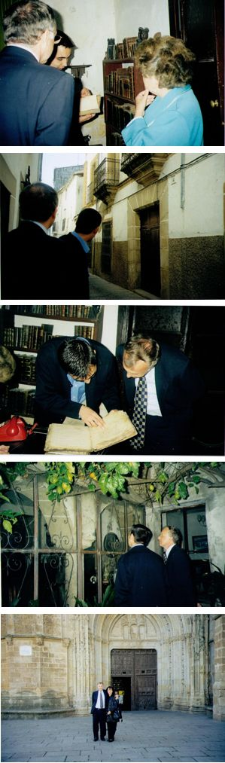

Referencias de las fotos al pie del articulo

El día de 8 de oktubre visiti la vieja sinagoga de Castelo de Vide del otro lado de la frontiera en Portugal. Observí ayí komo havía sido konstruida la sinagoga i el 9 de oktubre viaji kon mi mujer Ruthy a Coria adonde fuimos recivido por Juan Pedro Moreno. Moreno me mostro tres posibles lugares de la sinagoga pero deskarti los dos primeros (DNA, intuisión o mazal?) Kuando arivimos al terser lugar, me disho Moreno que ayi avia un problema porke la ansiana ke vivía ayí no asheptava avrir a ninguno. En subito, la ansiana (la señora Castañera), ke se asemejava exaktamente a mi madre, salio de su kaza. Le dishe ke vengo de Israel, me yamo Cory i ke la orijina de mi familia es de Coria. Keremos averiguar donde esta la sinagoga i la pedimos ke nos permita entrar en su kasa. Eya sonrió i nos invitó a entrar. Moreno estaba asombrado. Kuando entrimos, vi ke la kasa estava konstruída exaktamente komo la sinagoga de Castelo de Vide. Ma el portal era kuadrado i no en arko komo en la sinagoga de Vide. Kuando le demandi deke, me disho ke sintio de su familia ke morava en la misma kasa durante siglos, ke el portal original era en arko ma se destruyó durante el terremoto de 1755. Bashimos al sótano i nos mostro antiguos livros ma el mas antiguo era de 1500, después ke los jidíos fueron expulsados de España en 1492. Disho a Moreno ke estava de akuerdo a ke se hagan exkavasiones en su kasa para investigar los vestigios de la sinagoga.

Moreno me regaló un livro “Coria y Sierra de Gata” y eskrivió: “Para nuestros amigos israelitas, que este libro suponga un paso mas para el encuentro de unas culturas que nunca debieron separarse.” En 1999 la kasa de la señora Castañera fue vendida a un privado i asta 2011 no se izieron las exkavaciones ma Moreno me disho en 2011 ke bushkando en los arkivos de Coria komprobó desde algunos anyos ke esta kaza era efektivamente la kaza de la sinagoga. No se puede vizitar la sinagoga porke viven ayí privados. En internet meldi ke la komunidad djudía de Coria se remonta al siglo XII. En la judería vivían aproximadamente unas 46 familias ke se dedikaron a los ofisios de tornero, shastre, platero, arrendador de impuestos, etc. Kon motivo del dekreto de expulsión algunos djidíos se establesieron en Portugal donde se konvirtieron al kristianismo, komo Yuda de Alba. En realidad, estas son los fechas.

Yo presumo ke los djidíos de Coria (kon mis antepasados probablamente) se fuyiron al Portugal en 1492, siendo Coria en la frontera del Portugal que resivió djudios asta 1497. Pensavan que atornaran pishin a España y desharon la sinagoga al kuidado de una familia, ke troko su nombre komo munchos marranos kon nombres de arvoles – Castañera, los antepasados de la mujer ke ayinda morava ayí en 1998. Tomaron kon eyos todos los livros hebreos i por esto no avía en la kasa ningun livro anterior al 1500. Los djidíos de Portugal fueron forsados a konvertirse al kristianismo, ma munchos se fuyiron despues kon la kolaborasión de Dona Gracia Mendes i otros a Turkía, Gresia i Italia, donde mi familia moro asta ke emigraron a Egyto, Israel, Fransia o Brazil. La señora Castañera, ke problabamente savia ke su kasa avía sido la sinagoga, siendo marrana, desidio a su vejez permetir ke se agan exkavasiones i devolver su kaza a la funksion inisial de la sinagoga. Su semejansa kon mi madre no es una ilusión óptika porke tenemos fotos con eya, ma munchas djudías sefardías se asemejan hasta agora a espanyolas, porke no se kazaron kon otros ke Sefardís durante 500 anyos. La simpatía ke nos amostro, avriendo su kasa a un Israelí djidío kuando no kería avrirla a sus konsiudadanos, prueba probablamente ke savía algo sovre sus antepasados ebreos. Ma ken save komo se pasan las kosas, deke desidí vizitar Coria, deke el Arkeológo me demando ke le ayude a topar la sinagoga, deke la ansiana desidió avrirnos su kasa, komo un desendiente de Coria viniendo de Israel descuvrió la sinagoga después de 500 anyos? Sera una echizería, una koza de nada, una historia logica? Ken lo save?

Como me siguen  
En fila interminable  
Todos los yos que he sido!  
Como se abre el ante mi  
En infinita fila  
Para todos los yos que voy a ser!  
Y que poco, que nada soy yo  
Este yo, de hoy  
Que casi es de ayer,  
Que va a ser todo de mañana!

(Juan Ramón Jiménez, La realidad invisible, El presente)

**Fotos:**

1. Casa de la Sra. Castañera – Sinagoga de Coria: La Sra. Castañera, Juan Pedro Moreno, el arqueológo de Coria, y Jacques Cory.  
2. El portal de la casa de la Sra. Castañera – Sinagoga de Coria, con Moreno y Cory.   
3. Moreno y Cory examinan un libro antiguo en la biblioteca de la Sra. Castañera.   
4. El patio de la sinagoga de Coria – casa de la Sra. Castanera, que asemeja a la sinagoga de Castelo de Vide en la frontera de Portugal.   
5. Ruthy i Jacques Cory delante de la catedral de Coria. 

**Como descubrí la sinagoga de Coria? por el Dr. Jacques Cory**

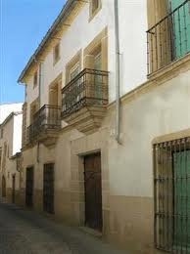

Sinagoga - Coria

Esta historia se puede leer como algo realista o surrealista. Algunos van a decir “si non e vero e ben trovato”, otros van a leerla con escepticismo, maravilla o incredulidad. No soy un arqueólogo, historiadór o un medium. Soy un hombre de negocios, con un doctorado en ética de negocios. Doy cursos en varias universidades, escribí libros academicos, artículos, un sitio internet, pero también una novela, obra de teatro, y algunos poemas. Cada uno a su manera…

El 10 de agosto de 1998 escribí una carta al Alcalde de Coria anunciándole que tenia la intención de visitar su ciudad, ya que se suponga que el nombre de mi familia Cory problabamente significa de Coria. Le dije que mi lengua materna es el ladino, pero que también estudié el castellano. Le decía que vivo en Israel, nací en Egypto, de padres y abuelos provenientes de Grecia y Turquía, y que estuve muchas veces en España por negocios.

El 20 de agosto de 1998 me escribio el Alcalde de la Ciudad de Coria: “Saluda a D. Jacobo Cory, y siendo conocedor del interés que tiene por visitar nuestra Ciudad me complace en invitarle y recibirle, dada la importancia de la empresa que le mueve venir hasta nuestra tierra. José Ma. Alvarez Pereira aprovecha esta ocasion para expresarle su consideracion personal.” El mismo día recibí un email de Juan Pedro Moreno, Arqueólogo responsable del Servicio de Asesoramiento Historico Cultural del ayuntamiento de Coria que me escribió: “El motivo de su visita me parece muy interesante y apasionante. El señor alcalde me ha transmitido su intención de visita. Coria, guarda en su memoria histórica el nombre de Calle de la Sinagoga, y hay dos posibles ubicaciones. Esperamos verle pronto por nuestra/su ciudad, sera bien recibido.” El 24 de agosto de 1998 le escribí que: “Me gustaría mucho visitar con Ud. la ciudad y ver las ubicaciones de la sinagoga y de la juderia. Quiza, puede ser que con mi DNA podré después de 500 anos, ayudarle a hallar la localización exacta donde mis antepasados vivían. Es muy importante por el turismo de su ciudad… Ya ve Ud. que soy todavía un localpatriota y espero hacer algo para contribuir a la economía de nuestra ciudad…”

El día de 8 de octubre visité la vieja sinagoga de Castelo de Vide del otro lado de la frontera en Portugal. Observí allí como había sido construida la sinagoga y el 9 de octubre viajé con mi mujer Ruthy a Coria adonde fuimos recibido por Juan Pedro Moreno. Moreno me mostro tres posibles ubicaciones de la sinagoga pero descarté las dos primeras (DNA, intuición o suerte?) Cuando llegamos al tercer sitio, me dijo Moreno que ahi habia un problema porque la anciana que vivía ahí no aceptaba abrir a nadie. De repente, la anciana (la señora Castañera), que se asemejaba exactamente a mi madre, salio de su casa. Le dije que vengo de Israel, me llamo Cory y que el origen de mi familia es de Coria. Tratamos de averiguar donde esta la sinagoga y la pedimos nos permita entrar en su casa. Ella sonrió y nos invitó a entrar. Moreno estaba asombrado. Quando entramos, vi que la casa estaba construída exactamente como la sinagoga de Castelo de Vide. Pero el portal era cuadrado y no en arco como en la sinagoga de Vide. Quando le pregunté porque, me dijo que oyo de su familia que vivía en la misma casa durante siglos, que el portal original era en arco pero se destruyó durante el terremoto de 1755. Bajamos al sótano y nos mostro antiguos libros pero el mas antiguo era de 1500, después que los judíos fueron expulsados de España en 1492. Dijo a Moreno que estaba de acuerdo a que se hagan excavaciones en su casa para investigar los vestigios de la sinagoga.

Moreno me regaló un libro “Coria y Sierra de Gata” y escribió: “Para nuestros amigos israelitas, que este libro suponga un paso mas para el encuentro de unas culturas que nunca debieron separarse.” En 1999 la casa de la señora Castañera fue vendida a un privado y hasta 2011 no se hicieron las excavaciones pero Moreno me dijo en 2011 que buscando en los archivos de Coria comprobó hace algunos años que esta casa era efectivamente la casa de la sinagoga. No se puede visitar la sinagoga porque viven ahí privados. En internet leí que la comunidad judía de Coria se remonta al siglo XII. En la judería vivían aproximamente unas 46 familias que se dedicaron a los oficios de tornero, sastre, platero, arrendador de impuestos, etc. Con motivo del decreto de expulsión algunos judíos se establecieron en Portugal donde se convirtieron al cristianismo, como Yuda de Alba. En realidad, estos son los hechos.

Yo presumo que los judíos de Coria (con mis antepasados probablamente) se huyeron al Portugal en 1492, siendo Coria en la frontera del Portugal que recibió judios hasta 1497. Pensaban que volverían pronto a España y dejaron la sinagoga al cuidado de una familia, que cambio su nombre como muchos marranos con nombres de arboles – Castañera, los antepasados de la mujer que aun vivía allí en 1998. Tomaron con ellos todos los libros hebreos y por esto no había en la casa ningun libro anterior al 1500. Los judíos de Portugal fueron forzados a convertirse al cristianismo, pero muchos huyeron despues con la colaboración de Dona Gracia Mendes y otros a Turquía, Grecia e Italia, donde mi familia vivio hasta que emigraron a Egypto, Israel, Francia o Brazil. La señora Castañera, que probablamente sabia que su casa había sido la sinagoga, siendo marrana, decidio a su vejez permetir que se hagan excavaciones y devolver su casa a la funcion inicial de la sinagoga. Su semejanza con mi madre no es una ilusión óptica porque tenemos fotos con ella, pero muchas judías sefardías se asemejan hasta ahora a españolas, porque no se casaron con otros que Sefardís durante 500 años. La simpatía que nos amostro, abriendo su casa a un Israelí judío quando no quería abrirla a sus conciudadanos, prueba probablamente que sabía algo sobre sus antepasados hebreos. Pero quien sabe como ocurren las cosas, porque decidí visitar Coria, porque el Arqueológo me pidió que lo ayude a hallar la sinagoga, porque la anciana decidió abrirnos su casa, como un descendiente de Coria viniendo de Israel descubrió la sinagoga después de 500 años? Sera una hechicería, un suceso, una historia logica? Quien lo sabe?

Como me siguen  
En fila interminable  
Todos los yos que he sido!  
Como se abre el ante mi  
En infinita fila  
Para todos los yos que voy a ser!  
Y que poco, que nada soy yo  
Este yo, de hoy  
Que casi es de ayer,  
Que va a ser todo de mañana!

(Juan Ramón Jiménez, La realidad invisible, El presente)

El Dr. Jacques Cory es un hombre de negocios internacional que se especializa en fusiones y adquisiciones, así como tambíen es autor pionero en la ética empresarial y profesor en las Universidades de Tel Aviv, Haifa, Technion (en 2006 en Insead), y otras. Cory ocupó altos cargos en la industria israelí de alta tecnología, escribió más de 100 planes de negocio, y ha iniciado las fusiones, los planes de reestructuración, adquisiciones y el know-how en los acuerdos de los EE.UU., Europa e Israel. Es autor de artículos y libros académicos publicados en los EE.UU. en Kluwer y Springer (minority shareholders), Mellen (sustainable society), y en Israel en Magnes, de una novela y una obra de teatro.

How I discovered the synagogue of Coria in Spain

Jacques Cory

This story can be read on a realistic or a

surrealistic level. Some people will say ‘‘if it is

not true it is a good fairy tale’’; others will

read it with scepticism, wonder or incredulity.

I am not an archeologist, an historian or

a medium. I am a businessman, with a

doctorate in business ethics. I teach courses

in various universities, wrote academic

books, articles, a website, but also a novel,

a play and some poems. Every one according

to his inclinations.

On the 10th of August 1998, I wrote a letter

to the mayor of Coria in Spain, notifying him

that I intended to visit his town, as it is a

tradition that my family name originates

probably from the town of Coria. I wrote

him that my mother tongue was Ladino, but

that I studied Spanish as well. I added that I

live in Israel, was born in Egypt, from

parents and grandparents originating from

Greece and Turkey, and that I visited Spain

many times on business.

On August 20th 1998, the mayor of Coria

wrote me: ‘‘Greetings to Don Jacobo CORY,

and being aware of the interest that he has in

our town I am pleased to invite and welcome

him, in view of the importance of the

enterprise that brings him to visit our

country. Jose Maria Alvarez Pereira takes

this opportunity to express him his personal

respect.’’ On the same day I received an email

from Juan Pedro Moreno, the archeologist

responsible for the Service of Historic and

Cultural Consultancy of the town council of

Coria, who wrote me: ‘‘The motive of his

visit seems to me very interesting and

exciting. Mr. Mayor has transmitted to me

his intention to visit us. Coria, keeps in its

historic memory the name of the Synagogue

street, and there are two possible locations.

We hope to see him soon in our/his town, he

will be well received.’’ On the 24th of August

1998 I wrote him that I would like very much

to visit with him in his town and see the

locations of the synagogue and the Jewish

quarter. Who knows, it might be that with

my DNA, I would be able after 500 years to

assist him in finding the exact location where

my ancestors lived. It is very important for

the tourism of his town He sees that I am

already a local patriot and I hope to

contribute something to the economy of our town’’.

On the 8th of October I visited the old

synagogue of Castelo de Vide on the other

side of the Portuguese border. I noticed there

how the synagogue was built, and on the 9th

of October I traveled with my wife Ruthy to

Coria where we were received by Juan Pedro

Moreno. Moreno showed me three possible

sites of the synagogue but I discarded the

first two ones (DNA, intuition or luck?)

When we arrived to the third site, Moreno

told me that there is here a problem as the

old lady who lives there, is unwilling to open

for anybody. Suddenly, the old lady (Mrs.

Castaniera), who exactly resembled my

mother, opened the door and came to us. I

introduced myself, told her that I come from

Israel, my name is Cory, and the origin of

our family is from Coria. We are trying to

find out where the synagogue is and we

would like her to let us visit her house. She

smiled and invited us to come in. Moreno

was astonished. When we entered the house,

I saw that the house was built exactly like the

synagogue of Castelo de Vide. But the porch

was square and not in an arch as with the

synagogue of Vide. When I asked her why,

she told me that she heard from her family,

who lived in the same house for centuries,

that the original porch was in an arch but it

was destroyed during the earthquake of 1755.

We went down to the basement and she

showed us ancient books, but the oldest one

was from 1500, after the Jews were expelled

from Spain in 1492. She told Moreno that

she agreed that excavations would be made

in her house to discover the traces of the synagogue.

Sharsheret Hadorot, Vol. 25, No. 1 xxvi

Moreno gave me a book ‘‘Coria and the

Sierra de Gata’’ and wrote: ‘‘For our Jewish

friends, let this book be another step for the

encounter of two cultures that never should

have been separated.’’ In 1999 the house of

Mrs. Castaniera was sold to a private owner

and until 2011 no excavations have been

made, but Moreno told me in 2011 that

looking into the archives of Coria he proved

a few years ago that this house was effectively

the site of the synagogue. It is impossible to

visit the synagogue as private people live

there. I read on the Internet that the Jewish

community of Coria dated back to the XIIth

century. In the Jewish quarter lived approximately

46 families with the professions of

turner, tailor, goldsmith, tax collectors, etc.

When the Jews were expelled from Spain,

some of them settled in Portugal where they

were converted later to Christianity, as Yuda

de Alba. Truly, those are the facts.

I presume that the Jews from Coria (with my

ancestors probably) fled to Portugal in 1492,

as Coria was near the border of Portugal

which received Jews until 1497. They thought

that they would return soon to Spain and left

the synagogue in the care of one of the

families, who changed her name, as many

Marranosdid to names of trees – Castaniera,

the chestnut tree. They were the ancestors of

the lady who still lived there in 1998. They

took with them all the books in Hebrew and

because of that there were not any book in

the house dating back to before 1500. The

Jews of Portugal were forced to convert to

Christianity, but many of them fled later on

with the assistance of Dona Gracia Mendes

and others to Turkey, Greece and Italy,

where my family lived until they emigrated to

Egypt, Israel, France or Brazil. Mrs. Castaniera,

who knew probably that her house was

the synagogue, being a Marrana, decided in

her old age to enable excavations and transform

the house to its initial function of a

synagogue. Her likeness to my mother was

not an optical illusion as we have pictures

with her, but many Sephardic Jewish women

until nowadays resemble Spanish women, as

they married with Sephardic men for 500

years. The sympathy that the lady showed us,

opening her house to a Jewish Israeli while

she did not want to open it to her fellow

townspeople, proved probably that she knew

something of her Jewish ancestry. But who

knows how things happen, why had I decided

to visit Coria, why the archeologist asked me

to assist him to find the synagogue, why the

old lady decided to open her house to us,

how a descendant from Coria coming from

Israel discovered the synagogue after 500

years? Is it witchcraft, a negligible incident, a

logic story? Who can know?

Just as an interminable row

Are all the past incarnations of me,

So too, in an interminable row

Are all my future incarnations.

How little – yea nothing – am I today

Which is almost consigned to yesterday,

But will be everything tomorrow.

(Juan Ramon Jimenez, The Invisible Reality, The Present)

Dr. Jacques Cory is an international businessman

specializing in Mcoryj@zahav.net.il or cory@netvision.net.il

website: http://www.businessethicscory.com

or http://www.businessethics.co.il

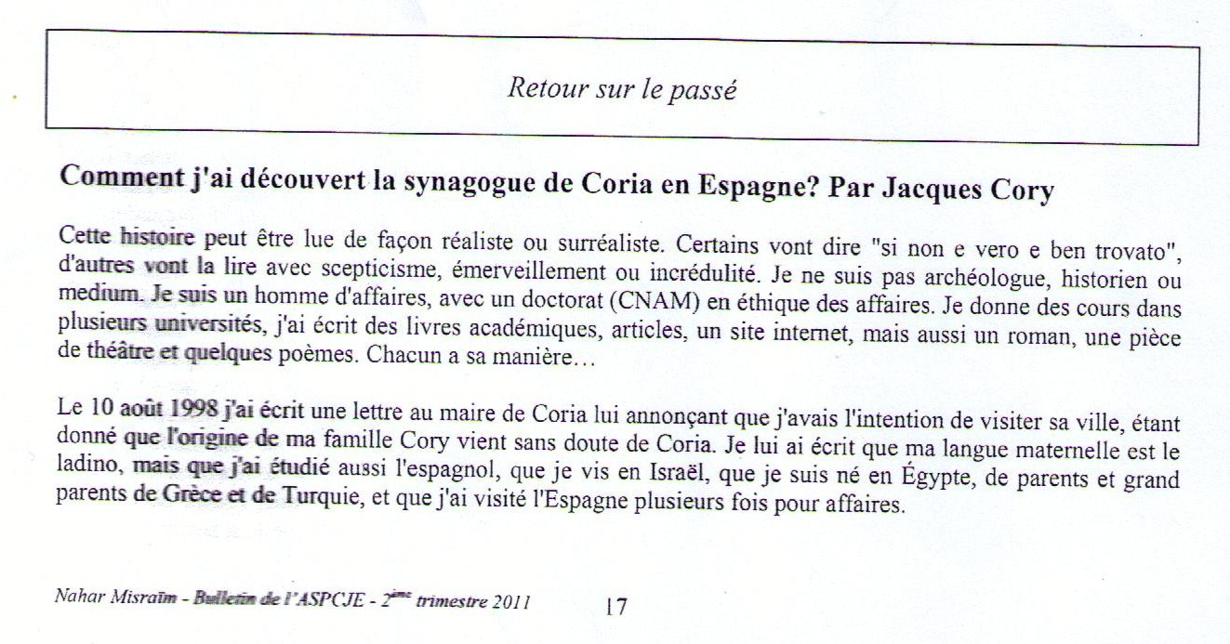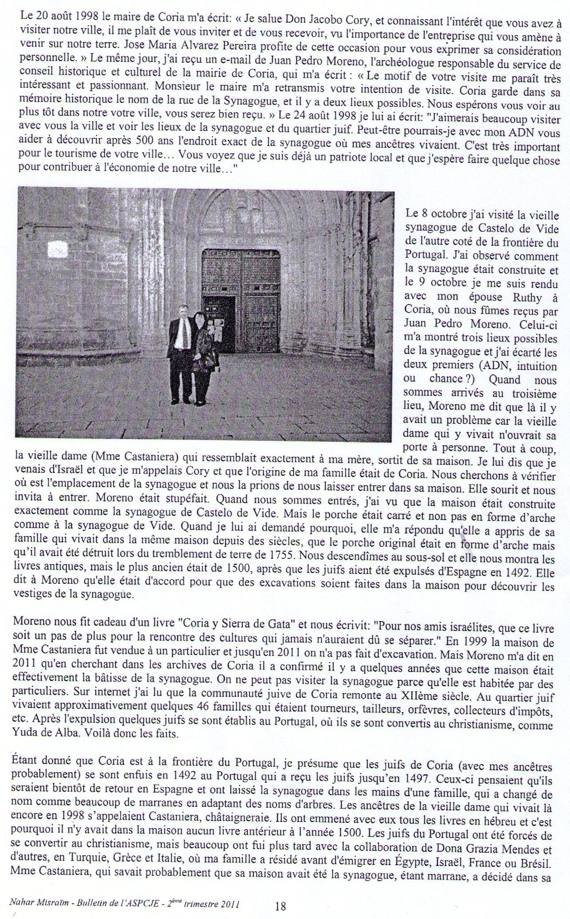

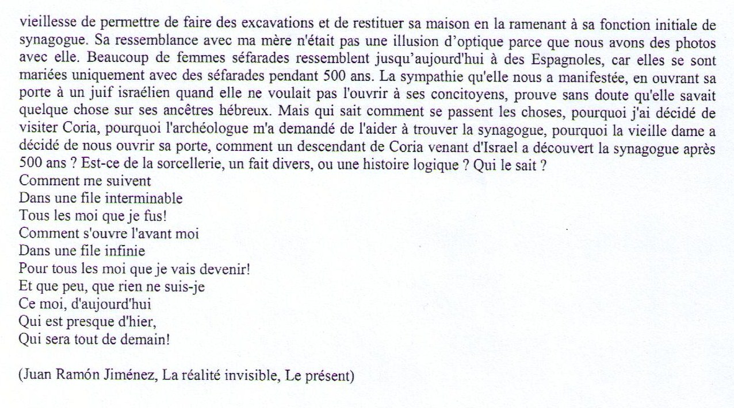

|  |  |  |  |  |
| --- | --- | --- | --- | --- |
| |  |  | | --- | --- | | [PrintLogo](http://www.news1.co.il/) |  |  |  |  | | --- | --- | |  | יום שני 20 יוני 2016  12:58 | |
|  |

|  |  |  |  |  |  |  |  |  |  |  |  |  |  |  |  |  |  |  |  |  |  |  |  |  |  |  |  |  |  |  |  |  |  |  |  |  |  |  |  |  |  |  |  |  |  |  |  |  |  |  |  |  |  |  |  |  |  |  |  |  |  |  |  |  |  |  |  |  |  |  |  |  |  |  |  |  |  |  |
| --- | --- | --- | --- | --- | --- | --- | --- | --- | --- | --- | --- | --- | --- | --- | --- | --- | --- | --- | --- | --- | --- | --- | --- | --- | --- | --- | --- | --- | --- | --- | --- | --- | --- | --- | --- | --- | --- | --- | --- | --- | --- | --- | --- | --- | --- | --- | --- | --- | --- | --- | --- | --- | --- | --- | --- | --- | --- | --- | --- | --- | --- | --- | --- | --- | --- | --- | --- | --- | --- | --- | --- | --- | --- | --- | --- | --- | --- | --- |
| |  |  |  |  |  |  |  |  |  |  |  |  |  |  |  |  |  |  |  |  |  |  |  |  |  |  |  |  |  |  |  |  |  |  |  |  |  |  |  |  |  |  |  |  |  |  |  |  |  |  |  |  |  |  |  |  |  |  |  |  |  |  |  |  |  |  |  |  |  |  |  |  |  |  |  |  |  |  | | --- | --- | --- | --- | --- | --- | --- | --- | --- | --- | --- | --- | --- | --- | --- | --- | --- | --- | --- | --- | --- | --- | --- | --- | --- | --- | --- | --- | --- | --- | --- | --- | --- | --- | --- | --- | --- | --- | --- | --- | --- | --- | --- | --- | --- | --- | --- | --- | --- | --- | --- | --- | --- | --- | --- | --- | --- | --- | --- | --- | --- | --- | --- | --- | --- | --- | --- | --- | --- | --- | --- | --- | --- | --- | --- | --- | --- | --- | | |  |  |  | | --- | --- | --- | |  |  |  |  |  | | --- | |  | | |  | | --- | | NEWS1NEW-167091012001038 | | שער הכניסה של בית הכנסת של קוריה שהוא ביתה של גב' קסטנירה [צילום: רותי קורי] | | |  | | **כיצד גיליתי את בית הכנסת של קוריה בספרד** | | **"אולי יתאפשר לי, עם הדנ"א שלי, לאחר 500 שנה, לסייע לך למצוא את המיקום המדויק של בית הכנסת בו ביקרו אבות אבותיי", כתבתי לארכיאולוג של עיריית קוריה, שמקור שם-משפחתי קורי הוא משמה של העיר midBullמה נחל החיפוש ומי היא גברת קסטנירה?** |  |  | | --- | |  |  |  |  |  |  |  |  |  |  |  |  |  |  |  |  |  |  |  |  |  |  |  |  |  |  |  |  |  |  |  |  |  | | --- | --- | --- | --- | --- | --- | --- | --- | --- | --- | --- | --- | --- | --- | --- | --- | --- | --- | --- | --- | --- | --- | --- | --- | --- | --- | --- | --- | --- | --- | --- | | |  |  |  |  |  |  |  |  |  |  |  |  |  |  |  |  |  |  |  |  |  | | --- | --- | --- | --- | --- | --- | --- | --- | --- | --- | --- | --- | --- | --- | --- | --- | --- | --- | --- | --- | --- | | |  |  |  |  |  |  |  |  |  | | --- | --- | --- | --- | --- | --- | --- | --- | --- | | |  |  |  | | --- | --- | --- | | |  | | --- | | NEWS1NEW-572926819324494 | | חואן פדרו מורנו, הארכיאולוג של קוריה ויעקב קורי בוחנים ספר עתיק בספרייה בביתה של גב' קסטנירה [צילום: רותי קורי] | | |  | | |  | | --- | | NEWS1NEW-287526965141297 | | ד"ר קורי מעיין בספר על קוריה שקיבל במתנה ממורנו שלימינו [צילום: רותי קורי] | | |  | | | |  |  |  |  | | --- | --- | --- | --- | |  | |  | | --- | |  | |  | |  | |  | | --- | | **הגברת הזקנה (שמה היה קסטנירה), שדמתה בצורה מדויקת לאמי, יצאה מביתה. אמרתי לה שאני בא מישראל, שמי הוא קורי, ומקור המשפחה שלנו מקוריה. אנחנו רוצים למצוא היכן היה בית הכנסת ואנו מבקשים את רשותה להיכנס לביתה. היא חייכה, והזמינה אותנו להיכנס** | |  | |  |  |  | | --- | |  | | |  |  | | --- | |  |  |  | | --- | |  |  |  | | --- | |  |  |  | | --- | |  |  |  |  | | --- | --- | | > | [מעשה קסם? סיפור הגיוני?](http://www.news1.co.il/ArticlePrintVersion.aspx?docId=57389&subjectID=3#PTEXT22178) | |  | |  |  | | --- | |  |   ניתן לקרוא סיפור זה במישור המציאותי או הסוריאליסטי. אחדים יאמרו "אם זה לא אמיתי, זו בוודאי מעשייה מוצלחת", אחרים יקראו אותו בספקנות, בהשתאות או בחוסר אמון. אינני ארכיאולוג, היסטוריון או מדיום. אני איש עסקים, עם דוקטורט באתיקה עסקית. אני מלמד קורסים בכמה אוניברסיטות, כתבתי ספרים אקדמיים, מאמרים, אתר אינטרנט, אך גם רומן, מחזה ומעט שירה. איש-איש כאשר ידבנו ליבו...   בעשרה באוגוסט 1998 כתבתי מכתב לראש העיר של קוריה בספרד והודעתי לו שבכוונתי לבקר בעירו, כי על-פי המסורת מקור השם שלי קורי הוא מקוריה. סיפרתי לו ששפת אמי היא לדינו אך למדתי גם ספרדית, אני חי בישראל, נולדתי במצרים, מהורים וסבים ממוצא יווני וטורקי, וביקרתי פעמים רבות בספרד בענייני עסקים.   בעשרים באוגוסט 1998 כתב לי ראש העיר של קוריה:   * **"אני מברך את דון חקובו קורי, ובהכירי את העניין שיש לו בביקור בעירנו אני מתכבד להזמינו ולארחו, בהביאי בחשבון את החשיבות של המטרה שהביאה אותו לרצות לבקר בארצנו. חוזה מריה אלברז מנצל את ההזדמנות על-מנת להביע בפניו את העניין האישי שלו".**   באותו היום קיבלתי דוא"ל מחואן פדרו מורנו, הארכיאולוג האחראי למחלקת ההיסטוריה והתרבות של עיריית קוריה, שכתב לי:   * **"המטרה של הביקור שלו נראית לי מאוד מעניינת ומרתקת. כבוד ראש העיר מסר לי על רצונו לבקר אותנו. קוריה, שומרת בזכרונה ההיסטורי את השם של רחוב בית הכנסת, ויש שני מקומות אפשריים למיקומו. אנו מקווים לראותו בקרוב בעירנו/עירו. נקבל אותו היטב".**   בעשרים וארבעה באוגוסט 1998 כתבתי למורנו:   * **"בחפץ רב אבקר עימו בעירו ואראה את האתרים של בית הכנסת והרובע היהודי. אולי, יתאפשר לי עם הדנ"א שלי לאחר 500 שנה, לסייע לו למצוא את המיקום המדויק של בית הכנסת בו ביקרו אבות אבותיי. זה מאוד חשוב למען התיירות של עירו... רואה אתה אדוני, שאני כבר לוקלפטריוט ואני חפץ לעשות דבר-מה על-מנת לסייע בכלכלת עירנו...".**   בשמונה באוקטובר ביקרתי בבית הכנסת העתיק של קסטלו דה וידה מהצד האחר של הגבול, בפורטוגל. שמתי לב איך נבנה בית הכנסת ובתשעה באוקטובר נסענו רעייתי רותי ואנוכי לקוריה, שם התקבלנו על-ידי חואן פדרו מורנו. מורנו הראה לי שלושה אתרים אפשריים לבית הכנסת, אבל פסלתי את שני הראשונים (דנ"א, אינטואיציה או מזל?). כאשר הגענו לאתר השלישי, אמר לנו מורנו שפה ישנה בעיה, כי הגברת הזקנה שגרה בבית לא מוכנה לפתוח את ביתה בפני אף אחד. לפתע, הגברת הזקנה (שמה היה קסטנירה), שדמתה בצורה מדויקת לאמי, יצאה מביתה. אמרתי לה שאני בא מישראל, שמי הוא קורי, ומקור המשפחה שלנו מקוריה. אנחנו רוצים למצוא היכן היה בית הכנסת ואנו מבקשים את רשותה להיכנס לביתה. היא חייכה, והזמינה אותנו להיכנס. מורנו היה המום.   כאשר נכנסנו, שמתי לב שהבית היה בנוי בדיוק כמו בית הכנסת של קסטלו דה וידה. אבל השער היה מרובע ולא בצורת קשת כמו בבית הכנסת בוידה. כאשר שאלתי אותה מדוע, היא אמרה לי שהיא שמעה ממשפחתה, החיה באותו הבית מזה מאות בשנים, שהשער המקורי היה קשתי, אבל הוא נהרס ברעידת-האדמה של 1755. ירדנו למרתף והיא הראתה לנו ספרים עתיקים, אך העתיק ביותר היה משנת 1500, לאחר שהיהודים גורשו מספרד בשנת 1492. היא אמרה למורנו שהיא מסכימה שייערכו חפירות בביתה על-מנת למצוא את שרידי בית הכנסת.   בתום הביקור, נתן לי מורנו במתנה ספר "קוריה וסיירה גאטה" וכתב הקדשה: **"לידידינו היהודים, שספר זה יניח צעד נוסף למפגש של תרבויות שלעולם לא היו צריכות להיפרד"**. |  |  |  |  |  |  |  |  |  |  |  |  |  |  |  |  |  |  | | --- | --- | --- | --- | --- | --- | --- | --- | --- | --- | --- | --- | --- | --- | --- | --- | --- | | |  |  |  | | --- | --- | --- | | |  | | --- | | **מעשה קסם? סיפור הגיוני?** | |  | | | |  | | --- | | NEWS1NEW-395565271377564 | | **הפטיו של בית הכנסת של קוריה [צילום: רותי קורי]** |  |  | | --- | |  | | | |  |  |  |  |  |  |  |  | | --- | --- | --- | --- | --- | --- | --- | --- | | |  | | --- | |  |  |  |  |  |  |  | | --- | --- | --- | --- | --- | |  | |  | | --- | | **היהודים של פורטוגל נאנסו להתנצר, כי לא איפשרו להם להגר כמו בספרד, אבל רבים מהם ברחו מאוחר יותר עם עזרתם של דונה גרציה מנדס ואחרים לטורקיה, ליוון ולאיטליה** | |  | |  |  |  | | --- | |  | |   בשנת 1999 נמכר ביתה של גברת קסטנירה לאדם פרטי ועד שנת 2011 לא בוצעו החפירות, אבל מורנו אמר לי בשנת 2011, שבחפשו בארכיבים של קוריה, הוכח לפני מספר שנים שבית זה אכן היה האתר של בית הכנסת. לא ניתן לבקר בבית הכנסת כי גרים בו אנשים פרטיים. באינטרנט קראתי שהקהילה היהודית בקוריה הייתה קיימת כבר במאה השתים-עשרה. ברובע היהודי חיו בערך 46 משפחות שעסקו במקצועות של חרטים, חייטים, צורפים, גובי-מס וכדומה. עם הגירוש מספרד, כמה מהיהודים השתקעו בפורטוגל, שם הם התנצרו, כמו יהודה מאלבה. אלה אם כן העובדות.   אני משער שהיהודים של קוריה (עם אבות אבותיי כנראה) ברחו לפורטוגל בשנת 1492, כי קוריה הייתה על גבול פורטוגל שקיבלה יהודים עד שנת 1497. הם חשבו שיחזרו בקרוב לספרד והשאירו את בית הכנסת במשמרת של אחת המשפחות, ששינתה את שמה, כמו אנוסים רבים, לשם של עץ - קסטנירה, עץ הערמון, אבות אבותיה של הגברת הזקנה שחיה עדיין באותו הבית בשנת 1998. הם לקחו עימם את כל הספרים בעברית ולכן לא היו בבית ספרים כלשהם מלפני שנת 1500. היהודים של פורטוגל נאנסו להתנצר, כי לא איפשרו להם להגר כמו בספרד, אבל רבים מהם ברחו מאוחר יותר עם עזרתם של [דונה גרציה מנדס](http://www.news1.co.il/Archive/003-D-53350-00.html) ואחרים לטורקיה, ליוון ולאיטליה, שם גרה משפחתי עד אשר היגרו שוב למצרים, לישראל, לצרפת או לברזיל.   הגברת קסטנירה, שכנראה ידעה שביתה היה בית הכנסת בהיותה אנוסה, החליטה בזקנותה לאפשר שיתבצעו חפירות ולהחזיר את ביתה לייעודו המקורי של בית כנסת. הדמיון שלה עם אמי הוא לא תעתוע אופטי כי יש לנו תמונות עימה, אבל יהודיות ספרדיות רבות דומות עד היום לספרדיות, כי הן התחתנו עם ספרדים במשך 500 שנה. הסימפטיה שהיא חשה כלפינו, בפותחה את ביתה בפני ישראלי-יהודי כאשר לא רצתה לפתחו לבני עירה, מוכיחה כנראה שהיא ידעה על אבות אבותיה היהודים.   אך מי יודע איך מתרחשים הדברים: מדוע החלטתי לבקר בקוריה, מדוע הארכיאולוג ביקש ממני שאסייע לו למקם את בית הכנסת, מדוע האישה הזקנה החליטה לפתוח לנו את ביתה, כיצד צאצא של קוריה שבא מישראל מצא את בית הכנסת אחרי 500 שנה? האם זה מעשה קסם, דבר של מה בכך, סיפור הגיוני? מי יודע?   * **איכה ילווני  בטור אינסופי  כל אלה אשר הייתי אנוכי!  איכה נפתח אשר הייתי  בטור אינסופי  עבור כל אלה אשר אהיה!  וכה מעט, כה כלום אנוכי  אנוכי של היום  שהוא כמעט של אמש,  שיהיה הכל של המחר!**   (חואן רמון חימנז, האמת הבלתי נראית, ההווה) | |  |  |  |  | | --- | --- | --- | | |  | | --- | | **בביתה של גב' קסטנירה. יעקב קורי וחואן פדרו מורנו [צילום: רותי קורי]** | | NEWS1NEW-295955836772919 | | |  | | |  |  | | --- | --- | |  | | | squreColored | **הכותב הוא מרצה לאתיקה באוניברסיטת חיפה.** | |  | |  |  | | --- | |  |  |  |  |  |  |  |  | | --- | --- | --- | --- | --- | --- | | |  |  |  |  |  | | --- | --- | --- | --- | --- | | תאריך: | 07/03/2011 | | | עודכן: | 08/03/2011 | | | | |

LETTER SENT BY THE SPANISH AMBASSADOR IN ISRAEL TO JACQUES CORY

Querido Sr Cory:

Muchas gracias por sus amables palabras. Le agradezco mucho su interesante trabajo sobre Coria. En mi país hay gran interés por sacar a la luz aspectos inéditos del importante legado judeo-español. Le animo a que prosiga sus esfuerzos.

Con toda amistad,

|  |  |
| --- | --- |
| **Álvaro Iranzo**  **Embajador de España en Israel**  **Tel.: +972 3 769 79 08** |  |

Letter dated 23/6/11, from the Spanish Ambassador in Israel, Alvaro Iranzo, to Jacques Cory:

Dear Mr. Cory:

Many thanks for your kind words. I am very grateful for your interesting work on Coria. In my country there is a lot of interest for discovering unknown aspects of the important Judeo-Spanish legacy. I encourage you to proceed with your efforts.

With all my friendship,

Alvaro Iranzo,

Spanish Ambassador in Israel

Tel.: +972 3 769 79 08

Afterword

The old lady, Mrs. Castañeda, has died and her two children inherited the house. Who are they?

The house was sold, the purchaser has given a deposit, but after receiving the keys he destroyed the roof, and has not proceeded with the payments. The matter is now waiting a court decision. What were the motives of the purchaser, of the mayors, of the Coria residents, of the children?

The house is in a very bad condition, the adjacent road is blocked, as it is dangerous to walk by the synagogue. The synagogue might be in Calle de la sinagoga, no. 2 and the Mikve (baths) might be in no. 4, where the old lady lived. Only excavations would setlle the matter.

The house in no. 2 is not for sale, but the house in no. 4 might be for sale, after the judicial problems are resolved. Would the neighbors be happy to have Jewish tourists visiting daily?

Those who believe in the supernatural, might think that there is a "curse" on the house, due to the tragic events that happened after the visit to Coria. But, has the visit to Coria precipitate the events? Are there no rational explanations to what has happened, as weird as they might seem?

Who is going to sort out the problems and restore the synagogue and mikve? The Spanish government, Jewish organizations, the town of Coria, private people, the Cory family?

Attached please find photos of the house and the street in 2011. Sic transit gloria mundi!

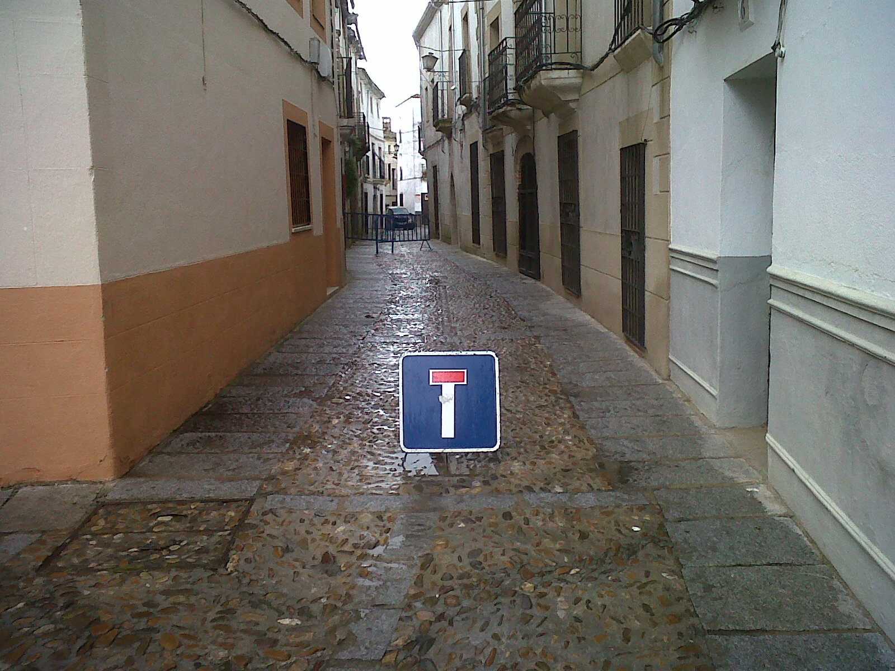

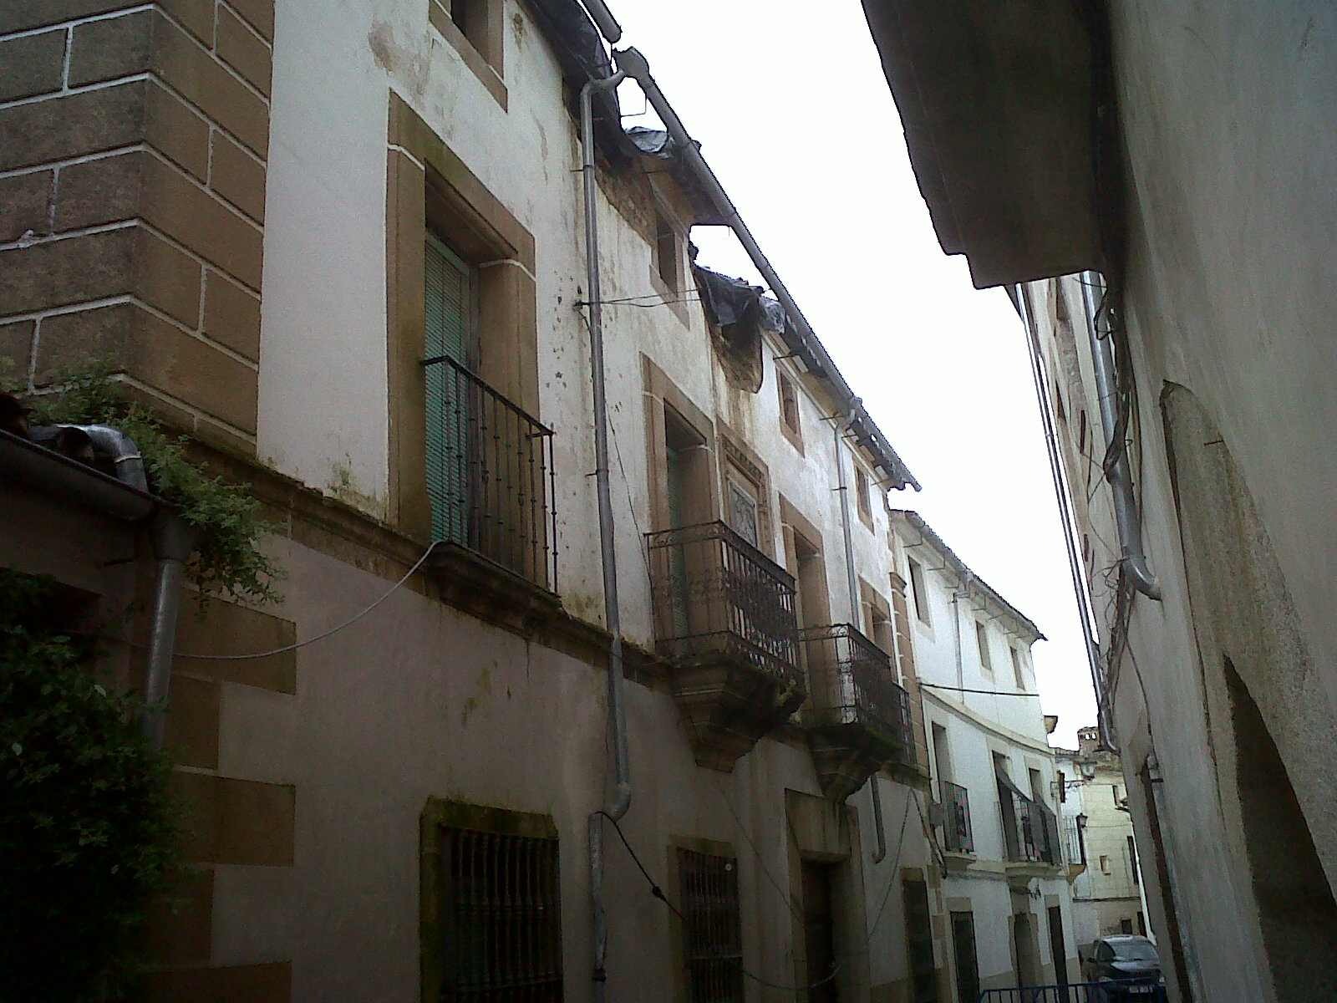

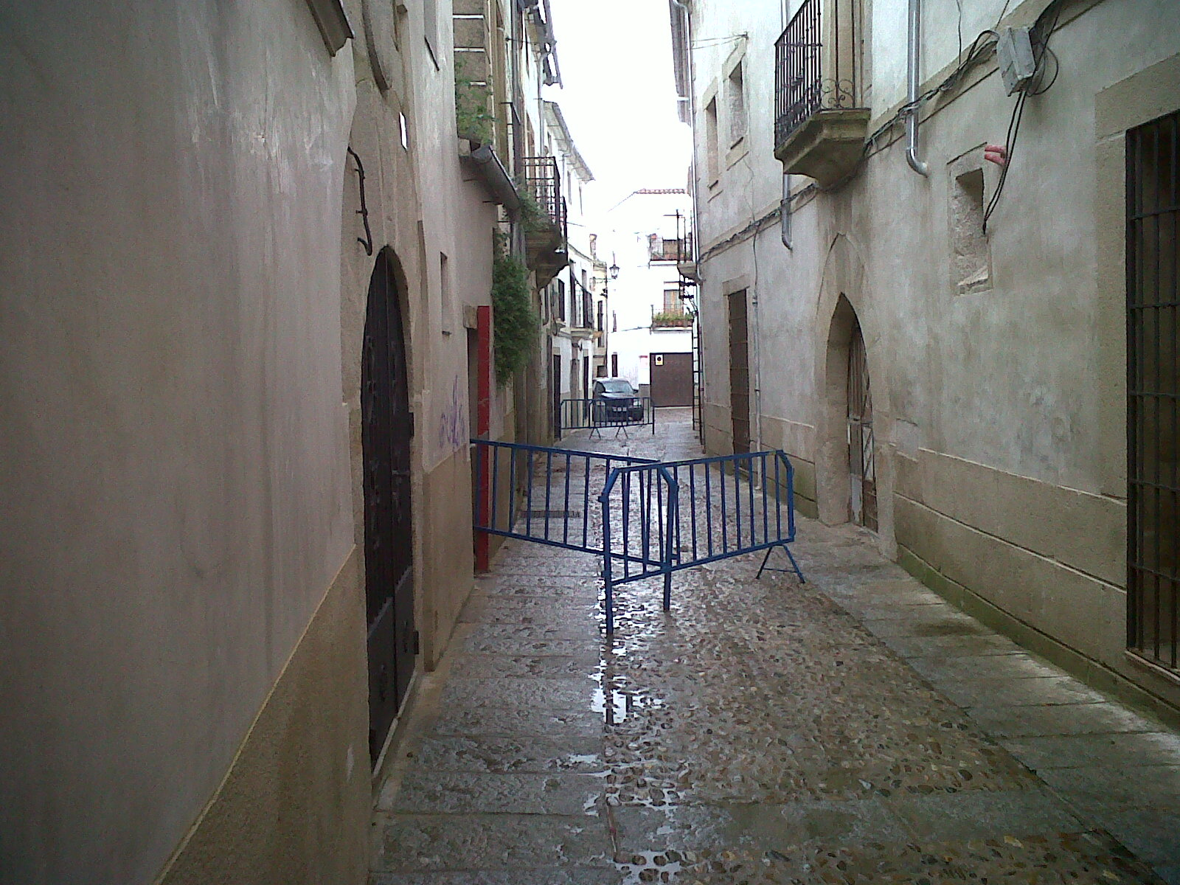

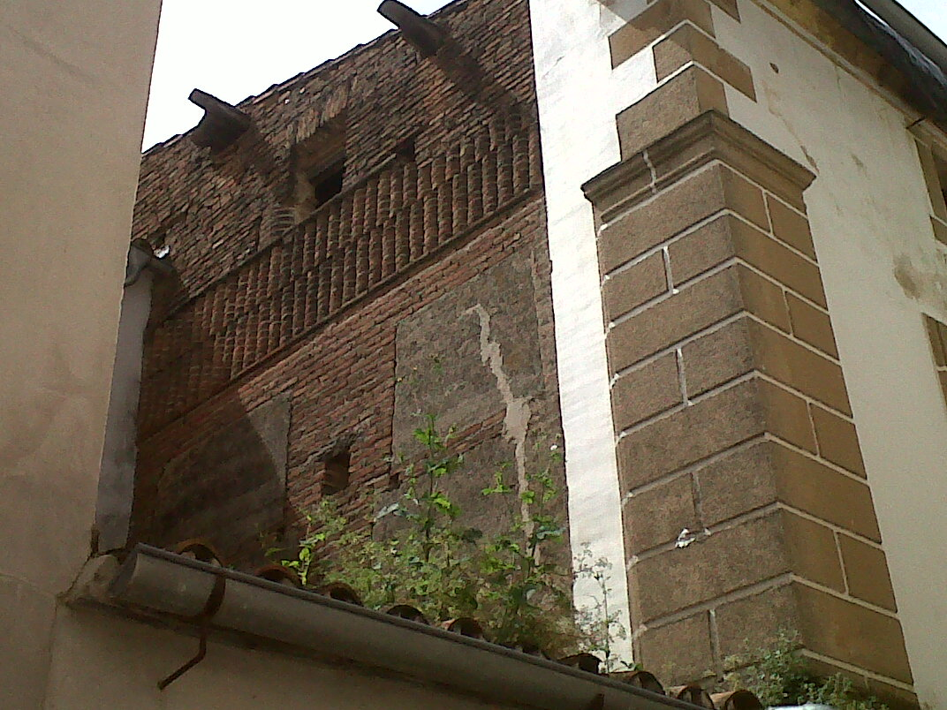

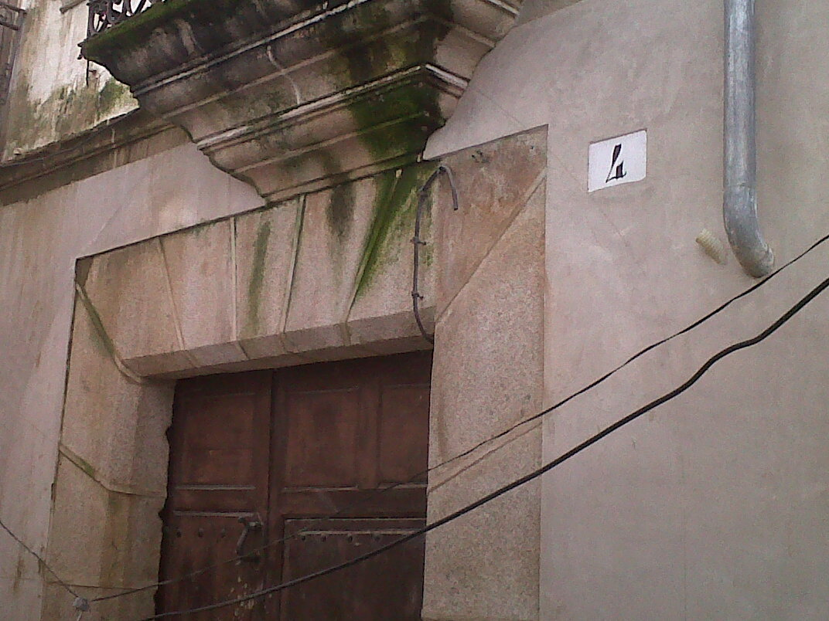

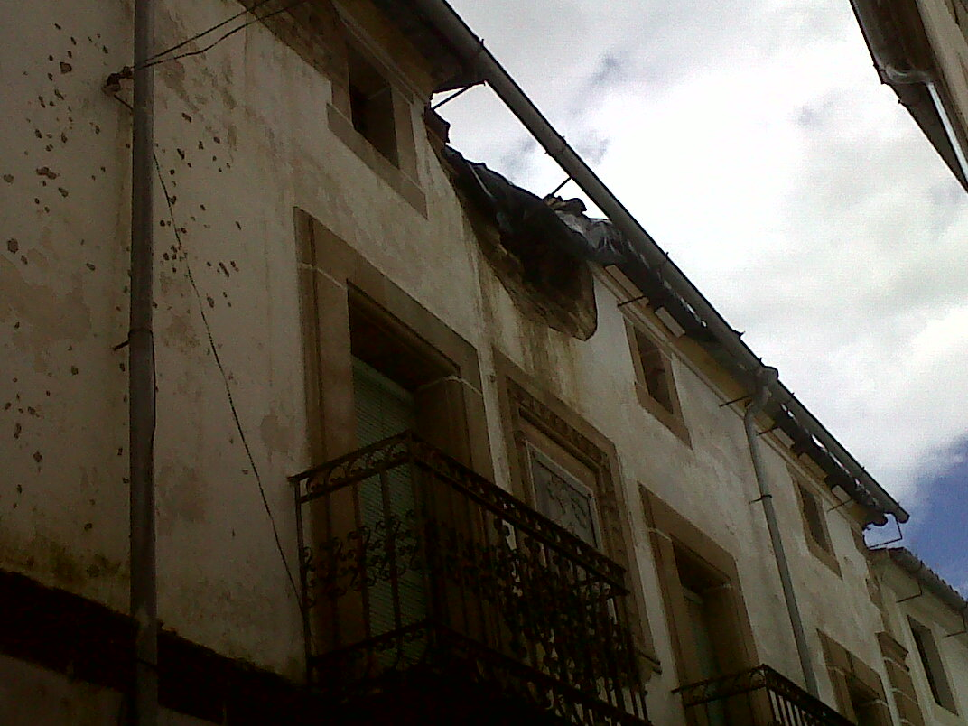

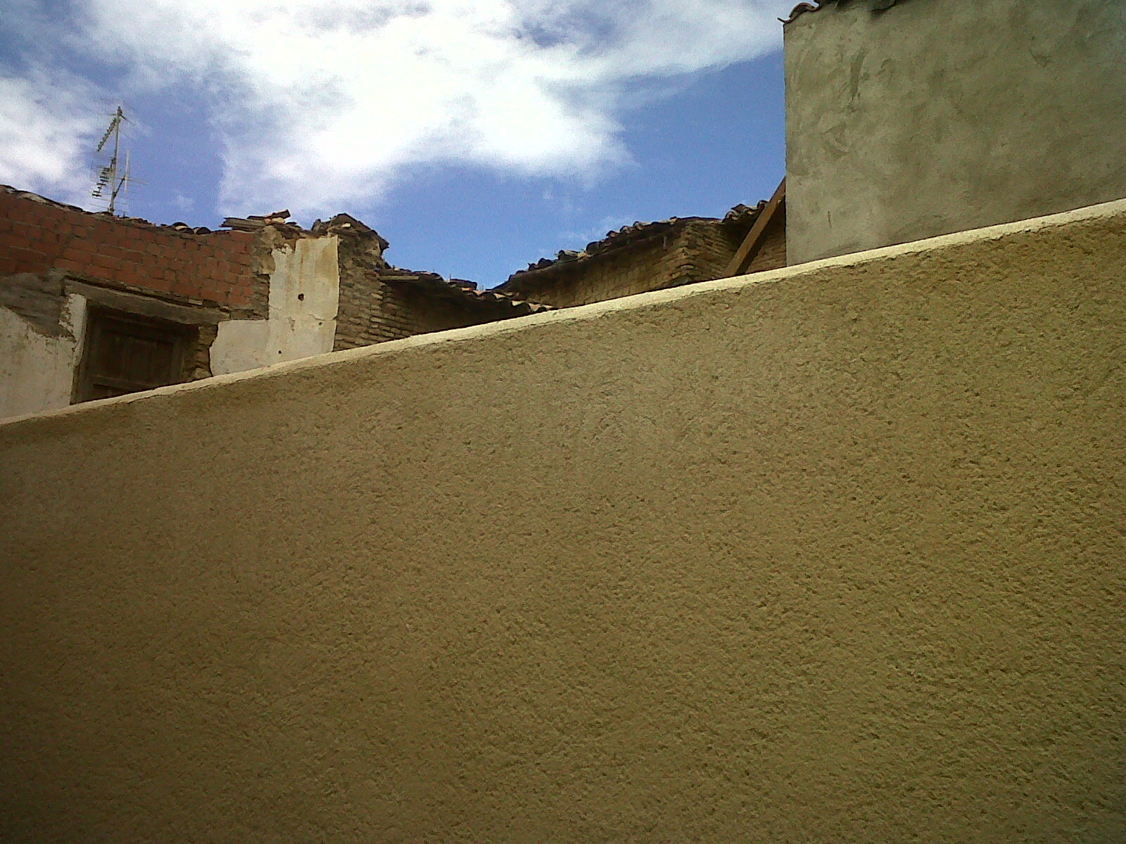

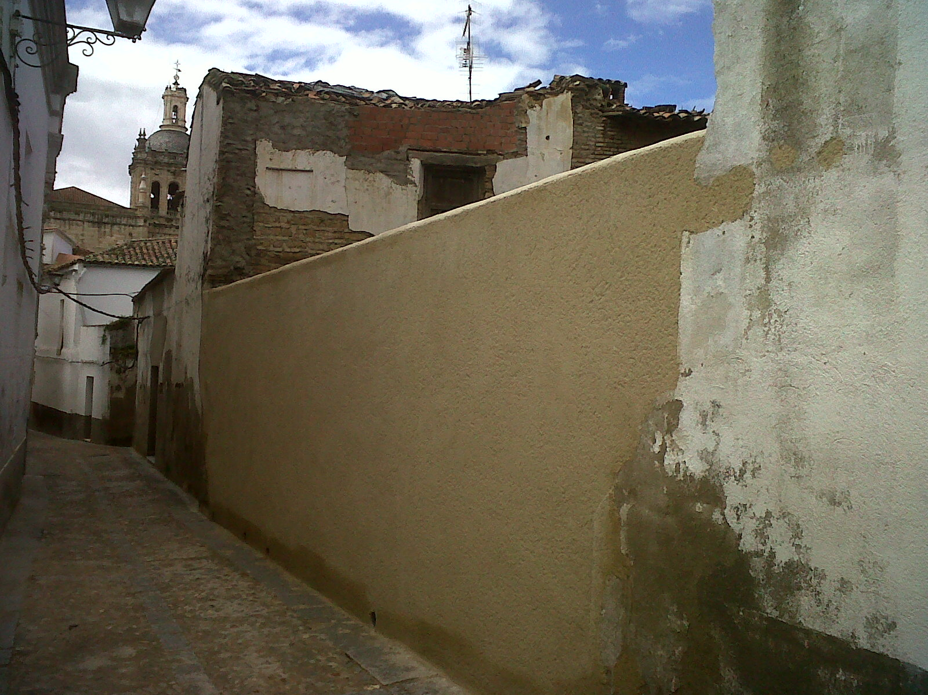

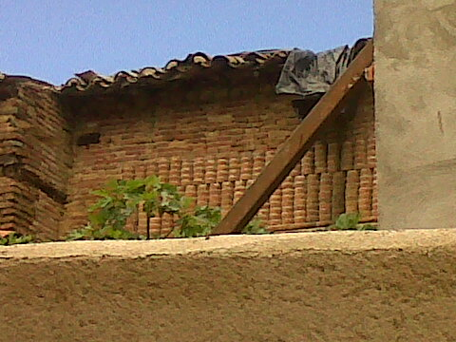

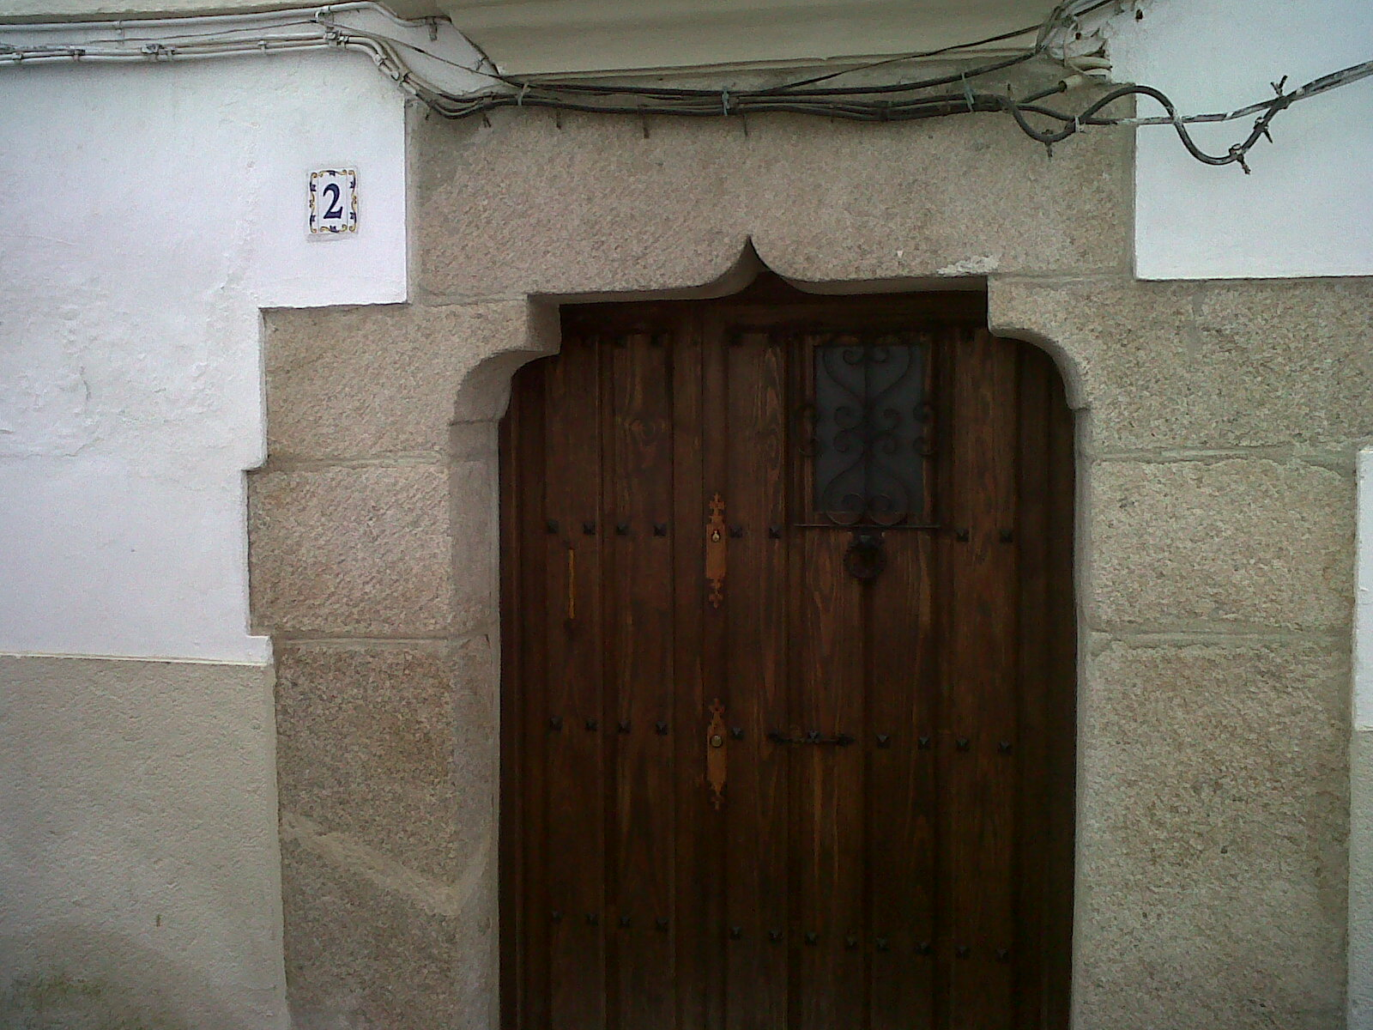

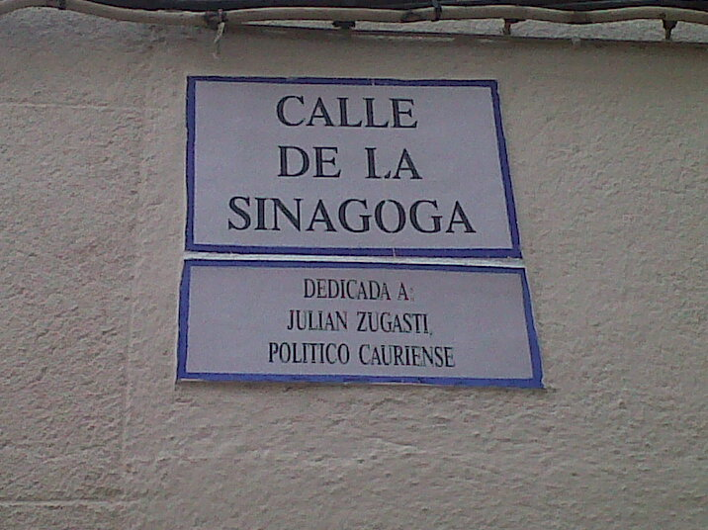

4. LADINO, TRANSLATION OF UN'S UNIVERSAL DECLARATION OF HUMAN RIGHTS INTO LADINO, PRESENT TO ISRAELI PRESIDENT NAVON, EN EL VERGEL DE LA REINA, PRAYER, DURME DURME, SEPHARDI JEWS, ODYSSEY, 3 ROMANCES, THEODOR HERZL, SEPHARDIC ZIONISM, HERZL'S ALTNEULAND IN LADINO, SINGING AGADA IN LADINO TO HARRY RECANATI WHO BURST OUT CRYING

**Reading in Ladino** – El Meam loez de Cantar de los cantares edited by Rosa Asenjo, La Odisea by Homer, Los Misterios de Pirei by Jak Luria, Vieja Nueva Tiera by Theodor Herzl, Djoha edited by Matilda Koen Sarano, Kuentos del folklor de la famiya Judeo-espaniola by Matilda Kohen Sarano, Konsejas I Konsejikas edited by Matilda Koen Sarano, Sefardic Proverbs and Sefardic Stories edited by Isaac Moscona. **Read recently** - Romansero Sefardi edited by Moshe Attias, Los dos mellizos by Pilar Romeu Ferre, En los kampos de la muerte by Moshe Ha-Elion.

**Judaeo-Spanish** (also **Judeo-Spanish** and Judæo-Spanish: *Judeo-Español*, [Hebrew script](https://en.wikipedia.org/wiki/Hebrew_alphabet): גֿודֿיאו-איספאנייול, [Cyrillic](https://en.wikipedia.org/wiki/Cyrillic_script): Ђудео-Еспањол), commonly referred to as **Ladino**, is a [Romance language](https://en.wikipedia.org/wiki/Romance_languages) derived from [Old Spanish](https://en.wikipedia.org/wiki/Old_Spanish_language). Originally spoken in the former territories of the [Ottoman Empire](https://en.wikipedia.org/wiki/Ottoman_Empire) (the [Balkans](https://en.wikipedia.org/wiki/Balkans), [Turkey](https://en.wikipedia.org/wiki/Turkey), the [Middle East](https://en.wikipedia.org/wiki/Middle_East), and [North Africa](https://en.wikipedia.org/wiki/North_Africa)) as well as in [France](https://en.wikipedia.org/wiki/France), [Italy](https://en.wikipedia.org/wiki/Italy), [Netherlands](https://en.wikipedia.org/wiki/Kingdom_of_the_Netherlands), [Morocco](https://en.wikipedia.org/wiki/Morocco), and the [UK](https://en.wikipedia.org/wiki/United_Kingdom), today it is spoken mainly by [Sephardic](https://en.wikipedia.org/wiki/Sephardi_Jews) [minorities](https://en.wikipedia.org/wiki/Minority_group) in more than 30 countries, most of the speakers residing in [Israel](https://en.wikipedia.org/wiki/Israel). Although it has no official status in any country, it has been acknowledged as a [minority language](https://en.wikipedia.org/wiki/Minority_language) in Israel, Turkey and France. The core [vocabulary](https://en.wikipedia.org/wiki/Vocabulary) of Judaeo-Spanish is [Old Spanish](https://en.wikipedia.org/wiki/Old_Spanish_language) and it has numerous elements from all the old [Romance languages](https://en.wikipedia.org/wiki/Romance_languages) of the [Iberian Peninsula](https://en.wikipedia.org/wiki/Iberian_Peninsula), such as [Old Aragonese](https://en.wikipedia.org/wiki/Navarro-Aragonese), [Astur-Leonese](https://en.wikipedia.org/wiki/Astur-Leonese_languages), [Old Catalan](https://en.wikipedia.org/wiki/Old_Catalan_language), [Old Portuguese](https://en.wikipedia.org/wiki/Galician-Portuguese) and [Mozarabic](https://en.wikipedia.org/wiki/Mozarabic_language). The language has been further enriched by [Ottoman Turkish](https://en.wikipedia.org/wiki/Ottoman_Turkish_language) and [Semitic](https://en.wikipedia.org/wiki/Semitic_languages) vocabulary, such as [Hebrew](https://en.wikipedia.org/wiki/Hebrew_language), [Aramaic](https://en.wikipedia.org/wiki/Aramaic_language), and [Arabic](https://en.wikipedia.org/wiki/Arabic_language), especially in the domains of [religion](https://en.wikipedia.org/wiki/Religion), [law](https://en.wikipedia.org/wiki/Law) and [spirituality](https://en.wikipedia.org/wiki/Spirituality) and most of the vocabulary for [new and modern](https://en.wikipedia.org/wiki/Renaissance) concepts has been adopted through [French](https://en.wikipedia.org/wiki/French_language) and [Italian](https://en.wikipedia.org/wiki/Italian_language). Furthermore, the language is influenced to a lesser degree by other local languages of the Balkans - [Greek](https://en.wikipedia.org/wiki/Greek_language), [Bulgarian](https://en.wikipedia.org/wiki/Bulgarian_language) and [Serbo-Croatian](https://en.wikipedia.org/wiki/Serbo-Croatian).

Historically, the [Rashi script](https://en.wikipedia.org/wiki/Rashi_script) and its cursive form [Solitreo](https://en.wikipedia.org/wiki/Solitreo) have been the main orthographies for writing Judaeo-Spanish. However today, it is mainly written with the Latin alphabet, though some other [alphabets](https://en.wikipedia.org/wiki/Alphabet) such as Hebrew and Cyrillic are still in use. Judaeo-Spanish is also locally known by many different names, major ones being: *Español/Espanyol*, *Judió/Djudyo* (or *Jidió/Djidyo*), *Judesmo/Djudezmo*, *Sefaradhí/Sefaradi* and *Ḥaketilla/Haketia*. In Israel, the language is called *(E)spanyolit* and *Ladino*. In Turkey and formerly in the Ottoman Empire, the language has been traditionally called *Yahudice*, meaning the [Jewish language](https://en.wikipedia.org/wiki/Jewish_languages). Judaeo-Spanish, once the [trade language](https://en.wikipedia.org/wiki/Lingua_franca) of the [Adriatic Sea](https://en.wikipedia.org/wiki/Adriatic_Sea), the Balkans and the Middle-East and renowned for its rich literature especially in [Thessaloniki](https://en.wikipedia.org/wiki/Thessaloniki), today is under serious threat of [extinction](https://en.wikipedia.org/wiki/Language_death). Most [native speakers](https://en.wikipedia.org/wiki/First_language) are elderly and the language is not transmitted to their children or grandchildren for various reasons. In some [expatriate](https://en.wikipedia.org/wiki/Expatriate) communities in [Latin America](https://en.wikipedia.org/wiki/Latin_America) and elsewhere, there is a threat of [dialect levelling](https://en.wikipedia.org/wiki/Dialect_levelling) resulting in extinction by assimilation into modern Spanish. However, it is experiencing a minor revival among Sephardic communities, especially in [music](https://en.wikipedia.org/wiki/Music).

The first book I read in Ladino in 1962 was [Romeo i Julieta in an old translation](http://jwa.org/encyclopedia/article/ladino-judeo-spanish-theater-in-united-states) in Rashi letters. I speak many languages, but I enjoy most speaking my mother tongue Ladino. What is special in Ladino, is that you can speak it with a high percentage of Turkish words, French words or Hebrew words, or speak it almost exclusively in old Spanish, the language that the Jews took with them when they were expelled from Spain in 1492. Unlike Yiddish, that has a high percentage of Hebrew words, Ladino is a versatile language with many similar words in Turkish, French, Hebrew, Greek, Spanish. When I decided to translate (with Ladinokomunita) and edit the UN Universal Declaration of Human Rights, I chose to take the Spanish version as the basis of my translation because I didn't want that Ladino speakers who don't speak Turkish or Hebrew would not understand the translation. To illustrate how versatile Ladino is, I bring here a saying that my mother, Pauline, used to tell me in Ladino that: Nosotros los povres no tenemos mazal, ma los rikos tienen shans, mazal i ventura. We, the poor people, don't have "mazal" (luck in Hebrew and Ladino), but the rich people have "shans/chance, mazal i ventura" (in Turkish, French, Hebrew and Spanish). All those words are legitimate in Ladino, as anything goes.

To illustrate the different versions of the Declaration we compare the first 7 articles in Ladino, Spanish, and Turkish, showing how the Ladino version was primarily based on Spanish:

LADINO

Artikolo 1

Todos los umanos nasen libres i iguales en dinyidad i diritos i, komo estan ekipados de razon i

konsensia, deven komportarsen kon ermandad los unos kon los otros.

Artikolo 2

Kada persona tiene todos los diritos i libertades proklamados en esta Deklarasion sin dinguna

diferensia de rasa, kolor, sekso, lingua, relijion, opinion politika, orijin nasionala o sosiala,

situasion ekonomika, nasimiento o kualkera otra kondision.

Endemas, no se azera dinguna diferensia bazada en la kondision politika, juridika o

internasionala del paez o territorio al kual apartiene una persona, ke sea un paez independente,

o un territorio basho administrasion legala, no otonomo, o sometido a kualkera otra limitasion

de soverania.

Artikolo 3

Kada persona tiene dirito a la vida, a la libertad i a la seguridad de su persona.

Artikolo 4

Dinguno estara sometido a esklavaje ni a servidumbre; el esklavaje i el komersio de esklavos

estan defendidos en todas sus formas.

Artikolo 5

Dinguno sera sometido a torturas ni a penas o tratamientos krueles, inumanos o degradantes.

Artikolo 6

Kada uno tiene dirito, en todas partes, al rekonosimiento de su personalidad frente a la ley.

Artikolo 7

Todos son iguales frente a la ley i tienen dirito a la proteksion iguala de la ley. Todos tienen

dirito a una proteksion iguala kontra toda diskriminasion en violasion de esta Deklarasion i

kontra toda provokasion a tala diskriminasion.

SPANISH

#### Artículo 1

Todos los seres humanos nacen libres e iguales en dignidad y derechos y, dotados como están de razón y conciencia, deben comportarse fraternalmente los unos con los otros.

#### Artículo 2

Toda persona tiene los derechos y libertades proclamados en esta Declaración, sin distinción alguna de raza, color, sexo, idioma, religión, opinión política o de cualquier otra índole, origen nacional o social, posición económica, nacimiento o cualquier otra condición.

Además, no se hará distinción alguna fundada en la condición política, jurídica o internacional del país o territorio de cuya jurisdicción dependa una persona, tanto si se trata de un país independiente, como de un territorio bajo administración fiduciaria, no autónomo o sometido a cualquier otra limitación de soberanía.

#### Artículo 3

Todo individuo tiene derecho a la vida, a la libertad y a la seguridad de su persona.

#### Artículo 4

Nadie estará sometido a esclavitud ni a servidumbre; la esclavitud y la trata de esclavos están prohibidas en todas sus formas.

#### Artículo 5

Nadie será sometido a torturas ni a penas o tratos crueles, inhumanos o degradantes.

#### Artículo 6

Todo ser humano tiene derecho, en todas partes, al reconocimiento de su personalidad jurídica.

#### Artículo 7

Todos son iguales ante la ley y tienen, sin distinción, derecho a igual protección de la ley. Todos tienen derecho a igual protección contra toda discriminación que infrinja esta Declaración y contra toda provocación a tal discriminación.

TURKISH

#### Madde 1

Bütün insanlar hür, haysiyet ve haklar bakımından eşit doğarlar. Akıl ve vicdana sahiptirler ve birbirlerine karşı kardeşlik zihniyeti ile hareket etmelidirler.

#### Madde 2

Herkes, ırk, renk, cinsiyet, dil, din, siyasi veya diğer herhangi bir akide, milli veya içtimai menşe, servet, doğuş veya herhangi diğer bir fark gözetilmeksizin işbu Beyannamede ilan olunan tekmil haklardan ve bütün hürriyetlerden istifade edebilir.

Bundan başka, bağımsız memleket uyruğu olsun, vesayet altında bulunan, gayri muhtar veya sair bir egemenlik kayıtlamasına tabi ülke uyruğu olsun, bir şahıs hakkında, uyruğu bulunduğu memleket veya ülkenin siyasi, hukuki veya milletlerarası statüsü bakımından hiçbir ayrılık gözetilmeyecektir.

#### Madde 3

Yaşamak, hürriyet ve kişi emniyeti her ferdin hakkıdır.

#### Madde 4

Hiç kimse kölelik veya kulluk altında bulundurulamaz; kölelik ve köle ticareti her türlü şekliyle yasaktır.

#### Madde 5

Hiç kimse işkenceye, zalimane, gayriinsani, haysiyet kırıcı cezalara veya muamelelere tabi tutulamaz.

#### Madde 6

Herkes her nerede olursa olsun hukuk kişiliğinin tanınması hakkını haizdir.

#### Madde 7

Kanun önünde herkes eşittir ve farksız olarak kanunun eşit korumasından istifade hakkını haizdir. Herkesin işbu Beyannameye aykırı her türlü ayırdedici mualeleye karşı ve böyle bir ayırdedici muamele için yapılacak her türlü kışkırtmaya karşı eşit korunma hakkı vardır.

I initiated to give as a present a computer manufactured by the high tech company, where I was VP Sales, to the Israeli President, Itzhak Navon, the first Sephardic president of Israel. This computer could type simalteneously in two languages (which was unique in those times), and I chose the [Ladino Romance](https://www.youtube.com/watch?v=Isur6AchdAo) En el vergel de la reina/In the Queen's Orchard, one of the most renowned romances. Navon was delighted, I was interviewed also on the Ladino radio station on computers, the first high tech interview in this language, and I became a Ladino "celebrity":

[En el vergel de la reina](https://www.youtube.com/watch?v=xcI3WyMCabA),         hay crecido un bel rozal.  
  2  La raíz tiene de oro        y la cimiente de un bel cristal.  
      En la ramica más alta,         un ruxibón sentí cantar.  
  4  El cantar que va diziendo,         gloria es de lo escuchar.  
      La reina estaba labrando        y la hija durmiendo está.  
  6  —Alevantéx, la mi hija,         del vuestro dulce folgar.  
      Venid, veréx como canta        la serenica de la mar.  
  8  —No es serena, mi madre,       sino es el conde Alimar,  
      que con mí quijo reire        y que con mí quijo burlar.  
10  —Si es esto, la mi hija,         yo lo mandaré matar.  
      —No lo matéx, la mi madre,        ni lo quijerex matar.  
12  El conde es niño y muchacho,        el mundo quiere gozar.  
      Desterrarldo de estas tierras,      de aquí no coma pan.—  
14  La reina, que de mal tenga,        presto los manda a matar.  
      Matólos y degoyólos      y los mandó a enterrar.  
16  El se hizo una graviyina;        eya se hizo una conjá.  
      La reina, desde que lo supo,       presto los mandó arancar.  
18  Arancólos y deshojólos       y los mandó echar a volar.  
      Eya se hizo un[a] paloma        y él se hizo un gavilán.  
20  La reina, desde que lo supo,        presto los mandó aferrar.  
      Aferrólos y degoyólos       y los mandó echar a la mar.  
22  Eya se hizo una perquia        y él se hizo una cara sazán.  
      La reina, desde que lo supo,       presto los mandó a pexcar.

24  Pexcólos y degoyólos        y los metió a cozinar.  
      Al fin de la mediodía,          los quitó por almorzar.  
26  Las espinas que salieron,         las enterró en su portal.  
      Eya se hizo una culebra         y él se hizo un alacrán.  
28  En el cueyo de la reina,         se le hue asarrear.

A prayer in Rashi letters – Ombre mortal porke duermes: Mortal man, why are you sleeping?:



In Latin letters: Ombre mortal porke duermes? Es tiempo ke rogues i te koniores. Az orasion, implora el pardon del Sinior de los Siniores! Antes ke tus dias se terminen, korijate de tos ovras peores. El Dio del Sielo te aliudara, si onde el kon prisa kores. Fuie de revilios i malisias, pensa ke ay kastigo i dolores. Dio! Kudia de tu puevlo Israel, tus fideles i tus servidores.

In English (translated by the "repentant" Jacques Cory): Mortal man why are you sleeping? It is time to pray and complain. Make a prayer, implore the pardon of the Master of all Masters! Before you end your days, mend your worst actions. God of Heaven will assist you, if you run fast towards him. Avoid offences and misdeeds, think that there are punishment and pain. God! Take care of your people Israel, your believers and servants.

HEBREW- אדם בן תמותה מדוע הנך ישן? הגיע הזמן שתתפלל ותתאונן. תן תפילה, תתחנן על מנת שהאל אדון האדונים יסלח לך. לפני בוא יומך תקן את מעשיך הנלוזים. אלוהים בשמים יבוא לעזרך, אם תרוץ מהר לקראתו. ברח מעבירות ומעשים רעים. חשוב שיש עונש וכאבים. אלוהים! דאג נא לעמך ישראל הנאמן לך והמשרת אותך. (תרגום מלאדינו בכתב רש"י – יעקב קורי המתחזק)

The Ladino lullabies are the sweetest of all, but this is of course subjective, although I heard as a baby lullabies in many languages – French, Italian and Ladino. [Durme, durme mi angelico](https://www.youtube.com/watch?v=VQ7vEyUxuIw), is probably the best lullaby, and its words accomapanied me throughout my life – Ah, cortaron las mis alas y mi boz amudicio – My wings were cut and my voice died away. That is what I felt when my friends betrayed me and I lost almost all my savings in one of the worst scams in Israel, when all the minority shareholders were wronged, and nothing could be done, in spite of all my endeavors. I enclosed this lullaby in my play "Nelly's Choice", with other references to Ladino, as the protagonist of my Odyssey – Uly/Ulysses Doron was from a Sephardic/Greek descent. But [I recovered from the ashes](https://www.youtube.com/watch?v=Hf6U9W75C4E) and started a completely knew career in Business Ethics, in order to prevent such unethical scams in the future, and I succeeded to fly once again.

|  |  |
| --- | --- |
| Durme, Durme mi angelico | *Sleep, sleep* |
| Hijico chico de tu nacion | *Little child of your nation –* |
| Criatura de Sion | *Child of Zion* |
| Por que nombre, ah me demandas, | *Without knowing pain* |
| Por que no canto yo? | *You ask me why do I not sing –* |
| Ah, cortaron las mis alas y mi boz amudicio. | *My wings were cut and my voice died away* |
| Ah, el mundo de dolor. | *Ah, what a world of pain …* |

**The reader can find details on the following eminent personalities, topics, and authors on Wikipedia and Encyclopaedias, on Amazon/Local books websites, on Cory's/books/authors/eminent personalities' websites**

[Sephardi Jews](http://en.wikipedia.org/wiki/Sephardi_Jews) originate from the Iberian Peninsula – Spain (Sepharad in Hebrew) and Portugal. They were expelled from their countries or forced to convert to Catholicism towards the end of the fifteenth century. They spoke Ladino, deriving from Old Spanish with Hebrew words, as well as Turkish, Greek, French, Italian, Bulgarian, etc. words. North African Sephardim consist of the descendants of the expellees from Spain who also left in 1492, but since the nineteenth century they ceased to speak Ladino and Haketia (influenced by Maghrebi Arabic). There are today about a hundred thousand Ladino speakers. The Sephardim settled throughout the years in North Africa, Italy, all over America, the Netherlands, France, England, Poland, Israel, Egypt, Syria, some of them even returned to Spain and Portugal, but most of them settled in Turkey, Greece and the Balkans. They reside today mainly in Israel, France, the United States, Argentina, Turkey, Colombia, Morocco, Greece, Tunisia, Bosnia, and most of the Balkans countries.

Well known 12 distinguished Sephardi Jews are – Maimonides, Solomon Ibn Gabirol, Judah Halevi, Baruch Spinoza, Camille Pissarro, Jacques Derrida, Emma Lazarus, David Ricardo, Moses Montefiore, Benjamin Disraeli, Amedeo Modigliani, Israeli president Itzhak Navon, and 12 Nobel Laureates – Tobias Asser (1911, Peace, Netherlands, formation of the Permanent Court of Arbitration at the First Hague Conference), Boris Pasternak (1958, Literature, Russia, Doctor Zhivago), Emilio Segre (1959, Physics, Italy/US, group leader for the Manhattan Project), Rene Cassin (1968, Peace, France, drafting the UN Universal Declaration of Human Rights), Salvador Luria (1969, Medicine, Italy/US, replication mechanism and genetic structure of viruses), Baruj Benacerraf (1980, Medicine, Venezuela/US, discovery of the major histocompatibility complex genes), Elias Canetti (1981, Literature, Bulgaria/Austria/UK, modernist novelist and playwright, books – Auto-da-Fe, Crowds and Power), Franco Modigliani (1985, Economics, Italy/US, originator of the life-cycle hypothesis, which attempts to explain the level of saving in the economy), Rita Levi-Modigliani (1986, Medicine, Italy, nerve growth factor), Claude Cohen-Tannoudji (1997, Physics, France, research in methods of laser cooling and trapping atoms), Serge Haroche (2012, Physics, France, experimental methods that enable measuring and manipulation of individual quantum systems), Patrick Modiano (2014, Literature, France, books – les boulevards de ceinture, rue des boutiques obscures). Taking into consideration the very low number of Sephardi Jews (speaking Ladino or originating from Spain and Portugal) the Sephardim had an important cultural impact throughout history in Spain, France, Europe, Israel, and America – with eminent personalities such as Maimonides, Pissarro, Modigliani, Spinoza, Lazarus, Ricardo, Montefiore, Disraeli, Itzhak Navon, Cassin, Canetti, and other Nobel laureates, etc. Speaking of Nobel laureates, we should mention also two Cori who received the Medicine prize in 1947 for their discovery of how glycogen is broken down and resynthesized in the body for use as a store and source of energy: Carl Ferdinand Cori, a Czech/American biochemist, and his wife Gerty Cori who was born into a Jewish family in Prague (her mother was a friend of Franz Kafka, who was also a Jew). Gerty converted to Catholicism, enabling her and Carl to marry in the Roman Catholic Church, but did Carl Cori have a Jewish ancestry?

I visited most of the countries of the Sephardic diaspora, including Turkey, Greece, France, US, Netherlands, and the Balkans countries, enjoying very much beautiful Croatia and Slovenia, as well as Bosnia and Herzegovina, Republika Srpska, Serbia, Montenegro, Macedonia, Albania, Bulgaria and Romania. I was moved when my cousin Jak Kori took me early in the morning of Saturday to an Istanbul synagogue with Sephardic ritual in Hebrew and Ladino. The same ritual is practiced in Istanbul synagogues since 1492 and it is probably the original ritual. I do not go to synagogues as I am not relgious and didn't have a Bar Mitzvah (but my sons had it at the request of my wife and her parents), so I was quite curious to discover the rituals. All went well until when the Rabbi asked the honorable guest from Israel Jacques Cory to an aliyah (calling him for a segment of reading from the Torah). I did not know what to do and whispered to the Rabbi that it is my first time, but [the Rabbi told me that as I read Hebrew](https://www.youtube.com/watch?v=gpGKdTgQL6E) it should not be a problem and I have just to read a few lines of the Torah. I did that with pleasure, but this was my first and probably last time, since I did not go to a synagogue since then, except in my visits abroad.

You can read below a translation of my most beloved book- [the Odyssey by Homer](https://detroiaaitaca.wordpress.com/tag/moshe-haelion/), as translated by Moshe Ha-Elion from Greek, my mother's father tongue, into Ladino, my mother tongue:

#### [L’Odissea en ladino (traducció de Moshe ‘Ha-Elion)](https://detroiaaitaca.wordpress.com/2012/07/12/lodissea-en-ladino-traduccio-de-moshe-ha-elion/)

#### **Kante IX**

**En respondiendo estonses, le disho el astuto Odises:**  
**“Rey Alkinoos, el mas renomado entre todos los ombres,**  
**es, en verdad, una koza muy buena d’oyir un poeta**  
**komo es este, k’a la de los diozes su boz asemeja.**  
**I non existe, yo digo, un mas grande alkanso de gozo,**  
**ke kuando la alegría aferra a los sivdadinos.**  
**I los ke pransan adientro la kaza oyen al poeta,**  
**stando asentados en orden, i mezas delantre de eyos,**  
**yenas de karne i pan, i kon vino, un moso un djarro**  
**inche, i va, i a todos, al torno, les inche los kopos.**  
**Esta, de todas las kozas, es la mas mijor, me parese;**  
**ma el korason te pusho, sovre mis dolorozos apretos,**  
**de preguntarme, afin ke yo, stando yorando, sospire.**  
**Ke te dire en primero, i ke vo kontarte al kavo?**  
**Muchas dolores me dieron los diozes ke biven al sielo.**  
**Antes de todo, afin ke sepash, vo dizirvos mi nombre,**  
**i vo después, kuando me salvare del dia sentensiado,**  
**ser vuestro amigo, aunke yo moro en tierra leshana.**  
**……Yo se Odises, fijo de Laertes, ke se konosido**  
**por mi astusia por todos, i arriva al sielo mi fama.**  
**Es en Itaka ke moro, ke se ve de leshos; i tiene**  
**una montanya, Neriton, ke ruiyen sus sharas del aire;**  
**i muchas izlas a su derredor, una serka la otra,**  
**Sami, Dulihion, i Zakintos k’esta kon sharas kuvrida.**  
**Ama Itaka es yana i sta en la mar al Oeste,**  
**londje de todas – ke stan de la parte del sol i del Este –**  
**tierra penyoza, ma bravos mansevos grandese, i dulse**  
**mas de mi tierra no puedo yo ver en el mundo entero.**  
**……Ma me detuvo ayi Kalipso, la linda de las diozas,**  
**dientro de su grota gueka, su espozo kijendo ke sea;**  
**Kirke, la grande ramaya, de mizmo me detenia**  
**en su palasio, en Eea, kijendo ke sea su espozo.**  
**Ma el korason no pudieron las dos konvenser en mi pecho.**  
**Porke mas dulse non ay de la tierra natala d’un ombre,**  
**i sus parientes, i mizmo si mora en kaza muy rika,**  
**en tierra ajena aleshada, i de sus parientes muy londje.**  
**Ma, ven, i vo a kontarte de mi dolorozo retorno,**  
**ke Zeus me lo takso desde el dia ke me hue de Troya.**  
**……D’Ilios, tomándome el aire, me trusho ende los Kikonos,**  
**a Ismaros; la sivdad estruyi, i mati a los ombres.**  
**De la sivdad, las mujeres i muchos trezoros tomando,**  
**los despartimos en partes iguales, ayi, entre todos.**  
**I stuve a todos pushando d’ayi de fuyirmos prestozos,**  
**ma eyos – ke kriaturas! – del todo no me eskucharon.**  
**Vino bevian sin kuento, i ovejas muchas degoyavan**  
**a la oriya, i bueyes k’arrastan los pies en sus yida.**  
**Ma los Kikonos, en mientres, yamaron a otros Kikonos,**  
**k’al interior de la izla moravan, i eran sus vizinos,**  
**i d’eyos mas numerozos i bravos, i eran kapaches**  
**de gerrear kon karrosas, i a pie, menester si avia.**  
**la madrugada vinieron muchos, komo flores i fojas**  
**en primavera; i a nos, desgrasiados, mos vino estonses**  
**la mala suerte ke Zeus takso, para muy apenarmos.**  
**Serka las naves lijeras para gerrear se pararon,**  
**i estos a estos rojavan las lansas kon puntas de bronzo.**  
**En tanto k’era la alba i k’el santo dia kresia,**  
**nos rezistimos, malgrado ke eran akeyos mas muchos.**  
**Ma a l’abashada del sol, kuando el yugo kitan de los bueyes,**  
**los Kikonos prevalieron, i a los Ahayos empusharon.**  
**De kada nave, sesh de mis kompanyos kon las guadra-piernas,**  
**muertos kayeron, i el resto salvimos de muerte i de suerte.**  
**……Kon korasones muy tristes partimos d’ayi, ma alegres**  
**ke mos salvimos de muerte, aunke piedrimos kompanyos**  
**muy muy keridos. I yo no deshi ke s’alondjen las naves**  
**kurvas asta ke nombrimos tres vezes a kada kompanyo**  
**povre, ke por los Kikonos batido, murió en la yanura.**  
**I trusho Zeus, k’akoje las nuves, estonses la bora**  
**kontra las naves, tempesta terrivle, i tapo kon las nuves**  
**tierra i mar, i del sielo, prestoza abasho la nochada.**  
**I kon las proas abasho, eyas navigavan, i del huerte**  
**aire, en tres i en kuatro se despedasaron sus velas.**  
**Las abashimos anestas, d’espanto de topar la muerte,**  
**i en remando, bushkimos enverso la tierra de yirmos.**  
**Mientres dos noches i dias areo, ayi mos kedimos,**  
**i mos komiamos el korason de kanseria i fuga.**  
**Ma al treser, kuando vino Eos, de los bukles ermozos,**  
**nos, los mástiles alsimos, i en eyos spandimos las velas**  
**blankas; i el aire i los timoneros giavan las naves.**  
**I sano iya yegar yo agora a mi tierra natala;**  
**ma arrodeando a Malia, el korriente i la onda i la bora**  
**me desviaron, i londje de Kitera m’arrempusharon.**  
**…..Aires danyozos d’ayi me yevaron por mueve djornadas**  
**en la mar yena de peshes, i al dia de diez arrivimos**  
**ende los Lotofagos, ke kon flores solo se mantienen.**

We bring here the lyrics of 3 famous romances in Ladino – Adio Kerida – Goodbye My Beloved

Adio, Goodbye,

Adio kerida, goodbye beloved,  
No kero la vida, I don't want to live,  
Me l'amargates tu you made my life miserable.

Tu madre kuando te pario When your mother delivered you  
Y te kito al mundo and brought you to the world  
Korason eya no te dio she did not give you a heart  
Para amar segundo to love another one.

Adio, Goodbye,  
Adio kerida, goodbye beloved,  
No kero la vida, I don't want to live,  
Me l'amargates tu you made my life miserable.

Va, bushkate otro amor, Go, look for another love,  
Aharva otras puertas, knock on other ports  
Aspera otro ardor, in hope to find another passion,  
Ke para mi sos muerta because for me you are dead.

The second romance is – Los Bilbilikos Kantan – The Nightingales Sing

|  |  |
| --- | --- |
| La rosa enflorese | The rose blooms |
| En el mes de mai | In the month of May, |
| Mi alma s'eskurese | My soul darkens, |
| Sufriendo del amor. | Suffering from love. |
|  |  |
| El bilbiliko kanta, | The nightingale sings, |
| Suspira del amor, | It sighs with love, |
| Y la pasion me mata, | Passion kills me, |
| Muchigua mi dolor. | It increases my pain. |
|  |  |
| Los bilbilikos kantan | The nightingales sing |
| En los arvoles de la flor | In the flowering trees |
| Debasho se asentan | Beneath them sit |
| Los ke sufren del amor. | Those who suffer from love. |
|  |  |
| Mas presto ven, palomba, | Come more quickly, dove, |
| Mas presto ven con mi, | Come faster with me, |
| Mas presto ven, kerida, | Come more quickly, my dear, |
| Korre y salvame. | Run and save me. |

From the third romances, Arvoles Yoran – Trees are weeping – one strophe

|  |  |
| --- | --- |
| *Blanka sos, blanka vistes,  blanka la tu figura,  Blankas flores kayen de ti,*  *De la tu hermozura.* | White you are, white you wear,  White your shape,  White flowers fall from you  From your beauty. |

Most of the Sephardim were [zionists](https://en.wikipedia.org/wiki/Zionism), settled in Palestine, mainly in Jerusalem, Hebron, Safed, Tiberias, and even tried to found a Jewish entity in Palestine. In the middle of the 16th century [Dona Gracia Mendes Nasi](https://en.wikipedia.org/wiki/Gracia_Mendes_Nasi) and her nephew [Joseph Nasi](https://en.wikipedia.org/wiki/Joseph_Nasi), with the support of the Ottoman Empire, tried to gather the Portuguese Jews, first to [Cyprus](https://en.wikipedia.org/wiki/Cyprus), then owned by the Republic of Venice, and later to Tiberias. This was the only practical attempt to establish some sort of Jewish political center in Palestine between the fourth and 19th centuries. In the 17th century [Sabbatai Zevi](https://en.wikipedia.org/wiki/Sabbatai_Zevi) (1626–1676) announced himself as the Messiah and gained over many Jews to his side, forming a base in Salonica. He first tried to establish a settlement in Gaza, but moved later to Smyrna. After deposing the old rabbi [Aaron Lapapa](https://en.wikipedia.org/wiki/Aaron_Lapapa) even the Jewish community of [Avignon](https://en.wikipedia.org/wiki/Avignon) prepared to emigrate to the new kingdom in the spring of 1666. The readiness of the Jews of the time to believe the messianic claims of Sabbatai Zevi may be largely explained by the desperate state of European Jewry in the mid-17th century. The bloody pogroms of [Bohdan Khmelnytsky](https://en.wikipedia.org/wiki/Bohdan_Khmelnytsky) had wiped out one-third of the Jewish population and destroyed many centers of Jewish learning and communal life. Finally, Joseph Nasi was forced by the Ottoman Sultan [Mehmed IV](https://en.wikipedia.org/wiki/Mehmed_IV) to visit him and, to the surprise of his followers, in the presence of the Sultan he converted to Islam.

Sir [Moses Montefiore](https://en.wikipedia.org/wiki/Moses_Montefiore), famous for his intervention in favor of Jews around the world, including the attempt to rescue [Edgardo Mortara](https://en.wikipedia.org/wiki/Edgardo_Mortara), established a colony for Jews in Palestine. In 1854, his friend [Judah Touro](https://en.wikipedia.org/wiki/Judah_Touro) bequeathed money to fund Jewish residential settlement in Palestine. Montefiore was appointed executor of his will, and used the funds for a variety of projects, including building in 1860 the first Jewish residential settlement and almshouse outside of the old walled city of Jerusalem—today known as [Mishkenot Sha'ananim](https://en.wikipedia.org/wiki/Mishkenot_Sha%27ananim). [Laurence Oliphant](https://en.wikipedia.org/wiki/Laurence_Oliphant_(author)) failed in a like attempt to bring to Palestine the Jewish proletariat of Poland, Lithuania, Romania, and the Turkish Empire (1879 and 1882). In the 1890s, [Theodor Herzl](https://en.wikipedia.org/wiki/Theodor_Herzl) infused Zionism with a new ideology and practical urgency, leading to the First Zionist Congress at [Basel](https://en.wikipedia.org/wiki/Basel) in 1897, which created the World Zionist Organization (WZO). Herzl's [aim](https://en.wikipedia.org/wiki/First_Zionist_Congress#Basel_program) was to initiate necessary preparatory steps for the attainment of a Jewish state. Herzl's attempts to reach a political agreement with the Ottoman rulers of Palestine were unsuccessful and other governmental support was sought. The WZO supported small-scale settlement in Palestine and focused on strengthening Jewish feeling and consciousness and on building a worldwide federation.

We can find in the Jewish Virtual Library a short biography of Herzl. As Herzl wrote extensively on social and economic justice issues, mainly in Altneuland, I introduced this book in my courses on this subject, and I view Herzl as the precursor not only of Israel but also of the Third Way between capitalism and socialism, that today is very popular among some scholars as Joseph Stiglitz. Theodor (Binyamin Ze'ev) Herzl was the visionary behind modern Zionism and the reinstitution of a Jewish homeland. Herzl (born May 2, 1860; died July 3, 1904) was born in [Budapest](http://www.jewishvirtuallibrary.org/jsource/vjw/Budapest.html) in 1860. He was educated in the spirit of the German-Jewish Enlightenment, and learned to appreciate secular culture. In 1878 the family moved to [Vienna](http://www.jewishvirtuallibrary.org/jsource/vjw/Vienna.html), and in 1884 Herzl was awarded a doctorate of law from the University of Vienna. He became a writer, playwright and journalist. The Paris correspondent of the influential liberal Vienna newspaper Neue Freie Presse was none other than Theodor Herzl. Herzl first encountered the [anti-Semitism](http://www.jewishvirtuallibrary.org/jsource/antisem.html) that would shape his life and the fate of the Jews in the twentieth century while studying at the University of Vienna (1882). Later, during his stay in Paris as a journalist, he was brought face-to-face with the problem. At the time, he regarded the Jewish problem as a social issue and wrote a drama, The Ghetto (1894), in which assimilation and conversion are rejected as solutions. He hoped that The Ghetto would lead to debate and ultimately to a solution, based on mutual tolerance and respect between [Christians and Jews](http://www.jewishvirtuallibrary.org/jsource/anti-semitism/Christian.html). In 1894, [Captain Alfred Dreyfus](http://www.jewishvirtuallibrary.org/jsource/anti-semitism/Dreyfus.html), a Jewish officer in the French army, was unjustly accused of treason, mainly because of the prevailing [anti-Semitic](http://www.jewishvirtuallibrary.org/jsource/antisem.html) atmosphere. Herzl witnessed mobs shouting “Death to the Jews” in France, the home of the French Revolution, and resolved that there was only one solution: the mass immigration of Jews to a land of their own. Thus, the Dreyfus Case became one of the determinants in the genesis of [Political Zionism](http://www.jewishvirtuallibrary.org/jsource/Zionism/Political_Zionism.html). So, as the Chinese say – every crisis can lead to new opportunities.

Herzl concluded that [anti-Semitism](http://www.jewishvirtuallibrary.org/jsource/antisem.html) was a stable and immutable factor in human society, which assimilation did not solve. He mulled over the idea of Jewish sovereignty, and, despite ridicule from Jewish leaders, published [Der Judenstaat (The Jewish State, 1896)](http://www.jewishvirtuallibrary.org/jsource/Zionism/herzlex.html). Herzl argued that the essence of the Jewish problem was not individual but national. He declared that the Jews could gain acceptance in the world only if they ceased being a national anomaly. The Jews are one people, he said, and their plight could be transformed into a positive force by the establishment of a Jewish state with the consent of the great powers. He saw the Jewish question as an international political question to be dealt with in the arena of international politics. Herzl proposed a practical program for collecting funds from Jews around the world by a company to be owned by stockholders, which would work toward the practical realization of this goal. (This organization, when it was eventually formed, was called the Zionist Organization.) He saw the future state as a model social state, basing his ideas on the European model of the time, of a modern enlightened society. It would be neutral and peace-seeking, and of a secular nature.

In his Zionist novel, Altneuland (Old New Land, 1902), Herzl pictured the future Jewish state as a socialist utopia. He envisioned a new society that was to rise in the Land of Israel on a cooperative basis utilizing science and technology in the development of the Land. He included detailed ideas about how he saw the future state’s political structure, immigration, fund­raising, diplomatic relations, social laws and relations between religion and the state. In Altneuland, the Jewish state was foreseen as a pluralist, advanced society, a “light unto the nations.” This book had a great impact on the Jews of the time and became a symbol of the Zionist vision in the Land of Israel. Herzl's ideas were met with enthusiasm by the Jewish masses in Eastern Europe, although Jewish leaders were less ardent. Herzl appealed to wealthy Jews such as Baron Hirsch and [Baron Rothschild](http://www.jewishvirtuallibrary.org/jsource/biography/rothschild.html), to join the national Zionist movement, but in vain. He then appealed to the people, and the result was the convening of the [First Zionist Congress](http://www.jewishvirtuallibrary.org/jsource/Zionism/First_Cong_&_Basel_Program.html) in Basle, Switzerland, on August 29­31, 1897. What is less known is that the Zionist movement was received warmly also among Sephardic Jews, and Altneuland was translated very soon into Ladino.

The Congress was the first interterritorial gathering of Jews on a national and secular basis. Here the delegates adopted the Basle Program, the program of the Zionist movement, and declared, “Zionism seeks to establish a home for the Jewish people in Palestine secured under public law.” At the Congress the [World Zionist Organization](http://www.jewishvirtuallibrary.org/jsource/Zionism/wzo.html) was established as the political arm of the Jewish people, and Herzl was elected its first president Herzl convened six [Zionist Congresses](http://www.jewishvirtuallibrary.org/jsource/Zionism/zioncong.html) between 1897 and 1902. It was here that the tools for Zionist activism were forged: Otzar Hityashvut Hayehudim, the [Jewish National Fund](http://www.jewishvirtuallibrary.org/jsource/Orgs/jnf.html) and the movement’s newspaper Die Welt. After the First Zionist Congress, the movement met yearly at an international [Zionist Congress](http://www.jewishvirtuallibrary.org/jsource/Zionism/congstoc.html). In 1936, the center of the Zionist movement was transferred to [Jerusalem](http://www.jewishvirtuallibrary.org/jsource/Peace/jerutoc.html).

Herzl saw the need for encouragement by the great powers of the aims of the Jewish people in the Land. Thus, he traveled to the Land of Israel and [Istanbul](http://www.jewishvirtuallibrary.org/jsource/vjw/Turkeytoc.html) in 1898 to meet with Kaiser Wilhelm II of [Germany](http://www.jewishvirtuallibrary.org/jsource/vjw/Germanytoc.html) and the Sultan of the [Ottoman Empire](http://www.jewishvirtuallibrary.org/jsource/History/islamtoc.html). The meeting with Wilhelm was a failure - the monarch dismissed Herzl’s political entreaties with snide anti-Semitic remarks. When these efforts proved fruitless, he turned to [Great Britain](http://www.jewishvirtuallibrary.org/jsource/vjw/Englandtoc.html), and met with Joseph Chamberlain, the British colonial secretary and others. The only concrete offer he received from the British was the proposal of a Jewish autonomous region in east Africa, in Uganda. In 1899, in an essay entitled “The Family Affliction” written for The American Hebrew, Herzl wrote, “Anyone who wants to work in behalf of the Jews needs - to use a popular phrase - a strong stomach.” The 1903 Kishinev pogrom and the difficult state of Russian Jewry, witnessed firsthand by Herzl during a visit to Russia, had a profound effect on him. He requested that the Russian government assist the Zionist Movement to transfer Jews from Russia to Eretz Yisrael.

At the Sixth Zionist Congress (1903), Herzl proposed the British [Uganda Program](http://www.jewishvirtuallibrary.org/jsource/Zionism/Uganda.html) as a temporary refuge for Jews in Russia in immediate danger. While Herzl made it clear that this program would not affect the ultimate aim of Zionism, a Jewish entity in the Land of Israel, the proposal aroused a storm at the Congress and nearly led to a split in the Zionist movement. The [Uganda Program](http://www.jewishvirtuallibrary.org/jsource/Zionism/Uganda.html) was finally rejected by the Zionist movement at the [Seventh Zionist Congress](http://www.jewishvirtuallibrary.org/jsource/Zionism/firstcong.html) in 1905. Herzl died in [Vienna](http://www.jewishvirtuallibrary.org/jsource/vjw/Vienna.html) in 1904, of pneumonia and a weak heart overworked by his incessant efforts on behalf of Zionism. By then the movement had found its place on the world political map. In 1949, Herzl’s remains were brought to Israel and reinterred on [Mount Herzl](http://www.jewishvirtuallibrary.org/jsource/vie/Jerusalem4.html#Herzl) in Jerusalem. Herzl’s books [Der Judenstaat (“The Jewish State”)](http://www.jewishvirtuallibrary.org/jsource/Zionism/herzlex.html) and Altneuland (“Old New Land”), his plays and articles have been published frequently and translated into many languages. His name has been commemorated in the Herzl Forests at Ben Shemen and Hulda, the world's first Hebrew gymnasium — “Herzliya” — which was established in [Tel Aviv](http://www.jewishvirtuallibrary.org/jsource/vie/Telaviv.html), the town of [Herzliya](http://www.jewishvirtuallibrary.org/jsource/vie/Herzliya.html) in the Sharon and neighborhoods and streets in many Israeli towns and cities. Herzl coined the phrase “If you will, it is no fairytale,” which became the motto of the Zionist movement. Although at the time no one could have imagined it, Zionism led, only fifty years later, to the establishment of the independent State of Israel. Herzl was 44-years-old when he died in the summer of 1904, on the 20th of Tammuz in the Jewish calendar.

I wanted to read once again Altneuland (The Old New Land) by Theodor Herzl, the book that our founding father wrote with his vision about the old new land of the Jews. I have read several times Der Judenstaat – the Jewish State, but I wanted to enjoy once more the Utopia of Altneuland. I could read it in German as it was written initially in this language, in Hebrew as it has become a classic in Israel, in English, French, Spanish or in many of the other languages of the Jewish diaspora. But I chose to read it in Ladino from a rare book written a hundred years ago in Rashi letters in Saloniki, Greece. My father Albert and many of the Sephardic Jews read Herzl's books and were converted to Zionism, settling in Palestine and since 1948 in Israel.

Herzl's last literary work, *Altneuland* (in English: [*The Old New Land*](https://en.wikipedia.org/wiki/The_Old_New_Land), 1902), is a [novel](https://en.wikipedia.org/wiki/Novel) ([full text in English translation](https://web.archive.org/web/20081206142209/http:/www.hagshama.org.il/en/resources/view.asp?id=1600)) devoted to Zionism. Herzl occupied his free time for three years in writing what he believed might be accomplished by 1923. Though the form is that of a romance, It is less a novel than a serious forecast of what could be done within one generation. The keynotes of the story are love of [Zion](https://en.wikipedia.org/wiki/Zion) and insistence upon the fact that the suggested changes in life are not utopian but to be brought about simply by grouping all the best efforts and ideals of every race and nation. Each such effort is quoted and referred to in such a manner as to show that *Altneuland*, though blossoming through the skill of the Jew, will in reality be the product of the benevolent efforts of all the members of the human family. Herzl envisioned a Jewish state that combined modern Jewish culture with the best of the European heritage. Thus a "Palace of Peace" would be built in Jerusalem to arbitrate international disputes, and at the same time the [Temple](https://en.wikipedia.org/wiki/Temple_in_Jerusalem) would be rebuilt on [modern](https://en.wikipedia.org/wiki/Contemporary_history) principles. Herzl did not envision the Jewish inhabitants of the state as being [religious](https://en.wikipedia.org/wiki/Religious), but there was respect for religion in the public sphere. He also assumed that many languages would be spoken, and that [Hebrew](https://en.wikipedia.org/wiki/Hebrew) would not be the main tongue. Proponents of a Jewish cultural rebirth, such as [*Ahad Ha'am*](https://en.wikipedia.org/wiki/Ahad_Ha%27am), were critical of *Altneuland*.

In *Altneuland*, Herzl did not foresee any conflict between [Jews](https://en.wikipedia.org/wiki/Jews) and [Arabs](https://en.wikipedia.org/wiki/Arabs). One of the main characters in *Altneuland* is a Haifa engineer, Reshid Bey, who is one of the leaders of the "New Society". He is very grateful to his Jewish neighbors for improving the economic condition of Israel and sees no cause for conflict. All non-Jews have equal rights, and an attempt by a fanatical rabbi to disenfranchise the non-Jewish citizens of their rights fails in the election which is the center of the main political plot of the novel. Herzl saw clearly what the Palestinians and Arabs fail to see until now, that the Jews contributed to the welfare of Israel much more than any other Arab state contributed to their welfare. The Israeli Arabs/Palestinians thrive in Israel in spite of all the problems much more than in any other Arab state, economically and politically.

Herzl also envisioned the future Jewish state to be a "third way" between capitalism and socialism, with a developed welfare program and public ownership of the main natural resources. Industry, agriculture and trade were organized on a cooperative basis. Along with many other progressive Jews of the day, such as [Emma Lazarus](https://en.wikipedia.org/wiki/Emma_Lazarus), [Louis Brandeis](https://en.wikipedia.org/wiki/Louis_Brandeis), [Albert Einstein](https://en.wikipedia.org/wiki/Albert_Einstein), and [Franz Oppenheimer](https://en.wikipedia.org/wiki/Franz_Oppenheimer), Herzl desired to enact the land reforms proposed by the American political economist [Henry George](https://en.wikipedia.org/wiki/Henry_George). Specifically, they called for a [land value tax](https://en.wikipedia.org/wiki/Land_value_tax). He called his mixed economic model "Mutualism", a term derived from French [utopian socialist](https://en.wikipedia.org/wiki/Utopian_socialist) thinking. Women would have [equal voting rights](https://en.wikipedia.org/wiki/Women%27s_suffrage)—as they had in the Zionist movement from the Second Zionist Congress onwards. In fact Israel adopted many mutualist precepts – the Kibbutz, cooperatives… In *Altneuland*, Herzl outlined his vision for a new Jewish state in the [Land of Israel](https://en.wikipedia.org/wiki/Land_of_Israel). He summed up his vision of an open society: "It is founded on the ideas which are a common product of all civilized nations. ... It would be immoral if we would exclude anyone, whatever his origin, his descent, or his religion, from participating in our achievements. For we stand on the shoulders of other civilized peoples. ... What we own we owe to the preparatory work of other peoples. Therefore, we have to repay our debt. There is only one way to do it, the highest tolerance. Our motto must therefore be, now and ever: 'Man, you are my brother.'"

In his novel, Herzl wrote about an electoral campaign in the new state. He directed his wrath against the nationalist party, which wished to make the Jews a privileged class in Israel. Herzl regarded that as a betrayal of Zion, for Zion was identical to him with humanitarianism and tolerance—and that this was true in politics as well as religion. Herzl wrote: "Matters of faith were once and for all excluded from public influence. ... Whether anyone sought religious devotion in the synagogue, in the church, in the mosque, in the art museum, or in a philharmonic concert, did not concern society. That was his [own] private affair." *Altneuland* was written both for Jews and non-Jews: Herzl wanted to win over non-Jewish opinion for Zionism. When he was still thinking of [Argentina](https://en.wikipedia.org/wiki/Argentina) as a possible venue for massive Jewish immigration, he wrote in his diary: "When we occupy the land, we shall bring immediate benefits to the state that receives us. We must expropriate gently the private property on the estates assigned to us. We shall try to spirit the penniless population across the border by procuring employment for it in the transit countries, while denying it any employment in our country. The property owners will come over to our side. Both the process of expropriation and the removal of the poor must be carried out discretely and circumspectly ... It goes without saying that we shall respectfully tolerate persons of other faiths and protect their property, their honor, and their freedom with the harshest means of coercion. This is another area in which we shall set the entire world a wonderful example ... Should there be many such immovable owners in individual areas [who would not sell their property to us], we shall simply leave them there and develop our commerce in the direction of other areas which belong to us". Do we have in Israel a "third way society"or a neoliberal capitalistic regime? Are we a wonderful example to the entire world or a society that is boycotted by more and more states and peoples? Are we a country with the highest tolerance to others or a quasi-theocratic state ruled by ultra-orthodox and ultra-right parties? Where have the mutualists precepts vanished, the welfare state disappeared, most of Herzl's vision sunk into oblivion? I leave to the reader to answer those questions by himself, as sic transit gloria mundi?

Altneuland tells the story of Friedrich Löwenberg, a young [Jewish](https://en.wikipedia.org/wiki/Jewish) Viennese intellectual, who, tired with European decadence, joins an Americanized [Prussian](https://en.wikipedia.org/wiki/Prussia) aristocrat named Kingscourt as they retire to a remote [Pacific](https://en.wikipedia.org/wiki/Pacific) island (it is specifically mentioned as being part of the [Cook Islands](https://en.wikipedia.org/wiki/Cook_Islands), near [Raratonga](https://en.wikipedia.org/wiki/Raratonga), which may explain why this country and other Pacific tiny states support vehemently Israel…). Stopping in [Jaffa](https://en.wikipedia.org/wiki/Jaffa) on their way to the Pacific, they find [Palestine](https://en.wikipedia.org/wiki/Palestine_(region)) a backward, destitute and sparsely populated land, as it appeared to Herzl on his visit in 1898. Löwenberg and Kingscourt spend the following twenty years on the island, cut off from civilization. As they pass through Palestine on their way back to Europe, they discover a land drastically transformed, showcasing a free, open and [cosmopolitan](https://en.wikipedia.org/wiki/Multicultural) [modern](https://en.wikipedia.org/wiki/Modernity) society, and boasting a thriving [cooperative](https://en.wikipedia.org/wiki/Cooperative) industry based on state-of-the-art technology. In the two decades that have passed, European Jews have rediscovered and re-inhabited their *Altneuland*, reclaiming their own destiny in the [Land of Israel](https://en.wikipedia.org/wiki/Land_of_Israel). Herzl's novel depicts his blueprint for the realization of Jewish national emancipation, as put forward in his book [*Der Judenstaat*](https://en.wikipedia.org/wiki/Der_Judenstaat) (The Jewish State) published in 1896. Both ideological and utopian, it presents a model society which was to adopt a [liberal](https://en.wikipedia.org/wiki/Liberalism) and [egalitarian](https://en.wikipedia.org/wiki/Egalitarian) social model, resembling a modern welfare state. Herzl called his model "Mutualism" and it is based on a mixed economy, with public ownership of the land and natural resources, agricultural cooperatives, [state welfare](https://en.wikipedia.org/wiki/Social_welfare_provision), while at the same time encouraging [private](https://en.wikipedia.org/wiki/Private_property) [entrepreneurship](https://en.wikipedia.org/wiki/Entrepreneurship). A true modernist, Herzl rejected the European [class system](https://en.wikipedia.org/wiki/Class_system), yet remained loyal to Europe's cultural heritage. Rather than imagining the Jews in *Altneuland* speaking exclusively [Hebrew](https://en.wikipedia.org/wiki/Hebrew_language), the society is multi-lingual – with German, Hebrew and Yiddish being the main languages and reproducing European customs, going to the opera and enjoying the theatre. I share of course Herzl's vision, as I think that Israel has to be a cosmpolitan multi-lingual very cultural 'third way' society, quite opposite to the present situation. While Jerusalem is the capital, with the seat of parliament ("Congress") and the Jewish Academy, the country's industrial center is the modern city of [Haifa](https://en.wikipedia.org/wiki/Haifa). In the actual Israel, this role was to be taken by [Tel Aviv](https://en.wikipedia.org/wiki/Tel_Aviv), a city which did not yet exist at the time of writing and whose name was inspired by the book itself.

Herzl saw the potential of Haifa Bay for constructing a modern deep-water port. However, in reality it would be the [British Empire](https://en.wikipedia.org/wiki/British_Empire) rather than the Zionists which would realise that potential and make considerable strategic use of it during the [Second World War](https://en.wikipedia.org/wiki/Second_World_War). Though Israel would eventually inherit the Haifa port and city, by 1948 the central role of Tel Aviv (Altneuland in Hebew) was established, with Haifa – though a major Israeli city – relegated to a secondary position. As envisioned by Herzl, "All the way from Acco to Mount Carmel stretched what seemed to be one great park". In the actual Israel the very same area became a giant industrial zone, reckoned the most heavily polluted part of the country, and Haifa where I live has the highest rate of cancers in Israel. The final sentences of Altneuland emphasize what was the basis of this old new state, according to the main protagonists of the novel. We bring it here in English and in Ladino in Hebrew/Rashi letters as it was written about a hundred years ago in the Feuilleton El Tiempo of Saloniki, Greece, and translated into Ladino (from which language?) by Jean Florian. My humble contribution was in transcribing the Rashi writing into Latin writing:

At last Friedrich put a question, and every man answered it after his fashion.

אין איסטי איסטאדו די אלמה, פרידיריק ליב'ינבירג סוליב'אנטו אונה קיסטייון אלה קואלה טודוס לוס אסיסטיינטיס ריספונדיירון אונו דיספואיס די אוטרו קאדה אונו אסו מאנירה. לה קואסטייון אדריסאדה אירה לה סיגואינטי:

En este estado de alma, Friedrich Loewenberg solevanto una kuestion ala kuela todos los asistientes respondieron uno despues de otro kada uno asu manera. La kuestion adresada era la siguiente:

"We see a new and happy form of human society here," he said. "What created it?"

- נוזוטרוס ב'ימוס אקי אונה פ'ורמה נואיב'ה, מאס ב'ינטורוזה, די לה ב'ידה אין קומון די לוס אומבריס, קיין קריאו איסטו?

- Nosotros vimos aki una forma nueva, mas venturosa, de la vida en komun de los ombres, ken kreo esto?

"Necessity!" said Littwak the elder.

איל ב'ייז'ו ליטב'אק ריספונדייו: איל אפריטו.

El viejo Littwak respondio: El apreto.

"The reunited people!" said Steineck the architect.

איל ארשיטיקטה שטאייניק ריספונדייו: איל פואיב'לו אאונאדו!

El arshitekta Steineck respondio: El puevlo aunado!

"The new means of transportation!" said Kingscourt.

קינגסקורט דישו: לוס נואיב'וס מיזוס די קומוניקאסייון!

Kingscourt disho: Los nuevos mezos de komunikasion!

"Knowledge!" said Dr. Marcus.

איל דוקטור מארקוס דישו: איל סאב'יר!

El doktor Marcus disho: El saver!

"Will Power!" said Joe Levy.

יוסף לוי דישו: לה ב'ולונטאד!

Joseph Levy disho: La voluntad!

"The Forces of Nature!" said Professor Steineck.

איל פרופ'סור שאטייניק דישו: לאס פ'ואירסאס די לה נאטורה.

El Profesor Steineck disho: Las fuersas de la natura.

"Mutual Toleration!" said the Reverend Mr. Hopkins.

איל פרידיקאדור אינגלס אופ'קינס דישו: לה טולירנסייה מוטואלה!

El Predikador ingles disho: La toleransia mutuala!

"Self-Confidence!" said Reschid Bey.

ראשיד ביי דישו: לה קונפ'יאינסה אין סי!

Reshid Bey disho: La konfiensa en si!

"Love and Pain!" said David Littwak.

דוד ליטב'אק דישו: איל אמור אי לה סופ'ריאינסה!

David Littwak disho: El amor i la sufriensa!

But the venerable Rabbi Samuel arose and proclaimed: "God!"

מה איל ב'ייז'ו רבי שמואל סי ליב'אנטו סולאנילמינטי אי דישו: איל דייו!

Ma el viejo Rabbi Shmuel se levanto solanelmente i disho: El Dio!

And the Feuilleton El Tiempo invites the readers of Altneuland – Vieja Mueva Tiera – at the end of the novel, to read on next Sunday the new novel – La Mujer ke Mata... – The woman who kills – el mas sensasonial de los romansos – the most sensational novel.

Finally, I would like to end this chapter with a personal note, emphasizing more than anything else how Ladino is a sentimental link to tradition for all the Sephardic Jews. I had a friend, one of the most ethical and best men that I have ever met – Harry Recanati. He came from a very wealthy family, the Recanatis, originating from the Italian town Recanati, moving to Saloniki in the Ottoman Empire/Greece, and then to Israel. His father Leon Recanati founded the Discount Bank in Israel, one of the three largest banks, with Bank Hapoalim (Bank of the Workers) and Bank Leumi (National Bank). Discount bank hired mostly Sephardic Jews and its clientele was mainly Sephardic. Harry, as the eldest son, managed the Bank after his father died quite young. He told me and wrote in his book "Recanati, father and son" that he had to leave the management in view of an ethical conflict with his brothers on how to run the bank. The Israel Discount Bank added the international merchant banks of Ralli Brothers to its portfolio of private banks, and Harry Recanati left when the other Directors chose to [list](https://en.wikipedia.org/wiki/Listing_(finance)) the banking group publicly on the [Tel Aviv Stock Exchange](https://en.wikipedia.org/wiki/Tel_Aviv_Stock_Exchange), in 1970. The Israel Discount Bank became insolvent in 1983 and was controversially [nationalised](https://en.wikipedia.org/wiki/Nationalisation) by the Treasury of the Government of Israel. Harry Recanati had retained ownership of the Swiss [private bank](https://en.wikipedia.org/wiki/Private_bank) of Ralli Brothers (Bankers) S.A. which he later sold to [Security Pacific Bank](https://en.wikipedia.org/wiki/Security_Pacific_Bank) of [California](https://en.wikipedia.org/wiki/California), using the proceeds to found a number of public museums. These Ralli Museums are free, non-profit galleries, of contemporary Latin-American art. We used to meet in his apartment in the Caesarea Ralli Museum whenever he came to Israel (he lived in the Ralli Museums all over the world), and to mourn for the lack of ethics in Israel. He read my ethical academic books and novel (which had many Sephardic motives) and I read his book, the first book on ethics in banking that was written in Israel. Both of us spoke Ladino.

When Harry was almost ninety he had a stroke and he was brought to his apartment in the Rally Museum of Caesarea, where nurses took care of him day and night. The manager of the Museum, a remarkable and very talented woman, told me that Harry cannot communicate and does not understand what is told to him. I told her that nevertheless I want to visit him with my wife (he also met before my son Yossi who is an architect, as he was very interested in architecture). We came one morning, and noticed that indeed he could not communicate with any of the persons who were there, nurses, the manager and friends. I started to talk to him in Ladino, like we used to before. I told him: "Kerido Harry, saves ke otrun poko avemos Pesah i vamos a meldar la Agada kon toda nuestra familia. Te akodras komo kantavas en Ladino kuando estavas chiko kon tu papa i tu mama i toda tu familia? Es pekado ke no puedes estar kon nosotros, ma vamos a pensar a ti kuando vamos a kantar (i kanti): "**Este es el pan de la afriision ke komieron muestros padres en tierra de Ayifto. Todo el ken tiene ambre venga i koma. Todo el ken tiene de menester venga i paskue. Este anyo aki, a el anyo ke viene en tierra de Yisrael. Este anyo aki, siervos, a el anyo ke viene en tierra de Yisrael ijos fo-o-o-ros…"** When Harry heard me singing the famous Pesah song "ha lahma anyaa" in Ladino, as he used to sing when he was a kid, he burst out crying and large drops of tears came down his cheeks…

In English: "Dear Harry, you know that in a short while we'll have Pesah/Passover and we'll read the Agada with all our family. You remember how you used to sing in Ladino when you were a kid with your father and your mother and all your family? It is unfortunate that you'll not be able to be with us but we'll think about you when we'll sing (and I sang): This is the bread of affliction which our ancestors ate in Egypt. Let all who are hungry come and eat of it; all in need come and celebrate Passover. This year we observe it here; next year may we be in the Land of Israel. This year we are slaves in exile; next year may we be free men in the Land of Israel." In Aramaic: "A lakhma anya di ahalu avatana beara demitsrayim, kol dikhfin yeteh veyehol, kol ditsrikh yeteh veyifsakh, ashata aha leshana abaa beara deyisrael, ashata avdeh, leshana abaa beara deyisrael beneh horin." Written in Aramaic alphabet and translated into Hebrew:

ARAMAIC - "הָא לַחְמָא עַנְיָא דִּי אֲכָלוּ אַבְהָתָנָא בְּאַרְעָא דְמִצְרָיִם. כָּל דִּכְפִין יֵיתֵי וְיֵיכוֹל. כָּל דִּצְרִיךְ יֵיתֵי וְיִפְסַח. הָשַׁתָּא הָכָא. לְשָׁנָה הַבָּאָה בְּאַרְעָא דְיִשְׂרָאֵל. הָשַׁתָּא עַבְדֵּי לְשָׁנָה הַבָּאָה בְּנֵי חוֹרִין". HEBREW - "זהו לחם העוני שאכלו אבותינו בארץ מצרים. כל הרעב יבוא ויאכל, כל הצריך יבוא וייפסח (מלשון [קורבן פסח](https://he.wikipedia.org/wiki/%D7%A7%D7%95%D7%A8%D7%91%D7%9F_%D7%A4%D7%A1%D7%97)). השנה (אנו) כאן, לשנה הבאה ב[ארץ ישראל](https://he.wikipedia.org/wiki/%D7%90%D7%A8%D7%A5_%D7%99%D7%A9%D7%A8%D7%90%D7%9C), השנה (אנו) עבדים, לשנה הבאה בני חורין."

5. THE ODYSSEY OF THE PLAY/NOVEL BEWARE OF GREEKS' PRESENTS/NELLY DORON/NELLY'S CHOICE

In this final chapter on plays I present extracts and an analysis of other plays and opera, as well as extracts of my play/novel Beware of Greeks' Presents/Nelly Doron/Nelly's Choice, a synopsis and a table of contents. My play was "born" in a day of extreme frustration by my impossibility to punish the wrongdoers who have conned me and thousands of minority shareholders. As nobody was willing to join me in a legal suit, I read Homer's Odyssey in order to overcome my negative feelings, when all at once I had an illumination to write a play, a modern Odyssey, with Israelis protagonists – Ully/Ulysses/Odysseus, Nelly/Penelope, Arieh/Poseidon, Eli/Dionysus..., about an honest businessman who cannot fight the corruption prevailing in the business world in a long Odyssey. I wrote a synopsis of 60 pages on the sixth of July 1997, while every protagonist dictated to me what he wanted to be, I had the exhilarating experience of a muse assisting me to write the play, the birth of the play was very easy, during the following 18 days I wrote the play on my computer, and I achieved to write a very long play of five acts, a classical play – Nelly Doron. I gave it to read to my wife and children, and my wife vetoed the publication of the play as people would think that it is a personal play with Ruthy and me as Nelly and Ully, although the starting point was perhaps autobiographical – the surprise party of Nelly/Ruthy who took place a few years ago, but the plot was completely different, Nelly's Choice how to solve the impass, and of course the end of the play. In the meantime others read and liked the play.

A few years later a friend of mine who had a small publishing house was very moved by the play and advised me to adapt it to a novel – Beware of Greeks' Presents. That I did and he published my novel in 2001, that was sold only in a few hundreds copies. Since 2004, when I started to teach my courses in business ethics at Israeli's universities, I introduced my novel and play which I donated in several copies to the libraries in my curriculum, as it was the unique Israeli novel which dealt on business ethics issues, especially towards minority shareholders. Thousands of students read it, presented the ethical issues of the main protagonists, and the most famous Israeli playwright Joshua Sobol gave an excellent review on the play. The play was not staged in Israel and in France, in spite of it being translated by a French playwright and published in France. It was not published in Israel, but I donated copies to my universities of the adaptation of the play Nelly's Choice into a much shorter play which I wrote with Amalia Eyal, and I published on my website the original version of the play Nelly Doron, as well as extracts of my novel and Nelly's Choice. It was almost staged twice in Israel, once at the Haifa Theater where everything was settled, there was a draft agreement and I even hired an agent, but the theater got bankrupt on the day that we were supposed to sign the contract… The play was almost staged in another famous Israeli theater but did not get the final approval. However, the play was read to the public on July 30, 2008 by the students of the Theater Department of the University of Jerusalem, where I got my BA, is one of the leading universities in the world, and its publisher Magnes published my business ethics book in the same month. I even was asked to prepare a disc of the music accompanying the play, which I did and I present it here in text and in a link.

6. SYNOPSIS OF THE NOVEL "BEWARE OF GREEKS' PRESENTS" BY J. CORY

The novel “Beware of Greeks’ Presents” describes in a trenchant way the corruption in the business world, as only a businessman who knows the reality from personal knowledge can describe. The author, Jacques Cory, is a businessman who decided to write this book during a period in which the moral and ethical norms in the western world are deteriorating. The topic of corruption in business, as described by authentic novels written by businessmen, has not yet received adequate exposure in literature. Cory, with his large experience as a top level high tech executive and M&A specialist, has written a very original and convincing book which conveys a message about the future of society in the new millennium – a message of despair mixed with hope. “Beware of Greeks’ Presents” depicts current issues affecting the business world: corruption, racism and women’s liberation. But it is also a universal book about love and betrayal, and how love can surmount all hardships.

The protagonists of the book are Ully and Nelly Doron, an Israeli couple who are not ready to succumb to the new norms and, as a consequence, pay the full price, followed by the betrayal of their best friends. Their ordeal is related as a modern Odyssey, as the heroes are of Greek origin and are compared to those of Homer. The plot commences at a surprise party that Ully throws in his Tel Aviv home for his wife, in which all their friends participate. During the party a scheme is conceived by two of their friends, Arieh and Eli, to take over at a manipulated price a company that Ully assisted its founder, Hadas, to make public and invested heavily in, thus making him lose all his money as well as the investment of the minority shareholders. The idyll of the party stands in sharp contrast to the Kafkaesque nightmare that will ensue unveiling the masks of hypocrisy.

Ully, a modern Ullysses, is a shrewd and tough businessman who tries to fight the corruption while maintaining elementary ethical norms. However, he is not able to cope with the ruthless businessmen who act without any inhibitions and are backed by almost all of society. On the other hand, Nelly, a modern Penelope, develops out of the crisis from an innocent teacher to a fearless warrior. She ceases to be a submissive woman who weaves all day and is completely faithful to her husband, and transforms herself into a modern woman who takes fate into her own hands in order to save her husband, herself and their marriage. Sima Calipha, a modern Calypso, is a beautiful young ambitious and feminist woman. She works as a lawyer at Eli's company. After having succeeded to tempt Ully, she tries unsuccessfully to break his marriage, but hopes that by disclosing to him her bosses' schemes she will win back his heart. However, Ully remains this time faithful to his wife who stands by him remarkably, even after learning from Eli of Ully's affair with Sima.

Hadas, the honest and innocent scientist, is soon corrupted by Arieh and Eli and merges his company with them behind Ully's back to the detriment of his minority shareholders. He accuses Ully of double-crossing, being under the influence of Arieh's calumnies on Ully. But after discovering that he was conned too and suffering from heavy remorse of his betrayal he commits suicide with the tacit assistance of Arieh and Eli. Arieh, the ruthless entrepreneur and Chairman of the Board, has no scruples and believes that everything is permitted in order to grow and maximize profitability, including conning his stakeholders - his partners, shareholders, employees, and the government. Everybody is intimated by him, cooperates or at least doesn't blow the whistle, as the law of Omerta prevails in this mafia-like business environment. Only Ully dares to oppose Arieh's schemes, but all his friends who rally Arieh soon ostracize him.

Eli, the shrewd Machiavellian general manager, complements Arieh's skills by being his executioner. He does all the dirty work, which is often criminal, without fearing to be caught as he has the backing of the company with its large resources. Although very ugly, he is charming and very successful with women who are attracted by his satanic spell. But this feature is also his Achilles' heel, as proved by Nelly's successful plot. Finally, the solution is found by introducing a Trojan horse, a Greeks’ present, into the fortress of the enemy. But is the victory complete? Are the methods employed by the protagonists adequate, or are they not corruptive also? What is the line that one should not cross when fighting corruption? Is such a victory worthwhile? These questions form the main dilemma of the book – a dilemma in which every reader can find a parallel from his or her own personal experiences.

7. ON THE ORIGINS OF THE PHRASE "BEWARE OF GREEKS' PRESENTS" – TIMEO DANAOS ET DONA FERENTES IN LATIN AND IN GREEK – Φοβάμαι Έλληνες και δώρα φέροντες - Fovámai Éllines kai dóra férontes

***Timeo Danaos et dona ferentes*** is a [Latin](https://en.wikipedia.org/wiki/Latin) phrase from [*Aeneid*](https://en.wikipedia.org/wiki/Aeneid) (II, 49), written by [Virgil](https://en.wikipedia.org/wiki/Virgil) between 29 and 19 BC. It has been paraphrased in English as the [proverb](https://en.wikipedia.org/wiki/Proverb) "Beware of Greeks bearing gifts". Its literal meaning is "I fear the [Danaans](https://en.wikipedia.org/wiki/Danaans) [Greeks], even those bearing gifts" or "even when they bear gifts". Most printed versions of the text have the variant *ferentis* instead of *ferentes*. As related in the *Aeneid*, after a nine-year [war on the beaches of Troy](https://en.wikipedia.org/wiki/Trojan_War) between the [Danaans](https://en.wikipedia.org/wiki/Achaeans_(Homer)) (Greeks from the mainland) and the [Trojans](https://en.wikipedia.org/wiki/Troy), the Greek seer [Calchas](https://en.wikipedia.org/wiki/Calchas) induces the leaders of the Greek army to win the war by means of subterfuge: build a huge wooden horse and sail away from Troy as if in defeat - leaving the horse behind as a votive offering for a safe journey home. The [Trojan Horse](https://en.wikipedia.org/wiki/Trojan_Horse) actually contains a hand-picked team of crack Greek warriors hidden in its wooden belly. The Trojan priest [Laocoön](https://en.wikipedia.org/wiki/Laoco%C3%B6n) suspects that some menace is hidden in the horse, and he warns the Trojans not to accept the gift, crying, *Equō nē crēdite, Teucrī! Quidquid id est, timeō Danaōs et dōna ferentes.* ("Do not trust the horse, Trojans! Whatever it is, I fear the Danaans, even when bringing gifts.") Immediately after Laocoön proclaims his warning, he throws a spear at the horse, which pierces its side; Virgil writes that the groan from the Greek warriors hidden within would surely have alerted the Trojans to the trick if the gods had not already ordained Troy's destruction.

Soon after he casts his spear, enormous twin serpents slither out of the sea and attack Laocoön's sons. When Laocoön tries to help them, he too is viciously slain. The Trojans assume the horse has been offered at [Minerva](https://en.wikipedia.org/wiki/Minerva)'s ([Athena](https://en.wikipedia.org/wiki/Athena)'s) prompting and interpret Laocoön's death as a sign of her displeasure. The Trojans agree unanimously to place the horse atop wheels and roll it through their impenetrable walls as a trophy of their victory. Festivities follow, celebrating the end of the war. That night, the Greeks hidden inside the horse creep out and open the city gates to the entire Greek army, which has sailed back to Troy under cover of darkness. The Greek sack the city and Troy is destroyed. In the [modern era](https://en.wikipedia.org/wiki/Modern_Greek), the phrase was translated to [Katharevousa Greek](https://en.wikipedia.org/wiki/Katharevousa_Greek) as *Φοβοῦ τοὺς Δαναοὺς καὶ δῶρα φέροντας* ("fear the Danaans, even if bearing gifts!") and has become a common Greek proverb.

The **Trojan Horse** is a tale from the [Trojan War](https://en.wikipedia.org/wiki/Trojan_War) about the [subterfuge](https://en.wikipedia.org/wiki/Stratagem_(deception)) that the Greeks used to enter the city of [Troy](https://en.wikipedia.org/wiki/Troy) and win the war. In the [canonical](https://en.wikipedia.org/wiki/Literary_canon) version, after a fruitless 10-year siege, the Greeks constructed a huge wooden [horse](https://en.wikipedia.org/wiki/Horse), and hid a select force of men inside. The Greeks pretended to sail away, and the Trojans pulled the horse into their city as a victory trophy. That night the Greek force crept out of the horse and opened the gates for the rest of the Greek army, which had sailed back under cover of night. The Greeks entered and destroyed the city of Troy, decisively ending the war. [Metaphorically](https://en.wikipedia.org/wiki/Metaphor) a "Trojan Horse" has come to mean any trick or stratagem that causes a target to invite a foe into a securely protected bastion or place. A [malicious computer program](https://en.wikipedia.org/wiki/Malware) which tricks users into willingly running it is also called a ["Trojan horse"](https://en.wikipedia.org/wiki/Trojan_horse_(computing)). The main ancient source for the story is the [*Aeneid*](https://en.wikipedia.org/wiki/Aeneid) of [Virgil](https://en.wikipedia.org/wiki/Virgil), a [Latin](https://en.wikipedia.org/wiki/Latin) [epic poem](https://en.wikipedia.org/wiki/Epic_poem) from the time of [Augustus](https://en.wikipedia.org/wiki/Augustus). The event is referred to in [Homer](https://en.wikipedia.org/wiki/Homer)'s [*Odyssey*](https://en.wikipedia.org/wiki/Odyssey). In the Greek tradition, the horse is called the "Wooden Horse" (Δούρειος Ἵππος, *Doúreios Híppos*, in the [Homeric](https://en.wikipedia.org/wiki/Homeric_Greek) [Ionic dialect](https://en.wikipedia.org/wiki/Ionic_Greek)).

According to [Quintus Smyrnaeus](https://en.wikipedia.org/wiki/Quintus_Smyrnaeus), [Odysseus](https://en.wikipedia.org/wiki/Odysseus) thought of building a great wooden horse (the horse being the emblem of Troy), hiding an elite force inside, and fooling the Trojans into wheeling the horse into the city as a trophy. Under the leadership of [Epeios](https://en.wikipedia.org/wiki/Epeios), the Greeks built the wooden horse in three days. Odysseus' plan called for one man to remain outside the horse; he would act as though the Greeks had abandoned him, leaving the horse as a gift for the Trojans. An inscription was engraved on the horse reading: "For their return home, the Greeks dedicate this offering to Athena". Then they burned their tents and left to Tenedos by night. Greek soldier [Sinon](https://en.wikipedia.org/wiki/Sinon) was "abandoned", and was to signal to the Greeks by lighting a beacon. In Virgil's poem, Sinon, the only volunteer for the role, successfully convinces the Trojans that he has been left behind and that the Greeks are gone. Sinon tells the Trojans that the Horse is an offering to the goddess [Athena](https://en.wikipedia.org/wiki/Athena), meant to atone for the previous desecration of her temple at Troy by the Greeks, and ensure a safe journey home for the Greek fleet. Sinon tells the Trojans that the Horse was built to be too large for them to take it into their city and gain the favor of Athena for themselves.

While questioning Sinon, the Trojan priest [Laocoön](https://en.wikipedia.org/wiki/Laoco%C3%B6n) guesses the plot and warns the Trojans, in Virgil's famous line [*Timeo Danaos et dona ferentes*](https://en.wikipedia.org/wiki/Timeo_Danaos_et_dona_ferentes) ("I fear Greeks, even those bearing gifts"), Danai ([**acc**](https://en.wikipedia.org/wiki/Accusative) *Danaos*) or [Danaans](https://en.wikipedia.org/wiki/Danaans) (Homer's name for the Greeks) being the ones who had built the Trojan Horse. However, the god [Poseidon](https://en.wikipedia.org/wiki/Poseidon) sends two sea serpents to strangle him and his sons Antiphantes and Thymbraeus before any Trojan heeds his warning. According to [Apollodorus](https://en.wikipedia.org/wiki/Bibliotheca_(Pseudo-Apollodorus)) the two serpents were sent by [Apollo](https://en.wikipedia.org/wiki/Apollo), whom Laocoon had insulted by sleeping with his wife in front of the "divine image". In the Odyssey, Homer says that [Helen of Troy](https://en.wikipedia.org/wiki/Helen_of_Troy) also guesses the plot and tries to trick and uncover the Greek soldiers inside the horse by imitating the voices of their wives, and [Anticlus](https://en.wikipedia.org/wiki/Anticlus) attempts to answer, but Odysseus shuts his mouth with his hand. [King Priam's](https://en.wikipedia.org/wiki/Priam) daughter [Cassandra](https://en.wikipedia.org/wiki/Cassandra), the [soothsayer](https://en.wikipedia.org/wiki/Fortune-telling) of Troy, insists that the horse will be the downfall of the city and its royal family. She too is ignored, hence their doom and loss of the war.

This incident is mentioned in the [*Odyssey*](https://en.wikipedia.org/wiki/Odyssey):

*What a thing was this, too, which that mighty man wrought and endured in the carven horse, wherein all we chiefs of the* [*Argives*](https://en.wikipedia.org/wiki/Argives) *were sitting, bearing to the Trojans death and fate!* [4.271 ff](http://www.perseus.tufts.edu/cgi-bin/ptext?lookup=hom.+od.+4.271)

*But come now, change thy theme, and sing of the building of the horse of wood, which* [*Epeius*](https://en.wikipedia.org/wiki/Epeius) *made with* [*Athena*](https://en.wikipedia.org/wiki/Athena)*'s help, the horse which once Odysseus led up into the citadel as a thing of guile, when he had filled it with the men who sacked Ilion .* [8.487 ff](http://www.perseus.tufts.edu/cgi-bin/ptext?lookup=hom.+od.+8.487) (trans. [Samuel Butler](https://en.wikipedia.org/wiki/Samuel_Butler_(novelist)))

The most detailed and most familiar version is in Virgil's *Aeneid*, Book II (trans. A. S. Kline).

*After many years have slipped by, the leaders of the Greeks,  
opposed by the Fates, and damaged by the war,  
build a horse of mountainous size, through Pallas's divine art,  
and weave planks of fir over its ribs:  
they pretend it's a votive offering: this rumour spreads.  
They secretly hide a picked body of men, chosen by lot,  
there, in the dark body, filling the belly and the huge  
cavernous insides with armed warriors.* [...]  
*Then Laocoön rushes down eagerly from the heights  
of the citadel, to confront them all, a large crowd with him,  
and shouts from far off: "O unhappy citizens, what madness?  
Do you think the enemy's sailed away? Or do you think  
any Greek gift's free of treachery? Is that Ulysses's reputation?  
Either there are Greeks in hiding, concealed by the wood,  
or it's been built as a machine to use against our walls,  
or spy on our homes, or fall on the city from above,  
or it hides some other trick: Trojans, don't trust this horse.  
Whatever it is, I'm afraid of Greeks even those bearing gifts."*

Book II includes [Laocoön](https://en.wikipedia.org/wiki/Laoco%C3%B6n) saying: "[*Equo ne credite, Teucri. Quidquid id est, timeo Danaos et dona ferentes*](https://en.wikipedia.org/wiki/Timeo_Danaos_et_dona_ferentes)*.*" ("Do not trust the horse, Trojans! Whatever it is, I fear the Greeks, even bringing gifts.")

Well before Virgil, the story is also alluded to in Greek classical literature. In [Euripides](https://en.wikipedia.org/wiki/Euripides)' play [*Trojan Women*](https://en.wikipedia.org/wiki/Trojan_Women), written in 415 BC, the god Poseidon proclaims: "For, from his home beneath Parnassus, Phocian Epeus, aided by the craft of Pallas, framed a horse to bear within its womb an armed host, and sent it within the battlements, fraught with death; whence in days to come men shall tell of 'the wooden horse,' with its hidden load of warriors."

8. TABLE OF CONTENTS OF THE NOVEL "BEWARE OF GREEKS' PRESENTS"

Chapter 1 - The surprise party of Nelly with all their friends. The idyllic background.

Chapter 2 - The scheme of Arieh and Eli to takeover Hadas and Ully's company.

Chapter 3 - The disclosure of the scheme to Ully by Sima, who offers her assistance.

Chapter 4 - The confrontation between Hadas and Ully, who is accused of double-crossing.

Chapter 5 - Ully quarrels with Arieh and Eli and threatens to blow the whistle.

Chapter 6 - Ully's Odyssey, trying to convince his friends to rally his struggle.

Chapter 7 - Ully is abandoned by most of his friends and colleagues. Only Nelly stands by him.

Chapter 8 - Arieh and Eli stall Ully's campaign by a false promise of compromise.

Chapter 9 - Sima discloses to Ully that he was once more conned.

Chapter 10 - Nelly and Ully's row, after Eli discloses to Nelly of Sima and Ully's affair.

Chapter 11 - Nelly and Sima's confrontation.

Chapter 12 - Ully's traumatic birthday party, ending with Ully's stroke.

Chapter 13 - The Trojan Horse, the Greek's present, Nelly and Eli's orgy. Nelly offers to rally Eli and be his schemes' partner. Eli discloses to Nelly all his schemes, without knowing that he is being taped.

Chapter 14 - Nelly discloses to the astonished Ully the outcome of her plot.

Chapter 15 - Sima and Nelly's meeting with Hadas. Hadas discovers that he was conned by Arieh and Eli and commits in their presence suicide.

Chapter 16 - Nelly and Eli's confrontation after he discovers the sting where his 'confession' was given as 'smoking gun' evidence of his crimes to the police.

Chapter 17 - Nelly convinces Arieh to give up the management of the company and half of its shares to Ully and Nelly in return to their collaboration in exonerating him from Eli's crimes.

Chapter 18 - Ully, the new CEO, praises reluctantly but skillfully in a shareholders' meeting Arieh's heritage, but is consoled by his belief that he with Nelly will succeed to manage the company ethically.

9. Music for the play "Nelly's Choice" by Jacques Cory & Amalia Eyal – 1'30" (in 10 languages, from first to last scene)

1. Greek song – DROMOS

2. Greek song - TOU VOTANIKOU O MAGAS

3. Greek song by Theodorakis - VARKA STO GIALO

4. Greek song Rembetiko, sung by Dallaras - TA PEDIA TIS ANINAS

5. Italian song, sung by Domenico Modunio - DIO COME TI AMO

6. Wedding March by Mendelssohn

7. Yiddish song TUMBALALAIKA, sung by Mike Burshtein

8. Hebrew song "AL HADVASH VEAL HAOKETZ" by Naomi Shemer sung by Yossi Banai

9. Spanish song GRACIAS A LA VIDA by Violeta Parra, sung by Nana Muskuri

10. Greek song DIGA SE MAGISES, sung by Glikeria

11. Instrumental music of SIRTAKI by Theodorakis from "Zorba the Greek"

12. Duet from Rigoletto (Rigoletto & Gilda) by Verdi PIANGI FANCIULLA PIANGI

13. American song YOU ARE THE TOP from Cole Porter's musical ANYTHING GOES

14. Greek song by Mikis Theodorakis THA SIMANOUN I KABANES

15. Greek song KALIMERA ILIE

16. American spiritual by Louis Armstrong NOBODY KNOWS THE TROUBLE I'VE SEEN

17. German ballad from the Threepenny Opera by Brecht & Kurt Weill MACK THE KNIFE

18. Ladino romance sung by Yehoram Gaon DURME DURME MI ANGELICO

19. Hebrew song sung by Hava Alberstein "SHIR HAKIRKAS"

20. French Aria/Ballet: Gounod's Faust: LE VEAU D'OR, ET SATAN COUNDUIT LE BAL

21. Aria in Italian MISERERE from Verdi's opera Il Trovatore

22. Prayers in Latin from the REQUIEM by Verdi

23. Rembetiko song in Hebrew "SHIR HASHAIARA", sung by Arik Einstein

24. Greek song DIRLADA

25. Greek song NIKOLI NIKOLI

[Nelly's Choice, a Play in Hebrew by Jacques Cory and Amalia Eyal – Summary, Review by Joshua Sobol and List of Musical Numbers,](http://www.businessethicscory.com/playsummarysobolreviewmusic809.doc)[**Audio of Music Part 1,**](http://www.businessethicscory.com/coryplay1.mp4)[***Part 2***](http://www.businessethicscory.com/coryplay2.mp4) – direct links.

10. Review of the great Israeli playwright Joshua Sobol on the play "Nelly's Choice", sent to Jacques Cory on 10/06

I have read with pleasure your play "Nelly's Choice", and I found it very interesting. The protagonists, the relationships and the subjects that arise in your play are of extremely importance for the understanding of the values prevailing in the business world in the first decade of the 21st century. The moral nihilism of the characters explains, on the one hand, the human nature of the savage capitalism's heroes of modern time, and on the other hand, precisely this nihilism turns the heroes of the play into captivating and dramatically effective protagonists. On top of that, I was surprised and glad to discover that we have indeed a common interest in ethics or in the lack of ethics that characterizes the wild beasts of the brave new-old world in which we live today.

There is a renaissance spirit in your attitude and a blessed initiative to take out the theater from the bubble of entertainment into which it is inclined to deteriorate, and force it to renew its vital links with the most significant reality of our time, which is the reality of the business world, the capital market and the stock exchange manipulations. I loved in your play the tremendous sexual appetite of Elie which stems from the same libidinal energy that motivates also his predatory and ruthless nature in the business world. Finally, in the same way that he actually rapes Nelly in machismo savagery, and doesn't make exactly love with her, he f… in the same way everybody who has confidence in him in the business world. Elie is a creature who can only grab more and more without giving anything in return, except void promises, which he himself doesn't intend and cannot fulfill. And yet in human relationships between mature people there are allways transactions which are based on give and take, if those are honest transactions that are made in good faith and integrity.

An honest transaction in relationships is a transaction in which every partner declares sincerely what he wants to get and informs honestly what he can give in return, and from now on the other party has to decide if there is or there is not a transaction. A dishonest transaction is of course a transaction in which the rogue declares that he wants one thing while he really covets something else (declares for example that he is looking for love while he actually wants casual sex and nothing more), and in parallel he declares what he is willing and able to give in return, while he cannot give anything of what he has promised, and naturally he doesn't intend to give anything. Those insights are ancient as humanity itself in the domain of feelings, but nowadays they have received increased validity and weight in the domain from which originates all the simile of give and take, which is – the business world. The drama deals from the earliest times in breaking promises or in giving promises that it will be impossible to fulfill or that there was no intention initially to fulfill from the moment they were given.

# 11. EXTRACTS - BEWARE OF GREEKS' PRESENTS BY JACQUES CORY

1. EXTRACT FROM CHAPTER 3 (ULLY AND SIMA)

Sima and Ully met at a small Italian restaurant in Tel Aviv. In the background arias of famous operas played softly while waiters served the daily special.

Sima looked stunning in a low-cut black dress and many men at the restaurant stared at her.

But Ully didn't notice her looks; he was stunned only by her revelations.

"Eli and Arieh suspected me and tried to conceal from me their moves as long as they could," Sima said in hushed tones. "But now they don't have a choice, as it was necessary to make the closing with the lawyers. Eli tried to check if I would agree to cooperate against you, Ully, and I told him that I would think about it. He made me swear that I wouldn't tell you anything, and babbled that I have signed confidentiality agreements and that it would be against my professional ethics. Look who's talking about ethics! They rob during the daylight and have the audacity to teach me morals. If they will find out that I've met you, I will tell them that I tried to renew our romance."

Ully was reeling from Sima's disclosure and even more from the fact that he himself didn't suspect anything. He had noticed that Hadas wasn't answering his phone calls but thought that he was mad at him because he failed to prevent the collapse of the shares' prices and the depletion of the cash reserves of the company. He couldn't believe that Hadas has made an alliance with the devil. Hadas, the honest professor who paid from his personal money when he invited business colleagues to dinner, who traveled economy class, whose only interests were in science and who entrusted Ully to deal with all financial aspects.

Ully looked at Sima and asked:

"But why do you want to help me? You are really endangering your position, your future. Because of such a thing they can disbar you!"

"Ully, I love you and am ready to make any sacrifice for you. I haven't ceased for a moment loving you. When I sleep with my husband I think about you and only you. I've got you under my skin. At Nelly's party, I was stunned by how much you obviously love one another, and I decided to try to forget you, to keep away. But when I heard what the bastards at Larisa were planning to do to you, I got so angry, as if I was being burned alive. I am crazy about you. I can't resist it. I don't have any illusions that because of me you'll leave Nelly. I don't even ask you to stop loving her or even to start loving me. Only... be with me, a little. We fit so well together from all angles - intellectually and sexually... I don't share anything with my husband. I married him because I was broken, and I wanted a child. But he is nothing to me. I didn't even change my family name after the wedding. Not that I could fool anybody if all of a sudden I would be called 'Mrs. Weiss'. I need a man like you, not a blond spineless juvenile like him. You and me, we are from the same origin, we share the same energy, roots, background, temperament, the same endless ambition. You were and still are my whole world! Is it my fault that when you married Nelly I was only ten years old? Perhaps some oracle told you that you were going to fall in love with a Simone, and when you found Nelly Simon, you were sure that she was your destiny, but you didn't know that in a remote slum a small Simone was growing up who would eventually become Sima. Who knows to which of us the prophecy was addressed? What does Nelly have that I don't? I am younger, prettier, smarter..."

Ully was preoccupied.

The last thing he needed at the moment was the burden of an affair with a lover.

He looked at Sima and told her that it was impossible. He could barely live with himself after the enchanting fortnight in Paris five years ago. It was not by accident that he cut off the liaison with her immediately upon returning to Israel, and resigned subsequently from Larisa.

"I really like you, Simale! You are a fantastic woman, and you deserve to be happy. If you're not happy with your husband, divorce him, find yourself somebody else who would suit you. It is unbelievable that in the whole world there is only me!"

Sima persisted. "You really don't understand. Imagine that you would be asked to stop loving Nelly and find another woman. Could you do it? I am willing to do anything for you; steal documents from the company, bring you all the incriminating evidence. Endanger not only my license, but also my life. You remember the eccentric inventor of Larisa who had a quarrel with the company and was found dead in his garden from a snake's bite? The newspapers made some noise for a day or two and after that the affair was forgotten. Those bastards are really dangerous; for greed they are willing to resort to anything. But they are afraid only of you. You belong to a species that is becoming extinct. The knight of the Round Table who fights with his white horse against the rascals of the Star Wars! Did you even see their new building? Everything is made of dark glass and black marble, like in a science fiction movie. You left when they were busy with sex orgies conducted by 'Dionysus' Fuchs. They are corrupted and corruptors and nobody can stop them. Arieh and Eli, a fine pair, they really suit each other. One acts as the good guy and the other as the bad guy. But I still prefer Eli; with him you know at least where you stand. Arieh is the most dangerous, because behind the grandmotherly facade lurks the body of a dangerous wolf. Did you ever notice what wicked eyes he has? No wonder he hides behind dark glasses."

Ully looked at her for a long moment. Perhaps under other circumstances, in another life, she could have been the ideal woman for him, as they shared the same ardor. But only with Nelly he could find peace and serenity.

He came back to himself and told Sima: "How can an outstanding woman like you - conscientious, brilliant, wise - can stay for so many years in all this filth? At the end they will infect you with their wickedness. You know that they never sign anything and always let subordinates like you sign. Before you know what happens, you'll become a rhinoceros and be like them - a bloodsucking vampire."

"I stay with them because I am weak," stammered Sima, "I don't have your power. I also don't possess the support that you have from your wife and kids. I have a husband who is five years younger than me, a bum, a parasite, who is always fired from his jobs, making me the breadwinner... And yes, for the sake of my small child, I am ready to become even a vampire."

2. EXTRACT FROM CHAPTER 7 (ULLY AND NELLY)

When he returned home, Ully did not enter his bedroom.

It was 2 a.m. and he didn't want to wake up Nelly.

He took a shower and sat in his living room to relax.

Ully popped a CD in the stereo with the song 'Nobody knows the trouble I've seen'.

He felt the music and the profound, husky voice of Louis Armstrong seep into his body, and felt a tremendous identification with the words of the song.

He couldn't descend to a deeper low, he thought, as he wept silently and slowly fell asleep.

Suddenly, he felt a warm embrace.

Nelly leaned over him and stroked his hair:

"Dorile darling, why are you sitting all by yourself in the dark? Come to me and I'll indulge you."

Ully slowly stopped weeping, and she whispered to him:

"There, this is how I love you. Now you are once again the Ully who I know, my mythological hero, who after his long Odyssey has come home to his beloved wife."

But Ully could not be consoled. "I am like another Ully, Julius Caesar, who everybody stabbed in the back. This is probably how Job felt, when he was told of all the catastrophes that happened to him."

Nelly burst out in exasperation:

"Shame on you! How can you compare yourself to Job? Job lost his wife, his children, all his possessions. What have you lost? Only some money and some friends who revealed their true character in time of need. Don't be so dramatic; you have me, the children. Thank God that we're all healthy, we have a home, a livelihood, some savings This is not the end of the world. There are people who lose all their family in a car accident or in a terrorist attack. There are bereaved families, widows, widowers. Put things in the right perspective!"

"I know, but I can't," said Ully. "It is stronger than me. I believed in friends, in justice, that we live in a law-abiding country, where everybody pays for their crimes. I believed that my friends would stand by me in times of need, exactly like we stood by them. I believed that my clients appreciate what I do and that my colleagues are men and women of conscience. I even believed that Eli and your uncle Arieh, although I knew that they are despicable, wouldn't behave so low."

Nelly was so beautiful in the soft lighting of the living room. She continued to caress his head and tried to calm him.

"I also suffered a lot from the betrayal of our friends. People who you helped so much are not even willing to listen to you. Every such blow is like a stab in the heart. But it should only toughen us, make us become more united and loyal, because nobody can take from us our warm family nucleus. Everything else is only money and is worth less than nothing."

Ully loved her more than ever. He felt the need to share with her what he was experiencing:

"The problem is that when it rains it pours. First of all money; you know that we were left with almost no savings. Also, the betrayal, but most of all - work. I am completely dried out. I feel like a fish whose pond has become a small puddle, and he has to remain with the small fry. While the water continues to drain from the pond, it becomes harder and harder for him to breathe. It is like if an architect who built the ultramodern La Defense area in Paris has to build now low-income dwellings in the suburbs. I have the power to lift the world and all I am doing is make-work. And what eats me is that I myself have brought upon us all this trouble. I decided to invest all our money in Molecula against your advice. I myself invited Arieh and Hadas to your surprise party. But my worst frustration is that it was me who started this crusade against those bastards and I can't even scratch them. It is as if a magic force attracts me to the abyss and I can't resist, as if I went blind and I have an eclipse and I can't get out of it. Maybe the gang really participates in black magic rituals, as you used to joke, stabbing a doll with pins while whispering in eery voices: Ully, Ully..."

"I don't mind the fact that you talk nonsense. But I'm afraid it will affect your health! We can overcome everything, but if all of a sudden you'll have a stroke or something, I will never forgive myself that I let you start this campaign. I am ready to assist you in anything, but if I'll notice that you're starting to hallucinate, fall into a depression or anything that will affect your health, I'll oppose your struggle like a tigress and not let you proceed with it, because you are more important to me than anything else in life, and I will never agree to let you take it so hard!"

3. EXTRACT FROM CHAPTER 8 (ULLY, ARIEH AND ELI)

A few days later, Ully was surprised to receive an invitation for lunch at Eli Fuch's office.

In spite of Nelly's urging him not to go, Ully decided to accept the invitation. If they invited him, he must have hit a sensitive nerve, causing them to be afraid.

In Eli's spacious office, Arieh, Eli and Ully sat at the table, while Joya, Eli's secretary, served them lunch, course after course.

"Ully, I notice that you are not eating," said Eli in an exulting voice. "What happened? Are you afraid that we'll poison you?"

Ully answered with humor:

"I like you too much and wouldn't want you to get in trouble if I'll also die here, like your VP of Sales. I heard that there is a lethal virus of a new species that attacks only those who endanger you. It will be too embarrassing if there would be enquiry commissions on Nelly's dear uncle. I am much too concerned with the good reputation of the family."

"It is swell that Arieh is not afraid to eat from the kitchen of my factory; he at least trusts us."

After a few more awkward pleasantries, Arieh and Eli explained to him that they heard of the enquiry that the mutual fund is conducting and that they know that Ully is behind it.

Ully did not deny it.

"You'll have to choose between a class action of 100 million dollars of all the shareholders of Molecula and a fair compensation to the mutual fund and myself. Make a cold economic analysis - you are after all intelligent businessmen - and let me know your decision. I told you that I will not abide by the merger and will not agree to the schemes that you throw around everybody. And don't try to liquidate me or something, as you did to the inventor who wanted to cross the lines to the competition and has stolen the secret formula of the drug that you developed."

"What are you talking about?" said Arieh, turning to Eli: "Do you know of what is he referring?"

But Ully didn't wait for Eli to respond. He continued ironically:

"This guy couldn't die of a lethal virus, as you have already used this excuse, so he died of a snake's bite in his garden. What I don't understand is how the snake had hands to take back the secret formula that was not found to this day. But I've got news for you; I've taken into consideration this eventuality as well, and I had long talks with Nelly over it. And you know what she said? That she prefers the risk that something will happen to me instead of me staying at home like a scared rat. But if I'll die, I'll drag you into Hades. I have a poison pill, and it doesn't matter how I got hold of it. The problem is that I cannot use it while I am alive. But from the moment I'll die, or vanish, or even fall into a coma, it will be published and destroy you. Even if you'll not be responsible for my death and I'll die by accident, everything will blow up in your face. So start praying that nothing will happen to me. Besides, Arieh, I know that you wouldn't want your Nellyka to become a widow. You love her so much, as we noticed the night of her surprise party, when you promised that if she needed you, you'd always be at her side.

Arieh burst out in anger:

"How dare you speak like this, you ungrateful bastard! After all I've done in your favor, you forget that I'm the godfather of your son!"

But Ully would not back down. "Perhaps you'll stop once and for all making those silly statements that you've built me. You know that it is exactly the opposite, I built you and because of me you are today a multimillionaire and you've left me with the crumbs. You've adopted the slogan of Goebbels - lie once and again, until everybody will believe you. You are now 'High Society', looking at me from your altitude, Mr. Arieh in Hebrew or Mr. Leon as you are called in the family in our Judeo-Spanish dialect. Or should I call you Don Leon, or even Cor-Leone? This is why you wanted so much to be the godfather of our son; you are anyhow the Godfather of all of us. Everybody is afraid of you, and fears that you'll put a dead cat in front of their door and make them an offer they can't refuse. A Mafia Godfather, speaking in an Anglo-Saxon accent that you have adopted. My mate, for us you're still Leonico Shimon and not Leo Simon, and you know exactly where you can smell us... You are pretending to be an honorable lord, but your acquaintances know that you are honorable exactly like Mack the Knife, who has no stains on his white gloves from all the many crimes that he has committed! I prefer to deal with Eli the shark who everybody sees his jaws full of blood. But with you, Macky, 'Das Messer sieht man nicht' - nobody sees the knife that you are hiding. You are the most dangerous kind, the honorable "knifes"..."

Boiling with fury, Arieh put down his fork, and addressed Ully:

"You've become all of a sudden German, quoting Brecht's German Operas! You dare mock me because I have changed my name to Arieh, you Mr. Buskela, who wanted to hide the Egyptian-Moroccan-Black origins of your father! 'Doron', you have suddenly become. Just when you turned 18, out goes Buskela, and you enlisted in the army as Doron. Your father has not forgiven you until this day your betrayal! But whom did you not betray - your origins, your father, your uncle, your company and clients... I wouldn't be surprised if you are also betraying Nelly!"

12. DONA GRACIA – BIOGRAPHIES: ANDREE BROOKS, CECIL ROTH, YITZHAK GOREN

We'll start with **Dona Gracia**, one of the most prominent figures in Jewish history, who was also probably responsible of enabling my forefathers to leave Portugal where they were forced to convert to Christianity and settle in Italy, Greece and Turkey. I have read about ten books/biographies of her life, and I'll bring here only three – The Woman Who Defied Kings – The Life and Times of Dona Gracia Nasi, a Jewish Leader During the Renaissance, by Andree Aelion Brooks. Cecil Roth: Dona Gracia of the House of Nasi, and the four books on Dona Gracia by Yitzhak Gormezano Goren, who is a personal friend and Egyptian/Israeli compatriot. Dona Gracia is for me a model (being a feminist), she was proud of her heritage, she didn't have any inferiority complexes towards kings, Christians, men and businessmen, she was one of the most prominent Sephardi personalities in the last 500 years, and a precursor of Zionism. I feel a personal great empathy to Dona Gracia, and reading the excellent biographies, and especially Goren's masterpiece, I imagine that I lived at this epoch and shared with her her dilemmas.

The Woman Who Defied Kings is the first modern, comprehensive biography of Doña Gracia Nasi, an outstanding Jewish international banker during the Renaissance. A courageous leader, she used her wealth and connections to operate an underground railroad that saved hundreds of her fellow Spanish and Portuguese conversos (Jews who had been forced to convert to Catholicism) from the horrors of the Inquisition. Born in Lisbon in 1510, she later moved onto Antwerp, Venice, and Ferrara where she was constantly negotiating with kings and emperors for better conditions for her people. Doña Gracia Nasi helped lead a boycott of the Italian port of Ancona in retaliation for the burning of 23 of her people by the Inquisition - an outrageous act in an era when Jews were more accustomed to appeasement. Finally settling in Constantinople, she persuaded Sultan Suleiman the Magnificent to grant her a long-term lease on the Tiberias region of Palestine, where she spearheaded one of the earliest attempts to start an independent state for Jews in Isr'l. Doña Gracia Nasi is equally important to history because she shatters the stereotype of how women, especially Jewish women, conducted their lives during the Renaissance period. Some historians have called her the most important Jewish woman since Biblical times.

From Publishers Weekly - In an assiduously researched biography of a 16th-century Jewish woman who managed a powerful business empire, Brooks, an associate fellow at Yale, has illuminated a mostly forgotten corner of history. Famed during her lifetime both in the Sephardic Jewish community for her unstinting philanthropy and in the wider world of the Muslim Ottoman Empire, where she fled to escape the Inquisition, Beatrice de Luna Mendes, better known as Dona Gracia Nasi (1510-1569), was a woman of formidable business acumen, personal courage, outstanding altruism and devotion to the Jewish religion, which, as a Catholic converso, she practiced in secret. Widowed early, Dona Gracia managed both the complex financial affairs of her late husband's merchant empire and its secret activities. The latter included huge bribes to the Church and (never repaid) loans to several monarchs, as well as an underground escape route that rescued thousands of conversos from the Inquisition's fury in Spain, Portugal and Italy. Despite their financial power, the Mendes family were forced by the Inquisition into quick moves and narrow escapes from Lisbon to Antwerp to Venice and Ferrara, back to Venice and then to Constantinople. Brooks's research, which involved previously unavailable documents in 13 languages and seven countries, effectively details 16th-century social, religious and economic conditions, especially as they affected the Jewish community. Her overeager attempt to lionize her subject, however, sometimes results in fulsome, even strident prose. Yet even if Dona Gracia is not a feminist heroine, as Brooks suggests, this saga of her life and times is a significant contribution to Jewish history during the Renaissance. Photos.   
Copyright 2002 Cahners Business Information, Inc. --This text refers to the [*Hardcover*](http://www.amazon.com/gp/product/1557788057/ref=dp_proddesc_1?ie=UTF8&n=283155) edition.

Review - "An excellent read ! The story of Dona Garcia is riveting. She would be a hero in any age and a role model for women today." --Fayne Erickson, publisher, Ms. Magazine. From the Publisher *FINALIST FOR THE 2002-03 JEWISH BOOK AWARD. About the Author - ANDRÉE AELION BROOKS is a journalist, author and lecturer specializing in Jewish history topics. For nearly two decades she was a contributing columnist and news writer for the New York Times. She wrote the award-winning book Children of Fast Track Parents. She founded the Women's Campaign School at Yale University, where she is an Associate Fellow, and served as the director/editor of an important teaching series for 5-7th graders in Sephardic Jewish history and culture called "Out of Spain." Over forty years of published work including: more than 2,000 articles in the New York Times during an 18 year span; countless pieces in other newspapers and magazines including The New York Times Magazine, European Judaism (academic journal), Equity, McCalls, Glamour, Reform Judaism, Hadassah Magazine, Historic Preservation…

Esther Nebenzahl wrote on Roth's Dona Gracia biography on December 10, 2000 her comments:

This is the biography of Dona Gracia, a Jewish woman who lived in the 15th century and whose personality is characterized by intelligence, shrewdness, generosity, and religious devotion. Born in Spain, she went to Portugal in 1492, following the expulsion of the Jews. In Portugal she was forcibly converted to Christianity and became one amongst many "New Christians," "Marranos," or "Conversos." At the age of 18 she married Francisco Mendes, the richest merchant in Lisbon at that time. Seven years later she became a widow and successfully took over her husband's business. Determined to reach Turkey where under the protection of the Ottoman Empire she would be able to profess her faith freely, she embarked on a long journey, which took 17 years. This journey took her to London, Antwerp, Lyon, Venice, Ferrara, Ancona, Ragusa, Salonika and finally Constantinople. Throughout her perils she proved to be highly courageous and an excellent businesswoman. She used her wealth and contacts to help Jews escape the Inquisiton, became the self-appointed protector of the conversos, built houses of prayer and teaching, devoted herself to good works, and was know as "the heart of her people."  
There are two importnat factors in the history of Dona Gracia: first, she represents one of the rare examples of fight against repression to the Jews by the use of commercial tactics (the Ancona Boycott), and the first to establish a Jewish colony in Paletine (Tiberias), a self-sustaining settlement for Jews and conversos from an hostile Europe. The author Cecil Roth is a well-known historian. He clearly demonstrates his admiration for Dona Gracia, his praises are many, and openly admits to the fact that he has not been able to find any historical proof to the contrary. Despite this embellishment, Dona Gracia remains a distant character, she carries an aura of mystery which contributes to her "divinity." Had the Jewish faith room for "canonization" Dona Gracia would certainly be a downright candidate. Her name stands amongst famous Jewish women, and as her contemporary the author Samuel Usque says, "she is much a heroine as Miriam, Deborah, and Judith." Cecil Roth was editor in chief of [*Encyclopaedia Judaica*](https://en.wikipedia.org/wiki/Encyclopaedia_Judaica) from 1965 until his death, and an exceptional author of [more than 600 works](https://en.wikipedia.org/wiki/Cecil_Roth).

Yitzhak Gormezano Goren was born in Alexandria, Egypt, in 1941 and immigrated to Israel as a child. He is a playwright and novelist. Goren studied English and French literature at the Hebrew University of Jerusalem and Tel Aviv University, and received a MFA in theater direction in the United States. In 1982, he co-founded the Bimat Kedem Theater, which promotes original Israeli productions with an emphasis on non-European Jewish culture. In 1998, the company established the Bimat Kedem Publishing House. Gormezano Goren has worked as a broadcast editor and is active in the Israeli theater and film world. He has been awarded the National Council for Culture and the Arts Prize for his play, The Gospel According to Midorus (1966), the Ramat Gan Prize for his novel, An Alexandrian Summer (1979), the Govinska-Baratz Prize for his play, A Simple Tale, based on Agnon's novel (1979), and the Prime Minister's Prize (2001). The four books on the biography of Dona Gracia are (the fourth one is about to be published):

|  |
| --- |
| The Holy Lie (biographical novel), Hakibbutz Hameuchad/ Siman Kriah, 2010 [Ha-Sheker Ha-Kadosh: Dona Gracia Be-Lisbo'a Portugal] – Dona Gracia in Lisboa, Portugal. |
| The Queen of Finance (biographical novel), Hakibbutz Hameuchad/ Siman Kriah, 2013 [Malkat Ha-Finansim: Dona Gracia Be-Anversa, Hi Antwerpen Flanderya] – Dona Gracia in Antwerpen. |
|  |

Venician Fever : Dona Gracia Mendes in Venice (biographical novel), Hakibbutz Hameuchad/ Siman Kriah, 2015 [ Kadachat Venetzianit: Dona Gracia Be-Venetzia Be-Italya] – In Venice.

**Gracia Mendes Nasi** (*Gracia* is [Portuguese](https://en.wikipedia.org/wiki/Portuguese_language) and [Spanish](https://en.wikipedia.org/wiki/Spanish_language) for the [Hebrew](https://en.wikipedia.org/wiki/Hebrew_language) *Hannah*, which means *Grace*; also known by her [Christianized](https://en.wikipedia.org/wiki/Christianization) name **Beatrice de Luna**, 1510–1569) was one of the wealthiest [Jewish](https://en.wikipedia.org/wiki/Jew) women of [Renaissance](https://en.wikipedia.org/wiki/Renaissance) [Europe](https://en.wikipedia.org/wiki/Europe). She married Francisco Mendes/[Benveniste](https://en.wikipedia.org/wiki/Benveniste). She was the aunt and business partner of Joao Micas (alias, Hebrew name [Joseph Nasi](https://en.wikipedia.org/wiki/Joseph_Nasi)), who became a prominent figure in the politics of the [Ottoman Empire](https://en.wikipedia.org/wiki/Ottoman_Empire). She also developed an escape network that saved thousands of [Conversos](https://en.wikipedia.org/wiki/Conversos) from the [Inquisition](https://en.wikipedia.org/wiki/Inquisition). Beatrice de Luna was born in [Portugal](https://en.wikipedia.org/wiki/Portugal) in 1510. The family was from [Aragon](https://en.wikipedia.org/wiki/Crown_of_Aragon) in Spain and were forcibly converted Jews known as [*Conversos*](https://en.wikipedia.org/wiki/Converso) (also called Crypto-Jews, Marranos and Secret Jews). So that they could still practice Judaism, the family had fled to Portugal when the [Catholic Monarchs](https://en.wikipedia.org/wiki/Catholic_Monarchs), Queen [Isabella I of Castile](https://en.wikipedia.org/wiki/Isabella_I_of_Castile) and King [Ferdinand II of Aragon](https://en.wikipedia.org/wiki/Ferdinand_II_of_Aragon), [expelled the Jews in 1492](https://en.wikipedia.org/wiki/Alhambra_decree). Five years later, in 1497, they were forcibly converted to Catholicism along with all the other Jews in Portugal at that time. Beatrice's father, Alvaro de Luna Micas, was of a family by the name [Nasi](https://en.wikipedia.org/wiki/Nasi_(Hebrew_title)) or [Prince](https://en.wikipedia.org/wiki/Prince) in Hebrew. ([A link to Dona Gracia's hotel](http://www.donagracia.com/pages/en/home.php) and museum in Tiberias, Israel).

In 1528, Beatrice de Luna married the very rich [black pepper](https://en.wikipedia.org/wiki/Black_pepper) trader and new Christian in Lisbon, Francisco Mendes. Francisco also happened to belong to the same very prominent Jewish family as her mother – [Benveniste](https://en.wikipedia.org/wiki/Benveniste) from [Castile](https://en.wikipedia.org/wiki/Crown_of_Castile) and [Aragon](https://en.wikipedia.org/wiki/Crown_of_Aragon) – and was also the great grandchild of Don Abraham [Benveniste](https://en.wikipedia.org/wiki/Benveniste) of [Castile](https://en.wikipedia.org/wiki/Crown_of_Castile). The couple were believed to have been married in the great cathedral of Lisbon, in a public [Catholic](https://en.wikipedia.org/wiki/Roman_Catholic_Church) wedding, and then to have had a [Crypto-Judaic](https://en.wikipedia.org/wiki/Crypto-Judaism) ceremony with the signing of a [ketubah](https://en.wikipedia.org/wiki/Ketubah),. Francisco Mendes and his brother, Diogo, were the directors of a powerful trading company and bank of world renown, with agents across Europe and around the [Mediterranean](https://en.wikipedia.org/wiki/Mediterranean_Sea). The House of Mendes/[Benveniste](https://en.wikipedia.org/wiki/Benveniste) probably began as a company trading precious objects and currency arbitrage. Following the beginning of the [Age of Discovery](https://en.wikipedia.org/wiki/Age_of_Discovery) and the finding, by the Portuguese, of a sea route to [India](https://en.wikipedia.org/wiki/India), the Mendes brothers became particularly important [spice traders](https://en.wikipedia.org/wiki/Spice_trade). They also traded in silver – the silver was needed to pay the Asians for those spices. In January of 1538, when Beatrice was only twenty-seven years old, Francisco died. In his will Francisco divided his fortune between Beatrice and his brother and business partner, Diogo; this bold decision put Beatrice on the path to becoming the successful and renowned business woman of the sixteenth century that we know her for today.

A few years before Francisco's death in 1538, his brother, Diogo, had opened a branch office of their house in the city of [Antwerp](https://en.wikipedia.org/wiki/Antwerp) together with his relative Abraham [Benveniste](https://en.wikipedia.org/wiki/Benveniste). Soon after Francisco's death, Beatrice Mendes moved to Antwerp to join Diogo with her infant daughter, Ana (the future wife of [Don Joseph Nasi](https://en.wikipedia.org/wiki/Don_Joseph_Nasi)) and her younger sister, Brianda de Luna. The move from Lisbon was also timely due to the changing political landscape in Portugal, when as of May 23, 1536, the Pope ordered the establishment of a [Portuguese Inquisition](https://en.wikipedia.org/wiki/Portuguese_Inquisition). Once they settled in Antwerp, Beatrice invested her family fortune in her brother-in-law's business, and started to make a name for herself not only as his business partner but as an independent business woman herself. The relationship between the de Luna and Mendes households became even stronger, with the marriage between Beatrice's sister, Brianda, and Diogo Mendes. But just five years after Beatrice Mendes settled in [Antwerp](https://en.wikipedia.org/wiki/Antwerp), Diogo also died. It was now 1542, and in his will he left his niece and sister-in-law control of the Mendes commercial empire, making Beatrice Mendes an important businesswoman. The enormous wealth enabled her to influence kings and [popes](https://en.wikipedia.org/wiki/Pope), which she did to protect her fellow Conversos. It also enabled her to finance her escape network. It is believed she was the driving force behind the publication of the [*Ferrara Bible*](https://en.wikipedia.org/wiki/Ferrara_Bible) from [Sephardic](https://en.wikipedia.org/wiki/Sephardic_Jews) source texts The second, public printing of the book was dedicated to her. All the while she had to fend off attempts by various monarchs to confiscate her fortune by trying to arrange a marriage of her only daughter to their relatives. Had this happened, a large portion of the family wealth would have been lost, by coming under the control of her daughter's husband. Beatrice Mendes resisted all these attempts, which often put her in personal peril.

Starting in Antwerp, she began to develop an escape network that helped thousands of fellow Conversos flee [Spain](https://en.wikipedia.org/wiki/Spain) and [Portugal](https://en.wikipedia.org/wiki/Portugal), where they had been constantly under threat of arrest as [heretics](https://en.wikipedia.org/wiki/Heretics) by the [Inquisition](https://en.wikipedia.org/wiki/Inquisition). These fleeing [Conversos](https://en.wikipedia.org/wiki/Conversos) were first sent secretly to spice ships, owned or operated by the House of Mendes/[Benveniste](https://en.wikipedia.org/wiki/Benveniste) , that sailed regularly between [Lisbon](https://en.wikipedia.org/wiki/Lisbon) and [Antwerp](https://en.wikipedia.org/wiki/Antwerp). In [Antwerp](https://en.wikipedia.org/wiki/Antwerp), Beatrice Mendes and her staff gave them instructions and the money to travel by cart and foot over the [Alps](https://en.wikipedia.org/wiki/Alps) to the great port city of [Venice](https://en.wikipedia.org/wiki/Venice), where arrangements were made to transport them by ship to the [Ottoman Empire](https://en.wikipedia.org/wiki/Ottoman_Empire) [Greece](https://en.wikipedia.org/wiki/Greece) and [Turkey](https://en.wikipedia.org/wiki/Turkey) in the East. At that time the [Ottoman Empire](https://en.wikipedia.org/wiki/Ottoman_Empire), under the Muslim Turks, welcomed Jews to their lands. The escape route was carefully planned. Even so, many died on the way as they traversed the mountain paths of the high [Alps](https://en.wikipedia.org/wiki/Alps). Under Beatrice Mendes (Doña Garcia Nasi), the House of Mendes/[Benveniste](https://en.wikipedia.org/wiki/Benveniste) dealt with King [Henry II of France](https://en.wikipedia.org/wiki/Henry_II_of_France), [Holy Roman Emperor Charles V](https://en.wikipedia.org/wiki/Holy_Roman_Emperor_Charles_V), his sister [Mary](https://en.wikipedia.org/wiki/Mary_of_Austria_(1505-1558)), Governess of the Low Countries, Popes [Paul III](https://en.wikipedia.org/wiki/Paul_III) and [Paul IV](https://en.wikipedia.org/wiki/Pope_Paul_IV), and [Sultan](https://en.wikipedia.org/wiki/Sultan) [Suleiman the Magnificent](https://en.wikipedia.org/wiki/Suleiman_the_Magnificent), [Sultan](https://en.wikipedia.org/wiki/Ottoman_Dynasty) of the [Ottoman Empire](https://en.wikipedia.org/wiki/Ottoman_Empire). These dealings involved commercial activities, loans, and [bribes](https://en.wikipedia.org/wiki/Bribe). Earlier payments to the Pope by the House of Mendes and their associates had delayed the establishment of the [Inquisition in Portugal](https://en.wikipedia.org/wiki/Portuguese_Inquisition) (see [History of the Jews in Portugal](https://en.wikipedia.org/wiki/History_of_the_Jews_in_Portugal)).

In 1544, she fled once again, this time to the [Republic of Venice](https://en.wikipedia.org/wiki/Republic_of_Venice), and took up residence on the [Grand Canal](https://en.wikipedia.org/wiki/Grand_Canal_(Venice)). The city-state offered Jews and conversos a safe base to live and conduct business, although most practicing Jews were confined in crowded ghettos; because of this situation that Jewish people were put into, the Mendes most likely practiced [Judaism](https://en.wikipedia.org/wiki/Judaism) secretly while still putting up the Catholic charade. She continued the type of business that she did with her brother-in-law, and very successfully traded pepper, grain, and [textiles](https://en.wikipedia.org/wiki/Textiles). While in Venice, she had a dispute with her sister, Brianda, Diogo's wife, regarding his estate, and left yet again to the nearby city state of [Ferrara](https://en.wikipedia.org/wiki/Ferrara) to avoid the ruling the Venetian Giudici al Forestier (Tribunal for the Affairs of Foreigners) decided would end the sisters' conflict over equal control of the fortune.

The city of Ferrara was eager accept the Mendes family; Ercole II, Duke of Este (1508-1559), agreed to the terms of Diogo Mendes's will so that the wealthy family would move to his city, and received them gracefully in 1549. In Ferrara, Beatrice Mendes, for the first time in her life, was able to openly practice Judaism with in a distinguished Jewish Sephardi Community and in a city that recognized her rights. This time in her life is most likely when she started to become known as Doña Gracia Nasi. The genealogy of her family starts to get a little confusing here; this is most likely when her sister Brianda adopted the name Reyna, when Beatrice's daughter Ana, became known as Reyna as well, and also when Brianda's daughter, named after Beatrice, was given the name Gracia. The family's new proud Jewish identity brought Doña Gracia beyond the realm of commercial business, and she became a large beneficiary and organizer for resettling Jewish people using her commercial network during the [Jewish diaspora](https://en.wikipedia.org/wiki/Jewish_diaspora). Doña Gracia became very involved with the Sephardic colony in Ferrara, and became an active supporter of the burst of literacy and printing among the Jews of Ferrara. Because of her humanitarian efforts and other successes, such books that were printed during this time, like the [Ferrara Bible](https://en.wikipedia.org/wiki/Ferrara_Bible) (published in 1553) and Consolation for the *Tribulations of Israel* (published 1553, written by [Samuel Usque](https://en.wikipedia.org/wiki/Samuel_Usque)), were dedicated to Doña Gracia Nasi. The move to Ferrara, however, did not end the quarrel between Doña Gracia and her sister, Brianda (now Reyna de Luna), over the control of the estate. To finally end the dispute, Doña Gracia briefly went to Venice to settle with her sister in the [Venetian Senate](https://en.wikipedia.org/wiki/Venetian_Senate). Doña Gracia was all what Brianda was not, which caused her jealousy.

After the settlement was made, her, her daughter Ana (now Reyna Nasi), and a large entourage moved to [Constantinople](https://en.wikipedia.org/wiki/Constantinople) (now [Istanbul](https://en.wikipedia.org/wiki/Istanbul)), in the Ottoman domains, where she arranged for her daughter to marry her husband's nephew and business partner, [Don Joseph Nasi](https://en.wikipedia.org/wiki/Don_Joseph_Nasi). This move in 1553, just as her others, proved to be just in time as the political atmosphere in [Counter-Reformation](https://en.wikipedia.org/wiki/Counter-Reformation) Italy started to become hostile. In Constantinople, Doña Gracia lived fashionably in the European quarter of Galata. She was very dedicated to her Jewish lifestyle, and assumed a role of leadership in the Sephardi world of the Ottoman Empire. In 1556, soon after Doña Gracia arrived in Constantinople, the Pope sentenced a group of Conversos in Ancona to [the stake](https://en.wikipedia.org/wiki/Execution_by_burning), claiming they were still practicing Jewish rites. In response, Dona Gracia organized a [trade embargo](https://en.wikipedia.org/wiki/Embargo) of the port of [Ancona](https://en.wikipedia.org/wiki/Ancona) in the [Papal States](https://en.wikipedia.org/wiki/Papal_States). In Istanbul, she built [synagogues](https://en.wikipedia.org/wiki/Synagogue) and [yeshivas](https://en.wikipedia.org/wiki/Yeshiva). One of the synagogues is named after her (*La Señora*). These institutions were created primarily to help the refugees to return to Judaism, their ancestral faith. In 1558, she was granted a long-term lease on the [Tiberias](https://en.wikipedia.org/wiki/Tiberias) region in [Galilee](https://en.wikipedia.org/wiki/Galilee) (part of [Ottoman Syria](https://en.wikipedia.org/wiki/Ottoman_Syria) at the time), from [Sultan](https://en.wikipedia.org/wiki/Sultan) [Suleiman the Magnificent](https://en.wikipedia.org/wiki/Suleiman_the_Magnificent), in exchange for guaranteeing a substantial increase in the yearly tax revenues. The [Ottoman Empire](https://en.wikipedia.org/wiki/Ottoman_Empire), under the Sultan, had conquered that part of the [Holy Land](https://en.wikipedia.org/wiki/Holy_Land) some years earlier, but it was largely a desolate place. As a result, she obtained the ruling authority over the Tiberias area. With the help of the Sultan, she then began to rebuild the area's abandoned towns to make them available to refugees so they could settle there if they wished. Her aim was to make Tiberias into a major new centre of Jewish settlement, trade and learning. A Jewish traveler who visited Tiberias around this time mentions how she had leant support to the Jewish community there, and how that after her death they were compelled to ask for Jewish donations elsewhere. This venture has often been called one of the earliest attempts at a modern Zionist movement. Dona Gracia (Mendes) Nasi died in [Istanbul](https://en.wikipedia.org/wiki/Istanbul) in early 1569.

After reading ten biographies on her life I have become a bit expert on her life. That is why I think that we should change the usual ending of her biography. Most of the biographies mention that Dona Gracia died in Istanbul in 1569, however, we don't have historical substantiation on that. One can read on the Internet the entry "Where did Dona Gracia Die?" Posted on August 22, 2011 by Dona Gracia Admin: "We don’t know for sure where Doña Gracia died. Cecil Roth, the distinguished historian, always maintained she died in Tiberias, and that a special mansion had been built for here there. However, we could not find any evidence of this. We did, however, find a letter to the authorities in Dubrovnik, signed by her nephew and partner Don Joseph Nasi, informing them of her recent passing. Its language suggests she was still active in Istanbul right up until her death. I have always believed she died in the comfort of her family home there, rather than take the dangerous journey onwards to Tiberias. The confusion might have occurred because it’s possible Doña Gracia left instructions for her body to be taken to holy ground in Tiberias after her death. That’s one of the holiest burial places in Israel, second only to the Mt. of Olives in Jerusalem, where she had sent the bones of her late husband, who had died in Lisbon many years before." I, personally think that if Dona Gracia would have died in Istanbul we would have plenty of documentation on that as we have on other events that occurred in this city, which was the capital of the Ottoman Empire. She was one of the most prominent personalities of the capital, knew personally ambassadors and statesmen, and probably the richest person in Turkey. So, it is quite impossible that her death would not have been noticed. That is why she probably died in Tiberias, where she had a mansion, and because of that the event was not noticed in the capital. If we don't know the truth for sure, I think that one is allowed to take an [artistic license](https://en.wikipedia.org/wiki/Artistic_license), and decide that she settled in Tiberias and died there. This is too good to be overlooked, a woman, a Sephardi, a conversa, was the first modern Zionist, founded Tiberias and settled there, and only because of her early death her project of Zionist settlement in the Holy Land did not last. I cannot believe that Dona Gracia preferred to remain in Istanbul when all her life's purpose was to renew the state of Israel in her times. Why did she build a mansion in Tiberias if she did not intend to settle there? Dona Gracia always set the example to all her congregation, she dared opposing the King of Portugal, Chales V Emperor of the Holy Roman Empire, the Pope. All the time she had only one aim – to return to the faith of her ancestors and to renew the Jewish settlement in Tiberias and the Holy Land. So I cannot believe, that a moment before attaining her goal she decided to remain in Istanbul instead of settling in Tiberias.

Though Dona Gracia disappeared into oblivion almost immediately and remained hardly known for the subsequent 500 years, that is now changing, possibly due to a new sense of relevance among today's women and scholars. Instrumental to keeping her rich Jewish past alive for future generations of Jews, the Habsburg Trust headed by family relatives, Baron Corso de Palenzuela et al., have sponsored and supported historical, and testimonial exhibitions that bring to light the efforts of Dona Gracia to keeping and maintaining the Jewish civilization and legacy of the Jewish Diaspora throughout the ages. Indeed, Dona Gracia is fast becoming a cult figure on the world stage. New York City designated a Dona Gracia Day in June 2010, followed by a similar proclamation in Philadelphia a year later. Israel’s political leaders honoured her for the first time in October 2010. A dedicated website [[1]](http://www.donagraciaproject.org/) was launched in 2011. She now has a Facebook page: facebook.com/donagraciaworldwide. The Turkish government sponsored a Dona Gracia evening in New York City and has also sponsored an exhibit in Lisbon. There have been lectures, articles and festivals in her honour all over Europe. The growing numbers of women in business and the professions who attend the programs identify with her ambition, courage and even personal loneliness. An Italian white wine has been named after her. The Israeli mint has produced a commemorative medal. She now has a museum in Tiberias devoted to her life and deeds. She is idolised by the descendants of conversos she saved, now living in southern [Italy](https://en.wikipedia.org/wiki/Italy), the US, Central & South America. In the TV series [*Muhteşem Yüzyıl*](https://en.wikipedia.org/wiki/Muhte%C5%9Fem_Y%C3%BCzy%C4%B1l), Gracia Mendes Nasi is portrayed by Turkish actress [Dolunay Soysert](https://en.wikipedia.org/wiki/Dolunay_Soysert). (A link to a [lecture on the life](http://jewishhistorylectures.org/2015/12/16/who-was-dona-gracia-nasi/) and work of Dona Gracia.)

13. DRAMA IN LADINO – TRANSLATION INTO ENGLISH, YOSEF AVRAAM PAPO – TRANSLATION OF ATHALIE BY RACINE– FRENCH & LADINO, THE ORIGINAL PLAY LA VINYA DE NAVOT/THE VINEYARD OF NAVOT IN LADINO, POEM TO RUTHY

We wrote about the famous play Dybbuk in the Yiddish chapter and brought texts in Yiddish and English. But also in Ladino there was a great [effervescence in the US](http://jwa.org/encyclopedia/article/ladino-judeo-spanish-theater-in-united-states), Israel and other countries. I alreaday wrote how the first book that I read in Ladino was Romeo i Julieta in a translation in Rashi letters made in Greece. In the 1930s, one of the overriding concerns of the Sephardic colony was the escalating violence against the European Jewish people by the Nazis and their collaborators. *La Vara,* at the time the Nazis rose to power, was the only surviving Ladino newspaper in the United States, and is thus a major source chronicling the involvement of American Sephardic Jews in Holocaust relief efforts. Esther Cohen’s community expressed its distress about Nazi persecution of Jews through a performance in June of 1938, sponsored by a number of New Lots Sephardic organizations to benefit the United Palestine Fund. The play, *Baron Lenzer of Germany,* was based on issues of assimilation within German Jewish society and was directed by Cohen’s husband, Victor, and R. Albert Nahoum. Esther Cohen played the role of a servant employed in the house of Baron Lenzer, an assimilated German Jew. In one scene, she recited a dirge bemoaning Nazi brutality and pleading for the repatriation of the Jewish people in the land of Israel. Cohen, who composed the lyrics herself, sang the solo to the tune of “Eli, Eli” and, as *La Vara* reported, “moved the audience intensely.” The verses, transliterated and translated from the Ladino, read as follows:

Diós de los sielos, arekoje tu puevlo,

Aronjados por los Romanos,

Matados por los Jermanos.

Dámos libertad, dámos un lugar para repozar.

Diós de los sielos, estamos mucho sufriendo,

Mándamos un regmidor, mándamos la salvasión.

Dámos libertad, damos un lugar para repozar.

Diós de los sielos, perdónamos nuestros yeros.

Mira a tus kreados, arastando i yorando,

Mira a Hitler ke se está vengando,

Dámos libertad, dámos un lugar para repozar.

God of the heavens, restore life unto Your people,

Thrown out by the Romans, Murdered by the Germans.

Grant us liberty, grant us a place of respite.

God of the heavens, we suffer greatly!

Send us a savior, send us salvation!

Grant us liberty, grant us a place of respite.

God of the heavens, pardon our errors,

Look upon Your creatures, wandering and wailing,

Look upon Hitler, who is wreaking his vengeance.

Grant us liberty, grant us a place of respite.

And here we bring an extract of a translation made by Yosef Avraam Papo to Athalie by Racine, which was the basis for his monumental play La Vinya de Navot (the vineyard of Navot). I read the play which I have in my library in Rashi letters. Papo was from Ruschuk, Bulgaria (we visited the town in our trip to the Balkans and spoke there of [Elias Canetti](https://en.wikipedia.org/wiki/Elias_Canetti), another prominent Sephardi Jew born in this famous town who received the Nobel Prize but who wrote in German – I read one of his books Auto-da-Fe). Papo lived between 1865 to 1923 and besides translating Athalie by Racine (see below), he translated other plays from French as Shaul by Lamartine, and wrote besides La Vinya de Navot – the play Miriam la Hashmonea. La Vinya de Navot by Papo is in verses, but Racine's influence is only in the composition of the protagonists and the construction of the action.

|  |  |
| --- | --- |
| **[Shena tersera]**  **[Yeoyada:]** enteramente aboreser la verdad.  Vos amostraran la virtud en una afroza imaje,  Siendo eyos supieron azer trazyerar mizmo el mas savio de los reyes.  Prometed, dunke, sovre este livro i delantre todos estos testimonios  Ke el Dio sera siempre el primo de vuestros kudios,  Ke seresh sev[e]ro kon los malos, i el abrigo de los buenos,  Entre el prove i vos, tomaresh el Dio por justador.   En akodrandovos mi ijo ke  Komo eyos un dia fuistesh prove, i komo eyos guerfano.  **Yoash**: (djurando sovre el livro)  Yo prometo de observar todo lo ke la Ley ordena.  Mi Dio kastigadme siriozamente si yo vos abandono i me olvido de vuestra Ley.  **Yeoyada**: Venid rey a untarvos kon la azeite Santa,  I vos Jozabet, aparesid, venid mostradvosh      entre nozotros.  **Shena kuatrena**  Yoash, Yeoyada, Jozabet, Zeharia, Shelomit, Azaria, Yishmael, tres kapos de los Leviyim i el koro **Jozabet**: O rey, ijo de David!  **Yoash**:    O mi unika madre!  Zeharia, ven abrasar a tu ermano! **Jozabet**: Mi ijo, enkorvate a los pies de tu rey.  **Yeoyada:**  Ijikos, puedrash vozotros amarvos siempre este modo.  **Jozabet**: (a Yoash)  Ya savesh vos kuala sangre vos a dado la vida?  **Yoash**:  O si, ya se mizmo kuala mano me keria matar, i ke es grasias a vuestras asistensia ke yo bivo. | **Acte IV Scène III**  **Yoad**: Ils vous feront enfin haïr la vérité, Vous peindront la vertu sous une affreuse image.  Hélas! ils ont des rois égaré le plus sage.  Promettez sur ce livre, et devant ces témoins, Que Dieu sera toujours le premier de vos soins;  Que sévère aux méchants, et des bons le refuge,  Entre le pauvre et vous, vous prendrez  Dieu pour juge.  Vous souvenant mon fils, que caché sous ce lin,  Comme eux vous fûtes pauvre, et comme eux orphelin **Joas**: Je promets d'observer ce que la loi m'ordonne  Mon Dieu, punissez-moi si je vous abandonne .  **Joad**: Venez: de l'huile sainte il faut vous consacrer  Paraissez. Josabet: vous pouvez vous montrer .  **Acte IV Scène IV** Joas, Joad, Josabet, Zacharie, Azarias, Etc., Salomith, Le Choeur  **Josabet**: Ô Roi, fils de David!  **Joas**: O mon unique mère! Venez, cher Zacharie, embrasser votre frère.         **Josabet**: (à Zacharie) Aux pieds de  votre roi prosternez-vous, mon fils.  **Joad**: (pendant qu'ils s'embrassent)  Enfants, ainsi toujours puissiez-vous être unis!  **Josabet**: (à Joas)  Vous savez donc quel sang vous a donné la vie?  **Joas**: Et je sais quelle main sans vous me l'eût ravie |

The monumental book of Elena Romero on the Sephardi theater was published in three parts in Madrid 1979: [El Teatro de los Sefardies Orientales](https://books.google.co.il/books?hl=iw&id=Ha54AAAAIAAJ&dq=bibliogroup%3A%22Publicaciones+de+estudios+sefard%C3%ADes%3A+Literatura%22&focus=searchwithinvolume&q=la+vinya+de+navot). Romero found 201 dramas en Ladino – 91 original plays, 64 – translated plays, 45 – works in Ladino that their origin is not known. She found 44 authors, 28 translators and 5 (including Papo) who were original authors and translators as well. I bring below an extract of La Vinya de Navot in Ladino written in Latin alphabet, although it was written originally in Rashi writing, which today is very difficult to read. The extract is the last scene, which is an ode to the king and queen who reign in justice and vanquished malice and evil. As you can see it is in verse, in the classical style of Racine.

Todos

Biva el rey! Biva la reina! Biva la djustisia!

Abasho la inikuidad! Abasho la malisia!

(forman un kortejo para irsen al palasio, el rey i la reina adelantre i todos detrás van rodeando por la esena i kantando en kaminando avagar avagar a la luz del pigal en boz de שאו שערים ראשיכם)

Dio alto i temerozo, djusto i maraviozo,

Te rendemos a miliones grasias i alavasiones!

Nuestra tierra destruyida, nase, torna a la vida.

Por gozar kon su rey nuevo, ke es muy bravo mansevo. (gritan)

Biva el rey! Biva la reina! Biva la djustisia!

Abasho la inikuidad! Abasho la malisia! (kantan en boz de ""שובב ציון)

Kanta Israel por tu rehmision,

Ya vino goel para tu nasion.

Nuestro Dio fiel, kon su bendision,

Ara korrer miel dientro de Shomron.

Nos alegrara kon el nuevo rey

I nos atara kon su santa ley.

Nos kontentara kon su dulse fey.

Torna nos dira: "Tu mi pueblo sey!"

Kanta Israel por tu rehmision

Ya vino goel para tu nasion! (gritan)

Biva el rey! Biva la reina! Biva la djustisia!

Abasho la inikuidad! Abasho la malisia! (kantan en boz de ""צור שוכן עלי שמים)

Efrayim kon grande gozo, kanta este dia ermozo!

Vate para la kampanya, i grita en la montanya

Ke dios te tiro su sanya i te rindio muy orozo.

Efrayim, kon grande gozo, kanta este dia ermozo!

Ye'hu en Dios se arima, i atrae su estima,

Kon una reina sublima, forma un par muy glorioso

Efrayim, kon grande gozo, kanta este dia ermozo! (gritan)

Biva el rey! Biva la reina! Biva la djustisia!

Abasho la inikuidad! Abasho la malisia!

[Fin]

Finally, I would like to bring here my humble contribution to Ladino poetry, the poem "Onde estas mujer kerida" – "Where are you beloved wife", that I wrote to my wife Ruthy on the occasion of her birthday on 18/1/2000, that was published in [Aki Yerushalayim in 2005](http://www.businessethicscory.com/HebrewArticlesreadmore.html), in Ladinokomunita, and on other occasions, in which I praise all her merits – how she assists her dying father at the hospital, her bereaved mother, her children, her grandson, her pupils, how she visits the tumb of her grandmother, how she cares for everybody in innumerable good deeds…

Ma por ti marido kerido – But for you dear husband

Tengo la mas grande mitsva – I do the greatest "mitsva"/good deed (in Ladino, Yiddish, Hebrew)

Amarte sin fin – loving you forever

En siendo siempre fiel. – and being always faithful.

I si no tengo muncho tiempo para ti – And if I don't have much time for you

Ke sepas que sos todo mi mundo- you should know that you are all my world

I si ago tantas mitsvot para todos – and if I do so many "mitsvot"/good deeds for everbody

Es para rengrasiar a Dios ke me regalo a ti !– it is to thank God who gave you as a present to me.

Onde estas mujer kerida?איפה את אשתי היקרה

Onde estas mujer kerida?איפה את אשתי היקרה

Andjel, amor, onde estas?מלאכי, אהובתי, אייך

Un momento esto kon mi padre רגע אחד אני עם אבי

Ke esta hazino en el eshpital, הגוסס בבית החולים

Lo ayudo, le do a komer,מסייעת לו, מאכילה אותו

Le ago karizias, lo konsolo. מלטפת אותו, מנחמת אותו

En el otro vijito a mi madreברגע הבא מבקרת אני את אמי

Ke esta sola en kaza,שנותרה לבדה בביתה

Para konfortarla על מנת לחזק אותה

I darle koraje. ולנסוך בה אומץ רוח

Despues me vo a mi nuera אחר כך אני הולכת לכלתי

Ke pario ayer un ijo tempranero, שילדה אמש פג בטרם עת

I la embezo ke deve azerואני מלמדת אותה מה עליה לעשות

En este tiempo difisil.בעתות קשות אלה

Me vo tambien a mi ijoאני הולכת גם כן לבני

Traerle a komerמביאה לו אוכל

Lavarle la ropaמכבסת את בגדיו

Limpiarle la kaza.מנקה את ביתו

Ma tengo tambien ke lavorarאך עלי גם לעבוד

Y ensenyar a los elevosולחנך את תלמידי

Amarles komo mis ijosלאהוב אותם כמו את ילדי

Darles mi alma.לתת להם את נשמתי

No ulvido vijitarאיני שוכחת לבקר

La tomba de mi nona את קברה של סבתי

Meterle floresמביאה לה פרחים

Insindiendo kandelas de neshama.מדליקה לה נרות נשמה

Aziendo munchas mitsvotעושה מצוות רבות

En una semana בשבוע אחד

Ke otras azen שאחרות עושות

En una vida entera…במשך חיים שלמים

Ma por ti marido keridoאבל עבורך בעלי היקר

Tengo la mas grande mitsva :אני עושה את המצווה הגדולה מכולן

Amarte sin finלאהוב אותך ללא קץ

En siendo siempre fiel.ולהישאר תמיד נאמנה לך

I si no tengo muncho tiempo para tiואם אין לי זמן רב להקדיש לך

Ke sepas que sos todo mi mundoעליך לדעת שאתה כל עולמי

I si ago tantas mitsvot para todosואם עושה אני כה הרבה מצוות עבור כולם

Es para rengrasiar a Dios ke me regalo a ti ! זה בשביל להודות לאל על שהעניק לי אותך במתנה

Jacques Cory

יעקב קורי

14. JEWISH FOLKLORE, FOLK SONGS IN YIDDISH, [YEMENITE](https://en.wikipedia.org/wiki/Yemenite_Hebrew) AND LADINO – CHAVA ALBERSTEIN, OFRA HAZA, YITZHAK NAVON'S BUSTAN SEPHARDI, YEHORAM GAON'S FROM TOLEDO TO JERUSALEM

The Jewish people in general and Israel in particular are an amalgamation of cultures and folklores with a common denominator Judaism. They comprise of three main communities – [Ashkenazi](https://en.wikipedia.org/wiki/Ashkenazi_Jews): Jews from Germany and Eastern Europe and later – England, the US, most of them spoke Yiddish or German, but they spoke also Russian, Polish, English, Ukrainian, Romanian, Serb, Czech, and so on. [Oriental](https://en.wikipedia.org/wiki/Mizrahi_Jews) – Jews living in Arab speaking countries: Morocco, Algeria, Tunisia, Lybia, Egypt, Syria, Lebanon, Iraq, Yemen, and also Iran, Ethiopia and India. They spoke mainly Arabic or Judeo-Arabic languages, or Persian, Amhari and Hindi. [Sephardic](https://en.wikipedia.org/wiki/Sephardi_Jews): Jews originating from Spain, Portugal and Italy, and living in Italy, Greece, Bosnia, Macedonia, Bulgaria, Turkey, Israel/Palestine, France, Netherlands, the US, Latin America, speaking mainly Ladino, but also Greek, Turkish, Italian, Arabic, Bulgarian, French, Dutch, Spanish, English. There were of course countries where there were Jews from the 2 or 3 communities – as Egypt, Turkey, Bulgaria, the US, Latin America, France, England, Yugoslavia, and of course Israel.

From the Folklore chapter of the [Jewish Virtual Library](https://www.jewishvirtuallibrary.org/jsource/judaica/ejud_0002_0007_0_06599.html): "Jewish folklore can be defined as the creative spiritual and cultural heritage of the Jewish people handed down, mainly by oral tradition, from generation to generation by the various Jewish communities. The process of oral transmission took place alongside the development of normative, written literature. The science of folklore ("folkloristics") is a discipline which studies the historic-geographic origin and diffusion of folklore institutions, their social backgrounds, functions, intercultural affinities, influences, changes, and acculturation processes and examines the meanings and interpretations of the institutions' individual components. The national cultural heritages of the gentile neighbors among whom the Jewish people has lived throughout its wanderings and dispersions have been assimilated into Jewish folklore. While mutual intercultural contacts are evident in many realms, Jewish folklore has certain specific features common to Eastern and Western Jews which are characteristic of the creative folk ego of the Jewish people. The Judaization and adaptation of universal traditions bear witness to the qualities, trends, and hopes of the Jewish transformers. Through a comparative study of neighboring cultures, normative Jewish religion, and folk evidence which is substantiated by the transmission of many generations and culture areas inhabited by Jews, the special character of Jewish folk tradition may be apprehended.

Best known and the most widespread among the Jewish folklore genres, the realistic tale is mostly comprised of jokes and anecdotes depicting the comic aspects of life, especially as seen through Jewish eyes. The main heroes are fools, wits, misers, liars, beggars, tricksters, and representatives of various professions. The point of the Jewish joke, seemingly concluding it, is often followed by a "hyperpoint" – some clever and sophisticated addition to the humorous story, stressing a new, often specific Jewish aspect. Though the humorous motifs are universal, there is less of visual (situational) humor in Jewish jokes than in universal jests, and there is more of verbal humor, consisting of clever retorts, wordplay, "learned" interpretations of words and sentences, jests, and witty noodle stories. In most Jewish jokes the realistic background is typically Jewish, as are the heroes – well-known local wags (Hershele Ostropoler, Motke Habad, Froyim Greydinger, Jukha, etc.) whose fame has spread far beyond the border of their original place of activity. There are also "wise" places as, for example, Chelm in Poland, Linsk in Galicia, etc., whose "wise" inhabitants (in fact, fools) perform the same deeds as their "wise" colleagues – the inhabitants of Abdera (Greece), Schildburg (Germany), Gotham (England), etc.

Among the droll characters of the Jewish jokes, typical "Jewish" professions and types of socioeconomic failures are well represented: *schnorrers* ("beggars"), *shadḥanim* ("matchmakers"), cantors, preachers, but mostly *schlemiels* and *schlimazels.* Social misfits, their gawkishness, clumsy actions, and inability to cope with any situation in life make the listener enjoy his own superior cleverness (the feeling is often subconscious). A witty folk-saying distinguishes between the two characters: "A *schlemiel* is a man who spills a bowl of hot soup on a *schlimazel.*" Whereas the word *schlimazel* seems to be a combination of the German word *schlimm* ("bad") and the Hebrew word *mazal* ("luck"), the origin of *schlemiel* is obscure and has given rise to many German-Yiddish folk etymologies. Many of Shalom Aleichem's folk types, Tevye the Milkman and Menahem Mendel, have been given the traits of an irrepressible daydreaming *schlimazel*. Benyamin the Third, a character out of the world of Mendele Mokher Seforim, is similarly portrayed. The undertone of sadness and frustration underlining many Jewish jokes is probably rooted in the ceaseless struggle for survival in an anti-Jewish society; the laughter is thus often through tears. While the jokes and anecdotes carry a note of satirical (sometimes even biting) self-criticism, they are a means of consolation as well, either through minimizing troubles and hoping for a happy end ("a Jew will find his way out"; "the troubles of many are half a consolation"), or by relating stories about rich, successful, and influential Jews - the Rothschilds, Baron Hirsch, Jewish dignitaries, with whom the poor Jewish listeners identify.

In spite of the negative attitude of normative rabbinic Judaism toward communal secular singing by both sexes, stemming from the talmudic saying *kol be-ishah ervah* ("a woman's voice is a sexual incitement"), the secular folk song was part of the life of the individual, the family, and the society on many occasions. The lyrics are very diverse and cover all aspects of Jewish life: the biblical past, the Messianic future, the year cycle, the lifespan ("from the cradle to the grave"), problems of livelihood, work and frustration, social protest, national hope, love, separation, luck, and misfortune. Texts of the East European (Yiddish) folk song have been collected (An-Ski, Beregovski, Cahan, Ginzburg-Marek, Idelsohn, Prilutski, Rubin, Skuditski), popularized (Kipnis, Rubin), studied, and analyzed (Cahan, Idelsohn, Mlotek, Weinreich) more than any other Jewish folklore genre. Recent annotated collections (Cahan, ed. Weinreich; Pipe, ed. Noy), as well as attempts at scholarly synthesis (see in bibl. Cahan's *Studies*; Rubin's *Voices*; Mlotek), see the Yiddish folk song as a well-defined artistic folk genre, both in its melodic (cf. Idelsohn, Sekuletz) and in its poetical form and contents. The lyrics are emotional, tender, and introspective, even if some of them, especially children's rhymes, are at times coarse, satirical, and comic. The melody is, almost always, in a minor key infusing the most joyous and even frivolous words with a touch of tenderness and sadness. According to Y.L. Cahan, the oldest among the Yiddish folk songs, going probably back to the European Renaissance period, are love and dance songs. Older Hebrew influences, stemming mainly from the Song of Songs and from remnants of love songs as preserved in talmudic literature (cf. Ta'an. 4:8–15th of Av song; Ket. 17a – a song "Before the Bride in the West," Palestine) are also evident.

The establishment of musical research institutes by universities in Israel and the development of the study of liturgical poetry and music into scholarly disciplines, mainly in the training centers for cantors of the Jewish Theological Seminary, the Hebrew Union College, and the Israel Institute for Religious Music led to the study, analysis, and elaboration of many aspects of music and song in folk traditions. Data are collected and research is being continued in the field of East European Jewish musical folklore, stressing the role of folk musicians (*klezmerim*) and folk jesters (*badḥanim*). Other aspects emphasized are the social role of folk music, the interrelationship between sacred, liturgical, and ḥasidic music and religious folk songs (Geshuri, Vinaver), the music of the various Oriental-Jewish ethnic groups and the interrelationship of Jewish and non-Jewish folk music (Gerson-Kiwi; Idelsohn's *Thesaurus*; Tunisia-Lachman; Sephardi-Algazi; L. Levy). Many works on Jewish music and musicians (Avenary, Gradenwitz, Fater, Holde, Idelsohn, Rabinovitch, Werner) include studies on the lyrics of the folk song and on folk music. The influence of Jewish folk songs on Jewish and non-Jewish modern composers is still to be investigated. Jews are among the most important composers of American jazz and the Jewish folk heritage might have had a considerable effect on their compositions. Many Yiddish folk songs entered the main popular musical stream of the U.S. and are sung by leading performers and millions of people (*Bei Mir Bist Du Schein, Joseph-Joseph*, etc.): through their penetration into a foreign setting, they have become alienated from their Jewish tradition.

Only a few collections and studies deal with the non-Yiddish, Oriental-Jewish folk song. Comparatively great attention has been paid to the folk song of the Yemenite Jews (Idelsohn, Ratzhabi, Spector) and to the romance and the *copla* (Spanish ballad or popular song) as sung in Ladino-speaking Sephardi communities dispersed all over the world: Tetuan, Spanish Morocco (Alvar, Armistead-Silverman, Palacin); Salonika, Greece (Attias); Atlanta, Georgia, U.S. (MacCurdy-Stanley); etc. (cf. also Avenary, Ben-Jacob, Gerson-Kiwi, Molho, Pelayo, Shiloah). The study of the Judeo-Spanish *romancero* ("a collection of ballads or romances"; Katz), is a very young branch of Jewish ethnomusicology (cf. Ladino Literature). Modern Palestinian and Israel folk songs are currently alive in Jewish folklore. The Holocaust put a tragic end to the Yiddish folk song which has become a subject for social-historical (Dvorkin), linguistic (Hrushovski), and folkloristic (Mlotek, Noy) studies, but no longer exists as a living tradition. The assimilation and emigration of Oriental Jewish communities, uprooted from their places of birth and traditional folkways, led to a similar process with regard to the Oriental-Jewish folk song transmitted in Ladino, Aramaic (by Kurdistan Jews; cf., Rivlin), and Judeo-Arabic dialects.

The Palestinian folk song is characterized by two main traits: (1) the Hebrew lyrics; (2) the main theme, which is national. The central idea in the folk song focuses on the return of the Jewish people to their old-new homeland. The hope for the return is variously expressed and the trials and tribulations undergone are as diverse as the songs. Most of the songs were written by Palestinian authors and composers between the two world wars. Many others, dating back to the beginnings of the Jewish national revival and to the rise of the Zionist movement in 19th-century Russia, are strongly influenced by the songs of composers and bards like A. Goldfaden and E. Zunser. Some of the themes are: the yearning for Zion, the virtues of physical labor, self-defense, and pioneering in order to rebuild the land into a national home for the wandering Jew. The Palestinian folk song celebrates the struggles of the young and ardent *ḥalutz* in his homeland: defense and standing guard (*haganah* and Trumpeldor songs); road building ("*Hakh Pattish*"); and agricultural work (*Sabba Panah Oref*) and love songs (*Saḥaki Saḥaki Al ha-Halomot*) were imbued with idealistic pathos alluding to national duties and hopes. Many of the Palestinian folk songs served as accompaniment (with or without words) to the various folk dances, The main musical influences on Palestinian folk songs (and folk dances) have been has ḥaidic-Slavic, Oriental-Sephardi, Palestinian-Arabic, and Jewish-Yemenite (Music in Ereẓ Israel.).

Most of the Jewish proverb collections are compilations of single statements, aphorisms, and dicta, excerpted from the talmudic-midrashic and medieval literatures, or from specific post-biblical gnomic treatises, which have been transmitted in writing. The tannaitic *Avot*, for example, inspired many similar compilations. Only in recent decades have genuine collections of folk proverbs, committed to writing from the living oral tradition of the various Jewish communities, been published. The most comprehensive among them is I. Bernstein's collection of Yiddish proverbs, followed later by paroemiological collections and studies of Ayalti, Beem (Jewish-Dutch), Einhorn, Hurwitz, Kaplan (World War II death camps and ghettos), Landau, Mark, Rivkind, Stutshkov, and Yoffie. Other culture areas and ethnic groups represented in the various proverb collections and studies are: Judeo-Arabic (Yahuda); Judeo-Spanish (Besso, Kayserling, Luna, Saporta y Beja (Salonika) Uziel, Yahuda); Bukharan (Pinhasi); Neo-Aramaic from Iraqi Kurdistan (Rivlin, Segal); North African (Attal); Samaritan (Gaster); Yemenite (Goitein, Nahum, Ratzhabi, Shealtiel); Palestinian-Hebrew in kibbutzim and villages (Halter)."

The best Israeli folk singers are undoubtedly Chava Alberstein in Yiddish and Hebrew, Yehoram Gaon in Ladino and Hebrew, and Ofra Haza in oriental Jewish songs, mainly Yemenite, in Hebrew and also in Ladino. [Chava Alberstein's Yiddish songs](https://www.youtube.com/watch?v=lVAbyVYE2z4&index=1&list=PLAE4ADF501CCC3872), we bring here about fifty songs, are very loved by the Israeli public, but also by the Jewish diaspora, and she had the greatest influence to endear Yiddish songs to the young generations.One of the most well-known Yiddish songs is [Zog Nit Kayn' Mol](https://www.youtube.com/watch?v=sMkPo2RGK28), Never Say This Is The End, the Jewish partisan's song during World War II, sung by Chava Alberstein, but there are also lighter songs as [Tumbalalaika](https://www.youtube.com/watch?v=Zfil4kbGN5U).

We can compare these two songs to the Ladino songs: [Arvoles yoran por luvias](https://www.youtube.com/watch?v=R1VAbUqJPQ4), sung by the Jews from Saloniki when they were deported to Auschwitz, here sung by Yehoram Gaon, and the much lighter song [La vida do por el raki](https://www.youtube.com/watch?v=mIf_1vhuMsM) sung by Glykeria. And there are of course the most known Yiddish song [My Yiddishe Mame](https://www.youtube.com/watch?v=6_ydqpt041A), sung by Charles Aznavour in French, [Neil Sedaka](https://www.youtube.com/watch?v=fQDrGEpO2JU) in English, and [Dudu Fisher](https://www.youtube.com/watch?v=ujN3MtDqQ6Q) in Yiddish, and [Adio Kerida](https://www.youtube.com/watch?v=VOeNrC_2_ww&spfreload=1) in Ladino sung by Ofra Haza, the Israeli no. 1 folk singer, and by [Enrico Macias and Yasmin Levy](https://www.youtube.com/watch?v=trLFBGFGkFQ), two of the best Sephardic singers.

[Ofra Haza](https://en.wikipedia.org/wiki/Ofra_Haza) was known worldwide as a folk singer, very successful in Europe and the Americas; during her singing career, she earned many platinum and gold discs. Her major international breakthrough came in the wake of the album *Shirei Teiman* (Yemenite songs), which she recorded in 1984. The album consisted of songs that Haza had heard in childhood, using arrangements that combined authentic Middle Eastern percussion with classical instruments. Further recognition came with the single "[Im Nin'alu](https://www.youtube.com/watch?v=pkr1V9RZpi8)", taken from the album Shaday (1988), which won the New Music Award for Best International Album of the Year. Other well known songs are: [B'cherem Teiman](https://www.youtube.com/watch?v=hHpDkwQ2qMY), [Tzur Menati](https://www.youtube.com/watch?v=-aW-QAeLoMw), [Galbi, Shaday](https://www.youtube.com/watch?v=f_JXoqUO-2M), [Kaddish](https://www.youtube.com/watch?v=5hQ0OkcLKuE), [Ya Be Ye](https://www.youtube.com/watch?v=ZqKy6W8BcjE), and others.

We cannot speak of Ladino culture and folk songs without mentioning three masterpieces, the first two – [Sephardic Romancero](https://www.youtube.com/watch?v=nkUbaHbS9YA) (1968) and [Bustan Sephardi](https://www.youtube.com/watch?v=l0SIaw93bck)/Spanish Garden (1970), two musicals based on Sephardic folklore and wrote by [Yitzhak Navon](https://en.wikipedia.org/wiki/Yitzhak_Navon). Bustan Sephardi is the most popular play in Israel, performed more than 2000 times. It is a musical based on a musical collage telling the story of the Sephardic neighborhood of Ohel Moshe in Jerusalem in the thirties of the 20th century. The musical includes the most famous Sephardic romances from Yitzhak Levi's anthology, as well as Sephardic prayers and humorous stories on Sephardic life. Navon was one of the best Israeli presidents and is perceived as the man who did most to revive the Ladino language. Navon is the Chairman of the Autoridad Nasionala del Ladino.

The third Ladino materpiece is the documentary film by Yehoram Gaon "[De Toledo a Yerushalayim](https://www.youtube.com/watch?v=CaBP2IzgdkE)" – From Toledo to Jerusalem, spoken in Ladino with English subtitles, in which he relates the history of the Sephardic Jews from Spain into the Diaspora until they returned to Jerusalem. The film includes most of the well known folk songs in Ladino, Arvoles, La vida do por el raki, Irme a Yerushalayim, Si la mar era de leche, etc. Gaon is indeed a Genius (Gaon in Hebrew), as he has done a tremendous job in bringing the Jewish Sephardic heritage to the consciousness of a whole generation in Israel and throughout the world and he has revived the Ladino folk songs which were almost forgotten and now are loved by every one.

A special place in my heart belongs to Sephardic music which has become very trendy, with the romances sung by the best folk singers. The best show was the Sephardic Romancero by Itzhak Navon, later to become the 5th Israeli president. <http://www.youtube.com/watch?v=nkUbaHbS9YA>. I was born in Egypt, but I have nothing in common with the local music, as I was raised with love to my Sephardic/Spanish heritage.

And beyond the Sephardic folklore, with songs like Adio, Arvoles, La ija de la vizina, Avram Avinu, etc., comes of course the Spanish folklore, the flamenco, the Greek folklore from the rembetiko to Yorgos Dalaras and Nana Mouskouri. I had the privilege to hear Dalaras, the best singer of Greece (my mother's orgin) at the premier of his new show in the front row of a night club in Plaka, Athens, in 2000, where I was invited by my friend Georg Heine, a personal friend of Dalaras. This was one of the best performances I ever saw, for more than three hours, with the best audience one can think of, warm, enthusiastic, loving Dalaras and he loved them in return.

15. ON GREEK & LADINO LITERATURE IN CORY'S LIST OF THE BEST AUTHORS

**GREEK**: **Nikos Kazantzakis,** *Odyseeas Elytis* (1979), *Giorgos Seferis* (1963). 3 authors, 1 best of the best, 2 Nobel Prize laureates. My favorite book is the Odyssey by Homer, I try very hard to read in Ancient Greek Homer and Sophocles, and I have more success with Nikos Kazantzakis' Zorba the Greek, and with the poems by Elytis and Seferis, which I have in my library. So, in spite of the thousands of years that have elapsed since Homer, I try to keep in touch with my Greek ancestors, I have learned the language and read modern novels and poetry.

I have read plays in many other languages, sometimes partly and with translations in parallel – in Greek - Electra by Euripides, Oedipus the King by Sophocles, Lysistrata by Aristophanes, and I have brought an extract of the Odyssey in Greek and English in the Greek chapter of this book.

Kostis Palamas, Aristotelis Valaoritis, Emmanuel Rhoides. I heard of those two poets and novelist from articles on Greek literature, biographies on the Wikipedia, and poems of Palamas and Valaoritis in my book The Penguin Book of Greek Verse in Greek and English. This book brings Homer's poetry from the Iliad and the Odyssey, Hesiod, Archilochus, Alcaeus, Sappho, Ibycus, Simonides, and many other ancient poets, as well as extracts from the works of the playwrights Aeschylus, Sophocles and Euripides, and the philosophers Plato and Aristotle. This excellent anthology encompasses also poets from the Hellenistic World, the Byzantine Empire, Turkish rule, Modern Greece - 19th and 20th centuries.

KOSTIS PALAMAS: Songs of my fatherland, Hymn to Athena, Eyes of my soul. Lambs and Anapaest, The grave, The greetings of the sun-born, Twelve lays of the Gypsy, The king's flute, Yearnings of the lagoon, Satirical exercises, The state and solitude, Altars, Extempona, The 14 verses, The 5 verses, Cowardly and harsh verses, The 3 verse cycle, Passages and greetings, The night of the Phemirs, Evening fire, Death of a youth, The thrice-noble, Novels.

EMMANUEL RHOIDES: The papers Joamne, Psychology of the husband of Syros, The complaint of the undertaker, On the contemporean Greek Poetry, Stories, Articles, Letters from Agrinioten, I Milia, Novels of Syros, Historical essays.

ARISTOTELIS VALAORITIS: Athanasios Diakos, Thanasis Bagias, Astropagiannos, O andrias ton aoidimon Grigorion ton, O fotinos, I kira frosini, Poiemata, Erga, Vios kai erga, Poiemata anekdota, Ta apanta, Stichourgimata, Mnemosina.

**LADINO**: ELIA CARMONA (TURKEY): La pasion por la moneda, El poeta enganiado, El esfuenio del chiko, Zak, El mayoral gidio, El capitan corajozo, La ija de la lavandera, El acusado sin kulpa, La despraciada Florin, La novia aguna, El celozo marido, El ijo repentido, Cazado por dolor, El bandido, El ijo de guertelano, El riko pasensiozo, El vendedor de leche, Los dos guerfanos, Los sekretos de un ladron, adaptacions of others' plays, and a biography: Komo nacio Elia Carmona, como se engrandeso i como se izo direktor del Djugeton – How Elia Carmona was born, how he grew up, and how he became the manager of the Djugeton, which gives me an idea for the name of this autobiographic book: How Jacques (or Jako in Ladino) Cory was born in Egypt from a Turkish father and a Greek mother, how he grew up in Israel, learned Hebrew and spoke at home Ladino and French, how he became a high-tech manager traveling all over the world, a business ethics PhD and academic teaching thousands of students, an author of a novel, a play, academic books bought by thousands of most renowned universities' libraries, articles, children books, in five languages, how he discovered the synagogue of his hometown Coria in Spain, and how he co-translated the UN Universal Declaration of Human Rights into Ladino.

DAVID FRESCO (TURKEY): Editor of El Tiempo for almost 50 years, the first Ladino newspaper published in Istanbul, published three times a week. Fresco argued in favor of assimilation of the Ottoman Jews into Turkish society, learning also Turkish. He translated books: La ermoza Hulda de Espania, Espania y Yerushalaim, Povre Chikita, a Dictionary.

ALEXANDER BEN GUIAT (TURKEY): Ana Maria o El korason de mujer, Amor sin esperansa, Amor de salvages, El muerte ke esta bivo, En las tenievlas de la noche, Fuego!, Leonidas el matador.

MOSHE DAVID GAON (PALESTINE): Besamim mi Sefarad: meotsar hokhmat Yahadut Sefarad, Poesias, A bibliography of the Ladino Press, Hakhmei Yerushalaim – Articles in Hebrew, Yehudei hamizrah beeretz Israel in Hebrew, Miskiot Levav – Al Meam Loez in Hebrew, Mishpat hakahal – Giluy Daat al Hamatzav bevaad adat haSfaradim be Yerushalaim in Hebrew. Gaon is the father of the Israeli well-known singer, actor and author Yehoram Gaon.

MOSHE ATTIAS (GREECE/PALESTINE): Romancer Sefaradi in Ladino, Hebrew and Spanish, Kansoniero Sefaradi, Notzat Hazahav shel zipor hapele – 20 stories of the Greek Jews in Hebrew. Books in Hebrew on the Knesset, Sefer Hateudot 1918-1948. Sefer shitot utishbohot shel haShabtayim (in Hebrew with Yaakov Yona). Purim in Saloniki, Piut utehila lesimhat tora, Romances of Sarayevo, Complas de Adonenu, Kriat Shema shel Hamate in Ladino, The romance of Tarkinos and Lucrecia, Sharmes de patria, Shirei alyah vegagauim le Zion bemasoret ha Yehudim ha Sefaradim, Shlosha shirei Zion be Ladino.

16. ESSAY ON ARISTOTLE'S BOOK "ETHICS"

I have dealt at length in my books on philosophical issues, and we chose to bring here an essay that I wrote on Aristotle's philosophy and its relevance to business ethics throughout history:

After the Bible, Aristotle is the founder of the philosophy of ethics in his book 'Ethics' or 'The Nicomachean Ethics'. According to Aristotle man aspires to be happy, in the sense of eudaimonia, happiness, as the summum bonum of his existence. Happiness is not identical to pleasure, and the ethical man will aspire to live a happy life but not necessarily a pleasurable life. Happiness is not the end of each action, but it is nevertheless the supreme goal of life. “For even if the good of the community coincides with that of the individual, it is clearly a greater and more perfect thing to achieve and preserve that of a community; for while it is desirable to secure what is good in the case of an individual, to do so in the case of a people or a state is something finer and more sublime.” (Aristotle, Ethics, p.64) Aristotle maintains that wealth is certainly not the happiness that we are looking for, as it is only a means to obtain other goods. Money does not bring happiness, but it helps to obtain it. Man is by nature a social creature and his good should include his parents, his wife, his children, his friends, and his compatriots. “The conclusion is that the good for man is an activity of soul in accordance with virtue, or if there are more kinds of virtue than one, in accordance with the best and most perfect kind.” (Aristotle, Ethics, p.76) “And if, as we said, the quality of a life is determined by its activities, no man who is truly happy can become miserable; because he will never do things that are hateful and mean. For we believe that the truly good and wise man bears all his fortunes with dignity, and always takes the most honourable course that circumstances permit.” (Aristotle, Ethics, p.84)

Virtue has two faces – intellectual and moral. The intellectual virtue is acquired by education and experience. But the moral virtue is acquired by habit and ethos. “The moral virtues, then, are engendered in us either by nor contrary to nature; we are constituted by nature to receive them, but their full development in us is due to habit. Again, of all those faculties with which nature endows us we first acquire the potentialities, and only later effect their actualization.” (Aristotle, Ethics, p.91) A man is not ethical or unethical by nature, he can become so by habit, and the social role of humanity is to develop the ethical aptitudes of all humankind. One cannot be wholly happy without being wholly ethical and moral, and if we could inculcate these notions to the business world, and prove that it is not only a philosophical theory, but also a reality, which is proved in many cases, we could change the aptitudes of a large number of businessmen. As the businessmen at the start of their career are not good or bad, it is circumstances, milieu, ambiance of their companies, example of their superiors, influence of their families, which make them more or less ethical. The businessmen who remain ethical in spite of an unethical environment are very rare. A very strong character is needed, serious convictions and a vast intellectuality.

The good conduct is incompatible with excess, one has to be moderate in order to preserve his moral qualities. An excessive or insufficient sportive activity is harmful, and it is the same with food, drink, courage, pleasure, and all other human activities. Moderation is not equal to everybody and everybody has to aspire to find his equilibrium in the moderation that suits him. Aristotle treats ethical ignorance with indulgence “When a man repents of an act done through ignorance, he is considered to have acted involuntarily.” (Aristotle, Ethics, p.113)

According to Aristotle, the unjust men have chosen deliberately to be so, and now that they are so, they cannot change. This theory is in contradiction to Christian theory, which enables followers to repent even at their dying breath. It would be interesting to analyze how the modern unethical businessmen tend to repent or not. We only know that the robber barons have founded philanthropic institutions, the bankers who were condemned recently for insider trading have engaged in community activities, etc. But what is the conduct of those who were not apprehended, or those who do not think that they are rich enough to contribute money to society? Here again, if we would disclose their ethical wrongdoing, it would increase the probability of their penance, and activist business ethics would prevail!

We can reach truth according to Aristotle in five ways: through science – episteme, art – techne, prudence – phronesis, intelligence – nous, and wisdom – sophia. How many business administration faculties give courses or try to develop those qualities? They teach mathematical models, which are almost never applied in practice and are completely irrelevant, but who gives courses or case studies, which could develop those qualities that are so necessary to businessmen? One of the most striking features of modern businessmen is the intellectual superficiality of many of them. How many businessmen read classic literature, philosophical dissertations and poetry? How many go to the theater, to concerts, to museums? A business dinner consists almost always of talking about business matters, or often about the best restaurants in New York, Dallas, London or Singapore. With such a limited scope of interests, how can we wonder that some businessmen are not ethical, do not seek truth, moderation or wisdom? Are those qualities incompetent to businessmen? But the fact that this situation prevails in some cases does not mean that it should be so. Furthermore, we cannot allow ourselves to leave any domain of business without ethics even if it is difficult today to converge ethics and business. We are dealing with the salvation of the modern world, and all the world economy depends on it. This is the reason why it is necessary to inculcate ethics actively by all means at all levels.

In the same way that many people state that ethics in business is an oxymoron, we could state another one - that friendship in business is an oxymoron. Aristotle describes three kinds of friendship – friendship based on interests, friendship based on pleasure, and friendship based on goodness. The first two friendships are quite common in the business world, but the third is very rare, in spite of the maxims ‘love thy neighbor as yourself’. Friendship based on goodness is like love, as it accepts the others as they are, they want their good in all cases, even if they do not derive utility or pleasure from the friendship. It is ‘for better and for worse’, even if the businessman loses his job, his high level and his influence, or he gets sick or becomes poor. This friendship is permanent; they like to remain with each other, and they have complete trust in the friend. How is it possible that the Germans can be friends with the French, after centuries of animosity, and that unethical businessmen cannot establish true friendships and behave ethically towards their stakeholders and colleagues?

According to Aristotle, fortune is desirable but not if it is obtained at the price of treason. If we analyze the conditions of happiness in Aristotle’s Ethics, we have to conclude that most businessmen cannot be happy, as “it is evident that self-sufficiency and leisuredness and such freedom from fatigue as is humanly possible, together with all the other attributes assigned to the supremely happy man, are those that accord with this activity; then this activity will be the perfect happiness for man.” (Aristotle, Ethics, p.330) It is very difficult in the modern and competitive business world to possess the virtues required by Aristotle in order to achieve happiness, live a moderate life, without excessive fatigue and 15-hour work days, be content with what you possess, and have enough time to enjoy life and develop your intellect and culture.

Aristotle like Marcus Aurelius understood the value of detachment from day to day life and proposed examining periodically the chosen path and the price that we have to pay in order to pursue it. We need to obtain a psychological, emotional and spiritual equilibrium in order to be happy. There are very few businessmen who can find such equilibrium and find the time to examine the cost of doing it ‘my way’. In the excessive way of life that most of us live it is impossible to think and examine the ethical values. At the high speed that we travel in the modern business world we cannot stop and try to obtain the peace of mind necessary to be happy. And if businessmen will not be happy they could never conduct themselves equitably toward others, as it is very difficult to be good to others if your own life is miserable. According to Solon only those who possess moderate goods could be happy, and they will accomplish the best actions in living a moderate life, as it is possible for those who have an average wealth to be just.

How do we follow the precepts of Solon and Aristotle nowadays? According to American statistics stated in the “The Hungry Spirit” of Handy, 69% of Americans would like to conduct a more relaxed life, the per capita consumption has increased by 45% in the last 20 years, but the quality of life, as measured by the Index of Social Health, has deteriorated by 51%. Only 21% of the youth think that they have a good life, compared to 41% 20 years ago. In Great Britain, in a poll conducted in 1993 – 77% have considered their working hours as stressful, 77% were preoccupied with the effect that their working conditions had on their families. The stress costs in 1996 - 40 million working days and $10 billion in social security costs. The costs of nervous breakdowns in the U.S. are according to a study of MIT $47 billion, identical to the costs of cardiac diseases. We have therefore completely departed from the model of a happy life developed by Aristotle!

Furthermore, the richest one percent in the U.S. earned in 1989 - $600,000 per person, and as a group they earn more than the income of the poorest 40 percent of the population. The 1,000 best paid CEOs in 1992 earn on the average 157 times more than the average salary. The 400 richest men in the world have according to Forbes in 1993 a capital that is equal to the combined GNP of India, Bangladesh, Nepal and Sri Lanka. Seventy percent of international trade is conducted by 500 companies. Can we imagine that such an inequality and such a stressed population could subsist in the long term? Le Monde Diplomatique comments on the pessimism that prevails in France, where 80 percent of the French do not think that the economy can improve. Unemployment augments, especially among the youth, the nation does not have any more trust in the elites, who are often guilty of corruption, and there is much hostility toward the technostructure. Ironically, the French economy has improved, but nobody feels better about it; they do not even believe the statistics. There is therefore a large gap between the theories of Aristotle on ethics, happiness and welfare, and the actual condition of the world, which is much richer and more developed than Aristotle’s world.

17. PROFESSOR SHLOMO AVINERI AND MY EPICUREAN THOUGHT

I remember very well every lecture of Professor Shlomo Avineri in his excellent course on Greek Philosophy (1961/1962, in my 18th year) at the Political Sciences department of the Hebrew University of Jerusalem. He taught us Aristotle, Plato, Socrates, Heraclitus, Epicurus, and he opened for me a world that guided me throughout all my life. Rarely did I have the privilege to have such an excellent professor – as a matter of fact he was the only remarkable one who taught me at the University, at Insead – Professor Henri-Claude de Bettignies, and at CNAM – Yvon Pesqueux. 3 professors throughout all my academic studies – BA, MBA, PhD is not much, although I had some good ones, average ones, and some bad ones, especially in Economics. An excellent professor is one who influences your life, whom you remember forever as well as what he taught. That is why the best compliments that I have ever received were when my students whom I taught Business Ethics and many more subjects gave me time and again the highest grades and I was even nominated the best lecturer of all the University of Haifa, Israel. What is satisfaction in life – excessive wealth, nomination as a CEO of a large company, the most beautiful wife? For many people the answer would be – Yes, but not for me, and the reason for that is partly because of what Avineri has taught me when I was less than 18, and partly because what I thought about the meaning of life before that as I learned from my diary. I have an Aristotelian philosophy of life which influenced my ethical beliefs, and an Epicurean thought, not hedonism, as many would think, but the true Epicurean "*lathe biōsas* (λάθε βιώσας)", meaning "live in obscurity", "get through life without drawing attention to yourself", i.e., live without pursuing glory or wealth or power, but anonymously, which I have applied in my life.

The Epicureans did have an innovative theory of justice as a social contract. Justice, Epicurus said, is an agreement neither to harm nor be harmed (which is exactly the basis of ethics which guided me all my life and which I taught my students), and we need to have such a contract in order to enjoy fully the benefits of living together in a well-ordered society. Laws and punishments are needed to keep misguided fools in line who would otherwise break the contract. But the wise person sees the usefulness of justice, and because of his limited desires, he has no need to engage in the conduct prohibited by the laws in any case. Laws that are useful for promoting happiness are just, but those that are not useful are not just. (Principal Doctrines 31-40). As a matter of fact, I have met in my life many very rich people and many CEOs of large companies, and most of them were miserable and/or despicable, they were not happy, they were envious, ruthless, without scruples, with a lamentable family life, without love, with unworthy or ungrateful children, sometimes even they committed criminal acts which were not divulged. Marrying extremely beautiful women, models, or rich women because of their money did not bring them either happiness in most of the cases that I know. Being in the spotlight does not bring happiness, people get envious, they disclose or invent wrongs that you have done in the kindergarten, every thing that you do is scrutinized with a magnifying glass. I know how they feel as when I blew the whistle on some important issues the "crooks" tried to find some skeletons in my closet to no avail, and they had to resort to intimidation, threats and sabotage.

[**Epicurus**](https://en.wikipedia.org/wiki/Epicurus) ([Greek](https://en.wikipedia.org/wiki/Greek_language): Ἐπίκουρος, *Epíkouros*, "ally, comrade"; 341–270 BC) was an [ancient Greek philosopher](https://en.wikipedia.org/wiki/Greek_philosophy) as well as the founder of the school of philosophy called [Epicureanism](https://en.wikipedia.org/wiki/Epicureanism). Only a few fragments and letters of Epicurus's 300 written works remain. Much of what is known about Epicurean philosophy derives from later followers and commentators. For Epicurus, the purpose of philosophy was to attain the happy, tranquil life, characterized by [*ataraxia*](https://en.wikipedia.org/wiki/Ataraxia)—peace and freedom from fear—and [*aponia*](https://en.wikipedia.org/wiki/Aponia)—the absence of pain—and by living a self-sufficient life surrounded by friends. He taught that pleasure and pain are measures of what is good and evil; death is the end of both body and soul and should therefore not be feared; the gods neither reward nor punish humans; the universe is infinite and eternal; and events in the world are ultimately based on the motions and interactions of [atoms](https://en.wikipedia.org/wiki/Atomism) moving in empty space. At the age of seventy-two, and despite the prolonged pains from which he suffered, he wrote to [Idomeneus](https://en.wikipedia.org/wiki/Idomeneus_of_Lampsacus): "I have written this letter to you on a happy day to me, which is also the last day of my life. For I have been attacked by a painful inability to …, and also …, so violent that nothing can be added to the violence of my sufferings. But the cheerfulness of my mind, which comes from the recollection of all my philosophical contemplation, counterbalances all these afflictions." This is probably the ultimate case of bibliotherapy, commented throughout my book - as the soothing of his illness was his intellectual satisfaction, his philosophy, his optimism and happiness.

Epicurus is a key figure in the development of [science](https://en.wikipedia.org/wiki/Science) and scientific methodology because of his insistence that nothing should be believed, except that which was tested through direct observation and logical deduction. His statement of the [Ethic of Reciprocity](https://en.wikipedia.org/wiki/Ethic_of_Reciprocity) as the foundation of ethics is the earliest in Ancient Greece, and he differs from the formulation of [utilitarianism](https://en.wikipedia.org/wiki/Utilitarianism) by [Jeremy Bentham](https://en.wikipedia.org/wiki/Jeremy_Bentham) and [John Stuart Mill](https://en.wikipedia.org/wiki/John_Stuart_Mill) by emphasizing the minimization of harm to oneself and others as the way to maximize happiness, which is exactly what I think also as I oppose strongly the utilitarianism in my books and courses.Epicurus believed that the pleasure of the soul is greater than the pleasure of the body: the body is effective at present while the soul are more durable; also the pleasures of the soul can eliminate or reduce body aches. Epicurus regularly admitted women and slaves into his school and was one of the first Greeks to break from the god-fearing and god-worshiping tradition common at the time, by maintaining that the gods do not punish the bad and reward the good as the common man believes. Gods in reality, do not concern themselves at all with human beings. What a modern way of thinking more than 2,000 years ago, when even today billions of people believe that God has a balance for weighing the good and bad deeds of humans – sending the good ones to paradise and the bad ones to hell, rewarding the shahids with 72 virgins, deciding on Yom Kippur who will live and who will die.

Epicurus' philosophy is based on the theory that all good and bad derive from the sensations of what he defined as pleasure and pain: What is good is what is pleasurable, and what is bad is what is painful. His ideas of pleasure and pain were ultimately, for Epicurus, the basis for the moral distinction between good and evil. If pain is chosen over pleasure in some cases it is only because it leads to a greater pleasure. (If you study or work very hard in order to succeed in life and you suffer from privation and stress – it brings you ultimately a greater pleasure). Although Epicurus has been commonly misunderstood to advocate the rampant pursuit of pleasure, his teachings were more about striving for an absence of pain and [suffering](https://en.wikipedia.org/wiki/Suffering), both physical and mental, and a state of satiation and tranquility that was free of the fear of death and the retribution of the gods. Epicurus argued that when we do not suffer pain, we are no longer in need of pleasure, and we enter a state of [*ataraxia*](https://en.wikipedia.org/wiki/Ataraxia), "tranquility of soul" or "imperturbability". You obtain this tranquility of soul with intellectual pleasure mainly. This state of ataraxia can be achieved through philosophical contemplation rather than through pursuit of crass physical pleasures. He also believed, contrary to Aristotle, that death was not to be feared. When a man dies, he does not feel the pain of death because he no longer is and therefore feels nothing. Therefore, as Epicurus famously said, "death is nothing to us." When we exist, death is not; and when death exists, we are not. All sensation and consciousness ends with death and therefore in death there is neither pleasure nor pain. The fear of death arises from the belief that in death, there is awareness. From this doctrine arose the Epicurean epitaph: *Non fui, fui, non sum, non curo* ("I was not; I was; I am not; I do not care"), which is inscribed on the gravestones of his followers and seen on many ancient gravestones of the [Roman Empire](https://en.wikipedia.org/wiki/Roman_Empire). This quotation is often used today at [humanist](https://en.wikipedia.org/wiki/Humanism) funerals. As an ethical guideline, Epicurus emphasized minimizing harm and maximizing happiness of oneself and others: It is impossible to live a pleasant life without living wisely and well and justly, and it is impossible to live wisely and well and justly without living pleasantly. So modern and right! What a pity that most of the politicians and businessmen did not have a course on Greek philosophy with great professors as Shlomo Avineri, were not influenced by philosophers as Epicurus and Aristotle, and have not adopted their precepts…

Epicurus maintains that vain desires include desires for power, wealth, fame, and the like. They are difficult to satisfy, in part because they have no natural limit. If one desires wealth or power, no matter how much one gets, it is always possible to get more, and the more one gets, the more one wants. These desires are not natural to human beings, but inculcated by society and by false beliefs about what we need; e.g., believing that having power will bring us security from others. Epicurus thinks that these desires should be eliminated. Epicurus insists that courage, moderation, and the other virtues are needed in order to attain happiness. However, the virtues for Epicurus are all purely instrumental goods--that is, they are valuable solely for the sake of the happiness that they can bring oneself, not for their own sake. Epicurus says that all of the virtues are ultimately forms of prudence, of calculating what is in one's own best interest. In this, Epicurus goes against the majority of Greek ethical theorists, such as the [Stoics](http://www.iep.utm.edu/stoicism), who identify happiness with virtue, and [Aristotle](http://www.iep.utm.edu/aristotl), who identifies happiness with a life of virtuous activity. Epicurus thinks that natural science and philosophy itself also are instrumental goods. Natural science is needed in order to give mechanistic explanations of natural phenomena and thus dispel the fear of the gods, while philosophy helps to show us the natural limits of our desires and to dispel the fear of death. And I say that it really does not matter what is the reason for living a virtuous life as long as you live a virtuous life, I don't even see a difference if you should seek virtue per se or that philosophy and virtue are showing us the natural limits of our desires. Like the virtues, justice is valued entirely on instrumental grounds, because of its utility for each of the members of society. Epicurus says that the main reason not to be unjust is that one will be punished if one gets caught, and that even if one does not get caught, the fear of being caught will still cause pain. However, he adds that the fear of punishment is needed mainly to keep fools in line, who otherwise would kill, steal, etc. The Epicurean wise man recognizes the usefulness of the laws, and since he does not desire great wealth, luxury goods, political power, or the like, he sees that he has no reason to engage in the conduct prohibited by the laws in any case.

Epicurus consistently maintains that friendship is valuable because it is one of the greatest means of attaining pleasure. Friends, he says, are able to provide one another the greatest security, whereas a life without friends is solitary and beset with perils. In order for there to be friendship, Epicurus says, there must be trust between friends, and friends have to treat each other as well as they treat themselves. The communities of Epicureans can be seen as embodying these ideals, and these are ideals that ultimately promote ataraxia. Epicurus' emphasis on minimizing harm and maximizing happiness in his formulation of the [Ethic of Reciprocity](https://en.wikipedia.org/wiki/Ethic_of_Reciprocity) was later picked up by the democratic thinkers of the [French Revolution](https://en.wikipedia.org/wiki/French_Revolution), and others, like [John Locke](https://en.wikipedia.org/wiki/John_Locke), who wrote that people had a right to "life, liberty, and property." To Locke, one's own body was part of their property, and thus one's right to property would theoretically guarantee safety for their persons, as well as their possessions. This triad, as well as the [egalitarianism](https://en.wikipedia.org/wiki/Egalitarianism) of Epicurus, was carried forward into the American freedom movement and [Declaration of Independence](https://en.wikipedia.org/wiki/Declaration_of_Independence_(United_States)), by the [American founding father](https://en.wikipedia.org/wiki/Founding_fathers_of_the_United_States), [Thomas Jefferson](https://en.wikipedia.org/wiki/Thomas_Jefferson), as "all men are created equal" and endowed with certain "[unalienable rights](https://en.wikipedia.org/wiki/Unalienable_rights)," such as "life, liberty, and the pursuit of happiness." Jefferson considered himself an Epicurean. [Karl Marx](https://en.wikipedia.org/wiki/Karl_Marx)'s [doctoral thesis](https://en.wikipedia.org/wiki/Doctoral_thesis) was on [*The Difference Between the Democritean and Epicurean Philosophy of Nature*](http://www.marxists.org/archive/marx/works/1841/dr-theses/index.htm). And you cannot mention Epicureanism without mentioning Stoicism, which was also taught by Avineri and which guided my philosophy of life as the former two philosophies of Epicurus and Aristotle. To those I would add the ethical principles of Kant, the old and new testament of the Bible, and the Quran.

18. ON STOICISM

[**Stoicism**](https://en.wikipedia.org/wiki/Stoicism) is a school of [Hellenistic philosophy](https://en.wikipedia.org/wiki/Hellenistic_philosophy) founded in [Athens](https://en.wikipedia.org/wiki/Athens) by [Zeno of Citium](https://en.wikipedia.org/wiki/Zeno_of_Citium) in the early 3rd century BC. The Stoics taught that destructive emotions resulted from errors in judgment, and the active relationship between cosmic [determinism](https://en.wikipedia.org/wiki/Determinism) and human [freedom](https://en.wikipedia.org/wiki/Freedom_of_will), and the belief that it is [virtuous](https://en.wikipedia.org/wiki/Virtue) to maintain a will (called [*prohairesis*](https://en.wikipedia.org/wiki/Prohairesis)) that is in accord with nature. Because of this, the Stoics presented their philosophy as a way of life, and they thought that the best indication of an individual's philosophy was not what a person said but how that person behaved. To live a good life, one had to understand the rules of the natural order since they taught that everything was rooted in nature. Later Stoics—such as [Seneca](https://en.wikipedia.org/wiki/Seneca_the_Younger) and [Epictetus](https://en.wikipedia.org/wiki/Epictetus)—emphasized that, because "virtue is sufficient for [happiness](https://en.wikipedia.org/wiki/Philosophy_of_happiness)", a [sage](https://en.wikipedia.org/wiki/Sage_(philosophy)) was immune to misfortune. This belief is similar to the meaning of the phrase "stoic calm", though the phrase does not include the "radical ethical" Stoic views that only a sage can be considered truly free, and that all moral corruptions are equally vicious. So true, as I think that I am truly free because I did not succumb to any moral and pecuniary corruption, to any vice, to greed, to betrayal, to causing harm, to excessive conduct. The Stoics provided a unified account of the world, consisting of formal [logic](https://en.wikipedia.org/wiki/Logic), [monistic](https://en.wikipedia.org/wiki/Monism) [physics](https://en.wikipedia.org/wiki/Physics) and [naturalistic](https://en.wikipedia.org/wiki/Naturalism_(philosophy)) [ethics](https://en.wikipedia.org/wiki/Ethics). Of these, they emphasized ethics as the main focus of human knowledge, though their logical theories were of more interest for later philosophers.

Stoicism teaches the development of self-control and fortitude as a means of overcoming destructive [emotions](https://en.wikipedia.org/wiki/Emotion); the philosophy holds that becoming a clear and unbiased thinker allows one to understand the universal reason ([*logos*](https://en.wikipedia.org/wiki/Logos)). A primary aspect of Stoicism involves improving the individual's ethical and moral well-being: "*Virtue* consists in a *will* that is in agreement with Nature." This principle also applies to the realm of interpersonal relationships; "to be free from anger, envy, and jealousy," and to accept even slaves as "equals of other men, because all men alike are products of nature." And indeed, I was never envious or jealous and very seldom angry, I believe that all humans are equal, regardless of race, religion, sex, wealth, as stipulated in the UN Universal Declaration of Human Rights which guide me through all my life, which I read in more than 60 languages, and which I initiated, partly translated, and edited the translation into my mother tongue – Ladino. The Stoic ethic espouses a [deterministic](https://en.wikipedia.org/wiki/Determinism) perspective; in regard to those who lack Stoic virtue, [Cleanthes](https://en.wikipedia.org/wiki/Cleanthes) once opined that the wicked man is "like a dog tied to a cart, and compelled to go wherever it goes." A Stoic of virtue, by contrast, would amend his will to suit the world and remain, in the words of Epictetus, "sick and yet happy, in peril and yet happy, dying and yet happy, in exile and happy, in disgrace and happy," thus positing a "completely autonomous" individual will, and at the same time a universe that is "a rigidly deterministic single whole". This viewpoint was later described as "[Classical Pantheism](https://en.wikipedia.org/wiki/Classical_Pantheism)" (and was adopted by Dutch philosopher [Baruch Spinoza](https://en.wikipedia.org/wiki/Baruch_Spinoza)). Spinoza as we know was a Jew who was banned by the [Jewish religious authorities](https://en.wikipedia.org/wiki/Portuguese_Synagogue_(Amsterdam)), that issued a [*cherem*](https://en.wikipedia.org/wiki/Herem_(censure)) (Hebrew: חרם, a kind of ban, shunning, ostracism, expulsion, or [excommunication](https://en.wikipedia.org/wiki/Excommunication)) against him, effectively excluding him from Jewish society at age 23. His books were also later put on the Catholic Church's [*Index of Forbidden Books*](https://en.wikipedia.org/wiki/Index_Librorum_Prohibitorum). Spinoza lived an outwardly simple life as a [lens](https://en.wikipedia.org/wiki/Lens_(optics)) grinder, turning down rewards and honours throughout his life, including prestigious teaching positions. Scholars find many differences between Stoicism, Pantheism, [Aristotelianism](https://en.wikipedia.org/wiki/Aristotelianism), and Epicureanism, but in this chapter I refer to their common principles, to which I adhere, that are much more than the differences.

You can achieve your peace of mind, your stoicism, by being virtuous, with a clean conscience, and it soothes all your sickness, perils, ostracizing and disgrace, loss of money, betrayal of friends, and fear of death as well. How true this is and how it helped me to overcome all the hurdles and mishaps in my life. Stoicism became the foremost popular philosophy among the educated elite in the Hellenistic world and the Roman Empire. The Stoics propounded that [knowledge](https://en.wikipedia.org/wiki/Knowledge) can be attained through the use of [reason](https://en.wikipedia.org/wiki/Reason). [Truth](https://en.wikipedia.org/wiki/Truth) can be distinguished from [fallacy](https://en.wikipedia.org/wiki/Fallacy)—even if, in practice, only an approximation can be made. According to the Stoics, the [senses](https://en.wikipedia.org/wiki/Sense) constantly receive sensations: pulsations that pass from objects through the senses to the [mind](https://en.wikipedia.org/wiki/Mind), where they leave an impression in the [imagination](https://en.wikipedia.org/wiki/Imagination) (phantasia) (an impression arising from the mind was called a phantasma). The mind has the ability to judge (συγκατάθεσις, *synkatathesis*)—approve or reject—an impression, enabling it to distinguish a true representation of [reality](https://en.wikipedia.org/wiki/Reality) from one that is false. Some impressions can be assented to immediately, but others can only achieve varying degrees of hesitant approval, which can be labeled [belief](https://en.wikipedia.org/wiki/Belief) or opinion ([*doxa*](https://en.wikipedia.org/wiki/Doxa)). It is only through reason that we achieve clear comprehension and conviction ([*katalepsis*](https://en.wikipedia.org/wiki/Katalepsis)). [Certain](https://en.wikipedia.org/wiki/Certain) and true knowledge ([*episteme*](https://en.wikipedia.org/wiki/Episteme)), achievable by the Stoic sage, can be attained only by verifying the conviction with the expertise of one's peers and the collective judgment of humankind. A parting thought that summarizes it all: “Let no one be slow to seek wisdom when he is young nor weary in the search of it when he has grown old. For no age is too early or too late for the health of the soul. And to say that the season for studying philosophy has not yet come, or that it is past and gone, is like saying that the season for happiness is not yet or that it is now no more. Therefore, both old and young alike ought to seek wisdom, the former in order that, as age comes over him, he may be young in good things because of the grace of what has been, and the latter in order that, while he is young, he may at the same time be old, because he has no fear of the things which are to come. So we must exercise ourselves in the things which bring happiness, since, if that be present, we have everything, and, if that be absent, all our actions are directed towards attaining it.” — Epicurus, Letter to Menoeceus.

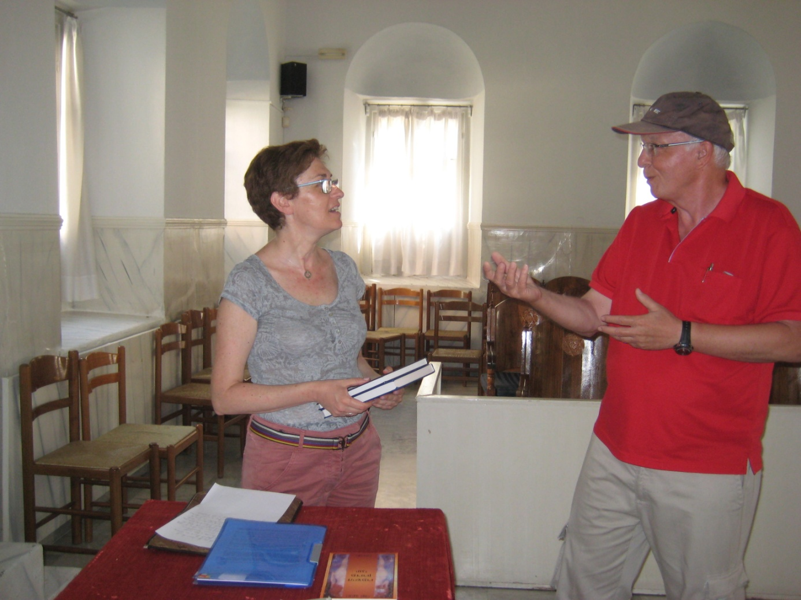

JACQUES CORY AT THE SYNAGOGUE OF LARISSA IN GREECE, HOMETOWN OF HIS MATERNAL GRANDFATHER HAIIM SIMON AVRAHAM. JACQUES CORY WAS RECEIVED IN 2016 BY THE LOCAL JEWISH COMMUNITY & GAVE AS A PRESENT A SAMPLE OF HIS ACADEMIC BOOKS IN ENGLISH AND FRENCH, HIS NOVEL IN HEBREW, AS WELL AS THIS ESSAY ON CORY'S GREEK AND LADINO HERITAGE, IN LADINO, GREEK, ENGLISH, FRENCH, HEBREW, SPANISH, ARAMAIC, LATIN…