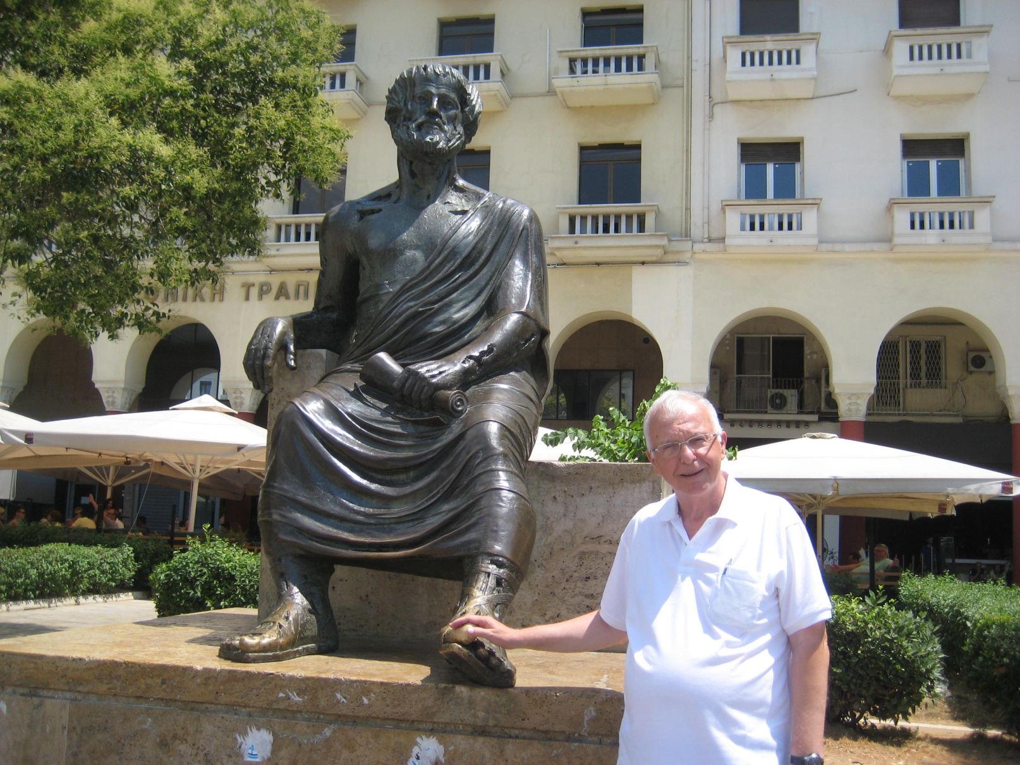

JACQUES CORY WITH HIS FRIEND & MENTOR ARISTOTLE IN THESSALONIKI – SUMMER 2016

JACQUES CORY'S GREEK & LADINO HERITAGE

PRESENTED AS A TOKEN OF FRIENDSHIP TO THE LARISSA JEWISH COMMUNITY BY JACQUES CORY IN HIS VISIT OF SUMMER 2016

